**DISCRETE MATHEMATICS**

LECTURE NOTES

**JAWAHARLAL NEHRU TECHNOLOGICAL UNIVERSITY ANANTAPUR**

**B. Tech II - I sem (Common to CSE & IT)**

|  |  |  |
| --- | --- | --- |
| **T** | **Tu** | **C** |
| **3** | **1** | **3** |

**(15A05302) DISCRETE MATHEMATICS**

**II Year B.Tech. I Sem. Course Objectives**

* Understand the methods of discrete mathematics such as proofs, counting principles, number theory, logic and set theory.
* Understand the concepts of graph theory, binomial theorem, and generating function in analysis of various computer science applications.

**Course Outcomes**

* Able to apply mathematical concepts and logical reasoning to solve problems in different fields of Computer science and information technology.
* Able to apply the concepts in courses like Computer Organization, DBMS, Analysis of Algorithms, Theoretical Computer Science, Cryptography, Artificial Intelligence

**UNIT I:**

**Mathematical Logic:**

Introduction, Connectives, Normal Forms, The theory of Inference for the Statement Calculus, The Predicate Calculus, Inference Theory of Predicate Calculus.

**UNIT II:**

**SET Theory:**

Basic concepts of Set Theory, Representation of Discrete structures, Relations and Ordering, Functions, Recursion.

**UNIT III:**

**Algebraic Structures:**

Algebraic Systems: Examples and General Properties, Semi groups and Monoids, Polish expressions and their compilation, Groups: Definitions and Examples, Subgroups and Homomorphism’s, Group Codes.

**Lattices and Boolean algebra:**

Lattices and Partially Ordered sets, Boolean algebra.

**UNIT IV:**

**An Introduction to Graph Theory:**

Definitions and Examples, Sub graphs, complements, Graph Isomorphism, Vertex Degree: Euler Trails and Circuits, Planar Graphs, Hamilton Paths and Cycles, Graph Coloring and Chromatic Polynomials.

**Trees:**

Definitions, Properties, Examples, Rooted Trees, Trees and Sorting, Weighted trees and Prefix Codes, Biconnected Components and Articulation Points

**UNIT V:**

**Fundamental Principles of Counting:**

The rules of Sum and Product, Permutations, Combinations: The Binomial Theorem, Combinations with Repetition

**The Principle of Inclusion and Exclusion:**

The Principle of Inclusion and Exclusion, Generalizations of Principle, Derangements: Nothing is in Its Right Place, Rook Polynomials, Arrangements with Forbidden Positions

**Generating Functions:**

Introductory Examples, Definitions and Examples: Calculation Techniques, Partitions of Integers, The Exponential Generating Functions, The Summation Operator.

**TEXT BOOKS:**

1. “Discrete Mathematical Structures with Applications to Computer Science”, J.P. Tremblay and

R. Manohar, Mc Graw Hill Education,2015.

1. “Discrete and Combinatorial Mathematics, an Applied Introduction”, Ralph P. Grimaldi and B.V.Ramana, Pearson, 5th Edition, 2016.

**REFERENCE BOOKS:**

1. Graph Theory with Applications to Engineering by NARSINGH DEO, PHI.
2. Discrete Mathematics by R.K.Bishtand H.S. Dhami, Oxford Higher Education.
3. Discrete Mathematics theory and Applications by D.S.Malik and M.K.Sen, Cenegage Learning.
4. Elements of Discrete Mathematics, A computer Oriented approach by C L Liu and D P Mohapatra, MC GRAW HILL Education.
5. Discrete Mathematics for Computer scientists and Mathematicians by JOE L.Mott, Abraham Kandel and Theodore P.Baker, Pearson ,2nd Edition

# UNIT -1

**Mathematical Logic**

1. Discrete Mathematics -Introduction

**Discrete Mathematics** is a branch of mathematics involving discrete elements that uses algebra and arithmetic. It is increasingly being applied in the practical fields of mathematics and computer science. It is a very good tool for improving reasoning and problem-solving capabilities.

* 1. Types of Mathematics.

Mathematics can be broadly classified into two categories −

* + - Continuous Mathematics
    - Discrete Mathematics

**Continuous Mathematics** is based upon continuous number line or the real numbers. It is characterized by the fact that between any two numbers, there are almost always an infinite set of numbers. For example, a function in continuous mathematics can be plotted in a smooth curve without breaks.

**Discrete Mathematics**, on the other hand, involves distinct values; i.e. between any two points, there are a countable number of points. For example, if we have a finite set of objects, the function can be defined as a list of ordered pairs having these objects, and can be presented as a complete list of those pairs.

1. Propositional Logic

The rules of mathematical logic specify methods of reasoning mathematical statements. Greek philosopher, Aristotle, was the pioneer of logical reasoning. Logical reasoning provides the theoretical base for many areas of mathematics and consequently computer science. It has many practical applications in computer science like design of computing machines, artificial intelligence, definition of data structures for programming languages etc.

**Propositional Logic** is concerned with statements to which the truth values, “true” and “false”, can be assigned. The purpose is to analyze these statements either individually or in a composite manner.

* 1. Propositional Logic – Definition

A proposition is a collection of declarative statements that has either a truth value "true” or a truth value "false". A propositional consists of propositional variables and connectives. We denote the propositional variables by capital letters (A, B, etc). The connectives connect the propositional variables.

Some examples of Propositions are given below −

* + - "Man is Mortal", it returns truth value “TRUE”
    - "12 + 9 = 3 − 2", it returns truth value “FALSE”

The following is not a Proposition −

* + - "A is less than 2". It is because unless we give a specific value of A, we cannot say whether the statement is true or false.

1. Connectives

In propositional logic generally we use five connectives which are − OR (∨), AND (∧), Negation/ NOT (¬), Implication / if-then (→), If and only if (⇔).

* 1. **OR (∨)** − The OR operation of two propositions A and B (written as A ∨ B) is true if at least any of the propositional variable A or B is true.

The truth table is as follows −

|  |  |  |
| --- | --- | --- |
| **A** | **B** | **A ∨ B** |
| True | True | True |
| True | False | True |
| False | True | True |
| False | False | False |

* 1. **AND (∧)** − The AND operation of two propositions A and B (written as A ∧ B) is true if both the propositional variable A and B is true.

The truth table is as follows −

|  |  |  |
| --- | --- | --- |
| **A** | **B** | **A ∧ B** |
| True | True | True |
| True | False | False |
| False | True | False |
| False | False | False |

* 1. **Negation (¬)** − The negation of a proposition A (written as ¬A) is false when A is true and is true when A is false.

The truth table is as follows −

|  |  |
| --- | --- |
| **A** | **¬A** |
| True | False |
| False | True |

* 1. **Implication / if-then (→)** − An implication A→B is False if A is true and B is false. The rest cases are true.

The truth table is as follows −

|  |  |  |
| --- | --- | --- |
| **A** | **B** | **A → B** |
| True | True | True |
| True | False | False |
| False | True | True |
| False | False | True |

* 1. **Biconditional / If and only if (⇔)** − A⇔B is bi-conditional logical connective which is true when p and q are both false or both are true.

The truth table is as follows −

|  |  |  |
| --- | --- | --- |
| **A** | **B** | **A ⇔ B** |
| True | True | True |
| True | False | False |
| False | True | False |
| False | False | True |

1. Tautologies

A Tautology is a formula which is always true for every value of its propositional variables.

**Example** − Prove [(A → B) ∧ A] → B is a tautology The truth table is as follows –

|  |  |  |  |  |
| --- | --- | --- | --- | --- |
| **A** | **B** | **A → B** | **(A → B) ∧ A** | **[(A → B) ∧ A] → B** |
| True | True | True | True | True |
| True | False | False | False | True |
| False | True | True | False | True |
| False | False | True | False | True |

As we can see every value of [(A → B) ∧ A] → B is “True”, it is a tautology.

1. Contradictions

A Contradiction is a formula which is always false for every value of its propositional variables.

**Example** − Prove (A ∨ B) ∧ [(¬A) ∧ (¬B)] is a contradiction The truth table is as follows −

|  |  |  |  |  |  |  |
| --- | --- | --- | --- | --- | --- | --- |
| **A** | **B** | **A ∨ B** | **¬A** | **¬B** | **(¬A) ∧ (¬B)** | **(A ∨ B) ∧ [(¬A) ∧ (¬B)]** |
| True | True | True | False | False | False | False |
| True | False | True | False | True | False | False |
| False | True | True | True | False | False | False |
| False | False | False | True | True | True | False |

As we can see every value of (A ∨ B) ∧ [(¬A) ∧ (¬B)] is “False”, it is a contradiction.

1. Contingency

A Contingency is a formula which has both some true and some false values for every value of its propositional variables.

**Example** − Prove (A ∨ B) ∧ (¬A) a contingency The truth table is as follows –

|  |  |  |  |  |
| --- | --- | --- | --- | --- |
| **A** | **B** | **A ∨ B** | **¬A** | **(A ∨ B) ∧ (¬A)** |
| True | True | True | False | False |
| True | False | True | False | False |
| False | True | True | True | True |
| False | False | False | True | False |

As we can see every value of (A ∨ B) ∧ (¬A) has both “True” and “False”, it is a contingency.

1. Propositional Equivalences

Two statements X and Y are logically equivalent if any of the following two conditions −

* The truth tables of each statement have the same truth values.
* The bi-conditional statement X ⇔ Y is a tautology.

**Example** − Prove ¬(A ∨ B) and [(¬A) ∧ (¬B)] are equivalent

**Testing by 1st method (Matching truth table)**

|  |  |  |  |  |  |  |
| --- | --- | --- | --- | --- | --- | --- |
| **A** | **B** | **A ∨ B** | **¬ (A ∨ B)** | **¬A** | **¬B** | **[(¬A) ∧ (¬B)]** |
| True | True | True | False | False | False | False |
| True | False | True | False | False | True | False |
| False | True | True | False | True | False | False |
| False | False | False | True | True | True | True |

Here, we can see the truth values of ¬ (A ∨ B) and [(¬A) ∧ (¬B)] are same, hence the statements are equivalent.

**Testing by 2nd method (Bi-conditionality)**

|  |  |  |  |  |
| --- | --- | --- | --- | --- |
| **A** | **B** | **¬ (A ∨ B)** | **[(¬A) ∧ (¬B)]** | **[¬ (A ∨ B)] ⇔ [(¬A) ∧ (¬B)]** |
| True | True | False | False | True |
| True | False | False | False | True |
| False | True | False | False | True |
| False | False | True | True | True |

As [¬ (A ∨ B)] ⇔ [(¬A) ∧ (¬B)] is a tautology, the statements are equivalent.

1. Inverse, Converse, and Contra-positive

A conditional statement has two parts − **Hypothesis** and **Conclusion**.

**Example of Conditional Statement** − “If you do your homework, you will not be punished.” Here, "you do your homework" is the hypothesis and "you will not be punished" is the conclusion.

Ex: **P->Q ⬄¬PvQ**

**Inverse** − An inverse of the conditional statement is the negation of both the hypothesis and the conclusion. If the statement is “If p, then q”, the inverse will be “If not p, then not q”. The inverse of “If you do your homework, you will not be punished” is “If you do not do your homework, you will be punished.”

Ex: Inverse Of P->Q Is **¬P->¬Q**

**Converse** − The converse of the conditional statement is computed by interchanging the hypothesis and the conclusion. If the statement is “If p, then q”, the inverse will be “If *q*, then *p*”. The converse of "If you do your homework, you will not be punished" is "If you will not be punished, you do not do your homework”.

Ex: Converse of P->Q Is **Q->P**

**Contra-positive** − The contra-positive of the conditional is computed by interchanging the hypothesis and the conclusion of the inverse statement. If the statement is “If p, then q”, the inverse will be “If not *q*, then not *p*”. The Contra-positive of "If you do your homework, you will not be punished” is "If you will be punished, you do your homework”.

**Ex:** Contra-Positive Of P->Q Is **¬Q->¬P**

1. Duality Principle

Duality principle set states that for any true statement, the dual statement obtained by interchanging unions into intersections (and vice versa) and interchanging Universal set into Null set (and vice versa) is also true. If dual of any statement is the statement itself, it is said **self-dual** statement.

**Example** − The dual of (A ∩ B) ∪ C is (A ∪ B) ∩ C

1. Normal Forms

We can convert any proposition in two normal forms −

* Conjunctive normal form
* Disjunctive normal form
  1. **Conjunctive Normal Form**

A compound statement is in conjunctive normal form if it is obtained by operating AND among variables (negation of variables included) connected with ORs.

**Examples**

* + - (P ∪ Q) ∩ (Q ∪ R)
    - (¬P ∪ Q ∪ S ∪¬T)
  1. **Disjunctive Normal Form**

A compound statement is in disjunctive normal form if it is obtained by operating OR among variables (negation of variables included) connected with ANDs.

**Examples**

* + - (P ∩ Q) ∪ (Q ∩ R)
    - (¬P ∩ Q ∩ S ∩¬T)

1. Predicate Logic
   1. **Predicate Logic – Definition**

A predicate is an expression of one or more variables defined on some specific domain. A predicate with variables can be made a proposition by either assigning a value to the variable or by quantifying the variable. The following are some examples of predicates −

* + - Let E(x, y) denote "x = y"
    - Let X(a, b, c) denote "a + b + c = 0"
    - Let M(x, y) denote "x is married to y"
  1. **Predicate calculus**

we'll symbolize the word "every" (or equivalently "all", "any", etc.) with an upside down 'A': . And we'll use a backwards-E for "some" and it's synonyms:  .

**Symbolizing "All" and "Some"**

**Example1:**( x)W(x): read this as "every x is such that it is valid" or as "all x make 'W(x)' true" or “every x, every member of the universe of discourse, is a valid argument:”

**Example2:**(  x)W(x): read this "there is an x such that x is valid" or as "there is an x making 'Wx' true.", or “some x, some member of the universe of discourse, is a valid argument.”

**Symbolizing "No" meaning "None"**

We have two logically equivalent ways to think about our "no" statement: "**No** cats are reptiles". This statement can be understood to be it's not true that some cat is a reptile ('~( x)R(x)') or it can be equivalently rendered as all cats are non- reptiles ('( x)~R(x)'). (To say that all cats are non-reptiles is to say that every cat fails to be a reptile.)

We will see these two ways of expressing "no" again and again, so let's put it in a box:

**QN: "no** cats are reptiles" can be symbolized '~(  x)R(x)' or, equivalently, '( x)~R(x)'.

We will return to the PL symbolizations later. For now keep in mind that "**no**", "**some**", and "**all**" have this complicated relation just called '**QN**'.

**3.2.3. Categorical Statements**

These three examples are of categorical statements. They relate categories. For example, "All dogs are mammals" takes the subject term "dogs" and relates it to the predicate term "mammals".

1. **A categorical statement of this form...**

All S are P

we call a "universal categorical statement". We'll call the *form* "universal".

1. **A statement of this "existential form":**

Some S are P :is an existential categorical statement.

1. **A statement of the last or "negative form":** No S are P is a negative categorical statement. **d)Obversion** has two forms to remember:

"All S are P" is logically equivalent to "No S are non-P". "No S are P" is logically equivalent to "All S are non-P". **e)Conversion has two forms for equivalence**:

"Some S are P" is logically equivalent to "Some P are S". "No S are P" is logically equivalent to "No P are S". **f)Contraposition**:

"All S are P" is logically equivalent to "All non-P are non-S".

11.4. Venn diagrams

Venn diagrams are the easy way to go to understand the meaning of categorical sentences. Think

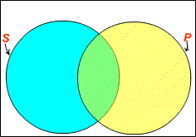of everything in the universe (of discourse) as being contained within the box just below.

Everything that falls into the category S is located in a circle (the left one). Everything falling into category P is located in the other circle (the right one).

If something is **both** S and P, then it's located in the area of overlap of the two circles: the area in green.

Anything which is **neither** S nor P, is outside both circles and in the white area.

**Now, let's use these diagrams for understanding categorical statements.**

We have three "official" categorical forms.

1. 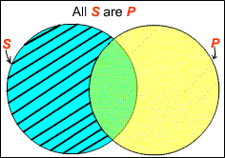**universal categorical form**: All S are P

The lines mean that the area *inside* S but *outside* P is empty. So, any S is P. Thus we have a diagram of our universal form.

1. 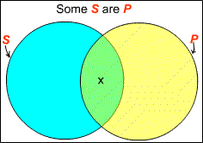**existential categorical form**: Some S are P

The 'x' is an arbitrary stand-in for an object. The diagram simply says that there is something in the green area of overlap between S and P.

1. **negative categorical form**: No S are P

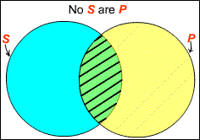This diagram represents there being nothing in the overlap. So, there is nothing that is both S and P.

Symbolization into strict categorical form

1. When we first wrote up a Venn Diagram for the universal form, we put it this way:

This diagram specifies the meaning of "All S are P". The idea is that everything that is in P is also in S. I.e., there is nothing in S that is not also in P. This last just means:

No S are non-P.

There is nothing in the overlap of S and non-P.

Second, a little thought shows that we've also justified the logical equivalence for this similar transposition:

**"No S are P" is logically equivalent to "All S are non-P".**

**Quantifiers-Types**

1. **Existential Form** can be manifested in English with phrases not including "some". For example, if one says any of...

**There is a whale in Ohio.**

**There is at least one whale in Ohio. Whales exist (or live) in Ohio.**

one could be taken to mean

**Some W are O**

Where 'W' stands for the category of whales, 'O' for things in Ohio.

1. **Trickier cases include: A whale lives in Ohio.**

**Whales are in Ohio.**

These clearly are also existential. But see below for similar case that are universal. Think about this one:

**Some dogs are not pets.**

This doesn't fit our existential categorical form only because "not a pet" is not itself a category phrase. But we can easily turn it into one: "not a pet" goes to "non-pet". So, we can symbolize this one as

**Some D are N**

where 'N' stands for the collection of non-pets. (***Warning***: Traditional logic recognizes a forth form: "Some S are *not* P". Let's call this existential negation. It's easy to see it's meaning. Now, how would you diagram it?)

1. **Negative Forms** to come in different styles that are logically equivalent:

**No S are P**

**Nothing is both S and P None of S are P**

1. **Universal Forms**

For example, any of the following could be symbolized as a universal form statement:

1. **Every whale is a mammal.**
2. **Each whale is a mammal.**
3. **Any whale is a mammal.**

So, when your job is to symbolize is standard form, you will take such English and change them into

**All W are M.**

Where 'W' is interpreted as the predicate naming whales, 'M' for mammals.

**Here are two more tougher ones:**

1. **Whales are mammals.**
2. **A whale is a mammal.**
3. **If a thing is a whale, then it's a mammal.**

Usually these two, 4 and 5, would also be symbolized as of universal form, the same way as for 1-3.

**All W are M.**

If you say "whales are mammals" you are pretty clearly thinking about ***all*** whales.

When "a whale is a mammal" is used, this is normally about an arbitrary whale. So, 5 too is universal.

1. is similarly about any thing. Keep 6 in mind; it will help us symbolize categorical statements into English.
2. **All losers complain.**
3. is missing a category term for the predicate. But this is easy to fix. Let 'C' stand for "people who complain".

**All L are C.**

1. **Tom always comes in late.**
2. doesn't even look like a categorical statement at first. But it's about all times. "All times when Tom comes are times when he's late".

**All C are L.**

1. **Wherever one goes one finds competition.**

This is "All places one goes are places one finds competition":

**All G are F.**

where 'G' stands for "places one goes" and 'F' for "places one finds competition".And another similar one:

1. **Whoever didn't pass should study harder.**

This is "All people who did not pass should study harder".

**All N are H.**

**The next few are trickier:**

1. Only humans are rational.
2. None but humans are rational.

These say that nothing else is rational besides humans: All rational beings are human. All R are H.

But they do not say that all humans are rational! So, "Only S are P" and "None but S are P" amount to "All P are S". Note the subject-predicate switch!.However, adding the word "The" makes all the difference!:

1. **The only rational creatures are humans.**

which is symbolized with no "switching": All R are H.

In general, "The only S are P" is logically equivalent to "All S are P".And, here's a last universal form symbolization:

1. **One pays taxes unless one is lucky.**

Unless means "if not" (you can prove this in SD). So, any person who is unlucky pays taxes. All U are P.

**Negations** can be tricky too.

1. **Not a single life should be wasted.**

15 means that all life should be saved, not wasted. All L are S.

Note that 15 is a negation of an existential: "Some life should be wasted". But 16 is different, it's the negation

1. **Not all politicians are crooks.**

This is "Some politicians are non-crooks": Some P are N.

where now 'N' stands for "non-crook".

* 1. Exercises

**Example1:**Take the syllogism All dogs are mammals.

All mammals are animals.

therefore

All dogs are animals.

To symbolize this argument using predicate logic, let's take each statement separately. The first statement "all dogs are mammals" says predicates doghood of some things, mammalhood of some things, and then says that all things that have doghood also have mammalhood. In other

words, for all things, if it is has doghood then it has mammalhood. We can give a similar analysis for the other two statements. Using "D" for "doghood," "M" for "mammalhood," "A" for "animalhood," "x" for "thing," "(x)" for "all things," and "→" for the "if....then" aspect, we have

|  |  |  |
| --- | --- | --- |
| Statement | Symbolization | Interpretation |
| All dogs are mammals. | (x) (Dx → Mx) | For all things, if it is a dog, then it is a mammal. |
| All mammals are animals. | (x) (Mx →Ax) | For all things, if it is a mammal, then it is an animal. |
| therefore |  |  |
| All dogs are animals. | (x) (Dx → Ax) | For all things, if it is a dog, then it is an animal. |

|  |  |  |
| --- | --- | --- |
| **Line no** | **Quantifiers** | **Rule** |
| **1.** | **(x) (D(x) → M(x))** | **P** |
| **2.** | **D(x) → M(x)** | **US,1** |
| **3.** | **(x) (M(x) →A(x))** | **P** |
| **4.** | **M(x) →A(x)** | **US,3** |
| **5.** | **D(x) → A(x)** | **Hypothetical Syllosim,2,4** |
| **6.** | **(x) (D(x) → A(x))**  All dogs are animals. | **UG,5** |

**Example2:**

Similarly, we can symbolize arguments involving statements such as "some mammals are dogs" by using "(Эx)" to stand for "some things" in place of "(x)" for "all things. Instead of ">" for the "if....then" aspect, for some types of statements we might use "^" for "and" and "v" for "or." And negation could be captured with a "-."

|  |  |  |
| --- | --- | --- |
| Statement | Symbolization | Interpretation |
| Some mammals are dogs. | (Эx) (Mx ^ Dx) | There is some thing, such that it is a mammal and a dog. |
| All dogs are barkers. | (x) (Dx →Bx) | For all things, if it is a dog, then it is a barker. |
| therefore |  |  |
| Some mammals are barkers. | (Эx) (Mx ^ Bx) | There is some thing, such that it is a mammal and a barker. |

|  |  |  |
| --- | --- | --- |
| **Line no** | **Quantifiers** | **Rule** |
| **1.** | (Э**x) (M(x)^D(x))** | **p** |
| **2.** | **M(x) ^D(x)** | **ES,1** |
| **3.** | **M(x) and D(x)** | **Simplication ,2** |
| **4.** | **(x) (D(x)→B(x))** | **P** |
| **5.** | **D(x)→B(x)** | **US,4** |
| **6.** | **B(x)** | **Moduspones,3,5** |
| **7.** | **M(x)^B(x)** | **Conjunction,3,6** |
| **8.** | (Э**x)(M(x)^B(x))**  **Some mammals are barkers** | **EG,7** |

**Example3:**

For reasons we cannot go into, logicians use an "^" for "and" to capture the "some mammals are dogs" type of statement instead of an "→" to characterize it as an "if....then."

All dogs are mammals. (x) D(x)→M(x) All cats are mammals. (x) C(x)→M(x) therefore

All dogs are cats. (x) D(x)→C(x)

**Solution:**

|  |  |  |
| --- | --- | --- |
| **Line no** | **Quantifiers** | **Rule** |
| **1.** | **(x) D(x)→M(x)** | **P** |
| **2.** | **D(x)→M(x)** | **US,1** |
| **3.** | **(x) C(x)→M(x)** | **P** |
| **4.** | **C(x)→M(x)** | **US,3** |
| **5.** | **D(x)→C(x)** | **Hypothetical Syllosim,2,4** |
| **6.** | **(x) D(x)→C(x)**  **All dogs are cats.** | **UG,5** |

**Example4:**

All turkeys are birds.: (x) T(x)→B(x) No birds are mammals. (x) Bx **→┐**M(x) therefore

No turkeys are mammals. (x) T(x) → ┐ M(x)

**Solution:**

|  |  |  |
| --- | --- | --- |
| **Line no** | **Quantifiers** | **Rule** |
| **7.** | **(x) T(x)→B(x)** | **P** |
| **8.** | **T(x)→B(x)** | **US,1** |
| **9.** | **(x) Bx →┐M(x)** | **P** |
| **10.** | **Bx →┐M(x)** | **US,3** |
| **11.** | **T(x) → ┐M(x)** | **Hypothetical Syllosim,2,4** |
| **12.** | **(x) T(x) → ┐M(x)**  **No turkeys are mammals** | **UG,5** |

**Example5:**

All turkeys are birds. (x) T(x) → B(x)

Some birds are not mammals. (Эx) B(x) **^ ┐**M(x) therefore

No turkeys are mammals. (x) T(x) → ┐M(x)

**Solution:**

|  |  |  |
| --- | --- | --- |
| **Line No** | **Quantifiers** | **Rules** |
| **1.** | **(Эx)B(x) ^┐M(x)** | **P** |
| **2.** | **B(x) ^┐M(x)** | **ES ,1** |
| **3.** | **B(x) and ┐M(x)** | **simplification ,2** |
| **4.** | **B(x)** |  |
| **5.** | ךּ **B(x)** | **Negation,4** |
| **6.** | **(x) T(x) → B(x)** | **P** |
| **7.** | **T(x) → B(x)** | **US,5** |
| **8.** | **T(x)** | **Modusponens,5,7** |

|  |  |  |
| --- | --- | --- |
| **9.** | **T(x) →┐M(x)** | **Conjunction,3,8** |
| **10.** | **(x) T(x) → ┐M(x)**  No turkeys are mammals. | **UG,9** |

**Examples of Valid & Invalid Logical Reasoning**

**Problem solving**

**Example 1**

* + 1. If all dogs are mammals, then all dogs are reptiles.
    2. All dogs are mammals.
    3. Therefore, all dogs are reptiles.

**Answers**

1. If all dogs are mammals, then all dogs are reptiles.
2. All dogs are mammals.
3. Therefore, all dogs are reptiles.

This argument is valid. The fact that the first premise and conclusion are false doesn’t mean the argument form is logically invalid. This same argument form can be used to make good arguments. The argument form is “If A, then B. A. Therefore, B.” A good argument with this argument form is the following:

1. If all dogs are mammals, then all dogs are animals.
2. All dogs are mammals.
3. Therefore, all dogs are animals.

How can we prove the argument is valid? We can show that it’s impossible to form a formal counterexample. We can assume the argument is invalid and prove that such an assumption is impossible because it will lead to self-contradiction.

The easiest way to realize that this argument form is valid is to realize what it means to say “If A, then B.” This statement means “If A is true, then B is true” or “B is true whenever A is true). That also implies that if B is false, then A must be false.

We can prove the argument form is valid using the following reasoning:

1. The counterexample must have true premises, and a false conclusion.
2. In that case we assume that “If A, then B” is true because it’s a premise, A is true because it’s a premise, and B is false because it’s our conclusion.
3. In that case ‘A’ must be false because “if A, then B” is assumed to be true, and ‘B’ is assumed to be false. (Consider the statement, “If dogs are mammals, then dogs are animals.” If we find out that dogs aren’t animals, then they can’t be mammals. If the second part of a conditional statement is false, then the first part must be false.)
4. Therefore, ‘A’ is true and false. That’s a contradiction.
5. The assumption that the argument is has true premises and a false conclusion leads to a contradiction.
6. Therefore, the argument form can’t be invalid.
7. Therefore, the argument must be valid.

**Example 2**

1. If all dogs are mammals, then all dogs are animals.
2. All dogs are animals.
3. Therefore, all dogs are mammals.

**Answer:**

1. If all dogs are mammals, then all dogs are animals.
2. All dogs are animals.
3. Therefore, all dogs are mammals.

Although the premises and conclusion are true, the argument form is invalid. The argument form is the following:

1. If A, then B.
2. B.
3. Therefore, A.

We can then replace the variables to create a counterexample that uses this argument form with true premises and a false conclusion. The variables will be replaced with the following statements:

A: All dogs are reptiles. B: All dogs are mammals.

This leads to the following counterexample:

1. If all dogs are reptiles, then all dogs are animals.
2. All dogs are animals.
3. Therefore, all dogs are reptiles.

Both premises are true, but the conclusion is false. Therefore, the argument form must be invalid.

**Example 3**

1. Either it’s wrong to indiscriminately kill people, or it’s not wrong to kill someone just because she has red hair.
2. It’s wrong to kill someone just because she has red hair.
3. Therefore, it’s wrong to indiscriminately kill people.

**Answer:**

1. Either it’s wrong to indiscriminately kill people, or it’s not wrong to kill someone just because she has red hair.
2. It’s wrong to kill someone just because she has red hair.
3. Therefore, it’s wrong to indiscriminately kill people.

This time the premises are true, the conclusion is true, and the argument form is valid. The argument form is the following:

1. Either A or not-B. (“Not-B” means “B is false.”)
2. B (is true).
3. Therefore A.

An example of a good argument with this argument form is the following:

1. Either dogs are warm-blooded or dogs aren’t mammals.
2. Dogs are mammals.
3. Therefore, dogs are warm-blooded.

Let’s try to prove this argument is valid by proving it’s impossible to provide a counterexample. We can assume it’s invalid only to find out that such an assumption will lead to a contradiction.

1. We assume the premises are true and the conclusion is false.
2. We assume ‘A’ is false because it’s the conclusion.
3. We assume ‘B’ is true because it’s a premise.
4. We assume “Either A or not-B” is true.
5. “Either A or not-B” requires that either A is true or not-B is true.
6. We know A is false, so not-B must be true.
7. Therefore, B and not-B are both true. That’s a contradiction.
8. Therefore, the the assumption that the premises are true and conclusion is false leads to a contradiction.
9. Therefore, the argument form can’t be invalid.
10. Therefore, the argument form is valid.

**Example 4**

1. Either disciplining people is always wrong or it’s not always wrong to discipline people for committing crimes.
2. Disciplining people hurts them.
3. Therefore, disciplining people is always wrong.

**Answer:**

1. Either disciplining people is always wrong or it’s not always wrong to discipline people for committing crimes.
2. Disciplining people hurts them.
3. Therefore, disciplining people is always wrong.

This argument is invalid, and it’s already a counterexample because the premises are true and the conclusion is false. The argument form is the following:

1. Either A or not-B.
2. C
3. Therefore, B.

Another counterexample is the following:

1. Either murder is always appropriate or it’s not always appropriate to murder people for making you angry.
2. Murdering people hurts them.
3. Therefore, murder is always appropriate.

**Example 5**

1. It’s often good to give to charity.
2. If it’s often good to give to charity, then the Earth is round.
3. Therefore, the Earth is round.

**Answer:**

1. It’s often good to give to charity.
2. If it’s often good to give to charity, then the Earth is round.
3. Therefore, the Earth is round.

This argument is logically valid, even though the premises seem to lack relevance. Logical validity doesn’t guarantee relevance.

The argument form is the following:

1. A.
2. If A, then B.
3. Therefore, B.

This is basically the same argument form as the first example, so no further proof of validity is required.

**Example 6**

1. The death penalty sometimes leads to the death of innocent people.
2. Therefore, the death penalty sometimes leads to the death of innocent people.

**Answer:**

1. The death penalty sometimes leads leads to the death of innocent people.
2. Therefore, the death penalty sometimes leads to the death of innocent people.

This argument is circular, but it’s still logically valid. The argument structure is the following:

1. A.
2. Therefore, A.

We can prove the argument is valid by proving that it’s impossible to have a counterexample. Such an argument looks like the following:

1. We must assume the premise is true and the conclusion is false.
2. We assume ‘A’ is false because it’s the conclusion.
3. We assume ‘A’ is true because it’s the premise.
4. Therefore, ‘A’ is true and false.
5. The assumption that the premise is true and conclusion is false leads to a contradiction.
6. Therefore, the argument form can’t be invalid.
7. Therefore, the argument form must be vaild.

**Example 7**

1. Murder is always wrong.
2. Sometimes murder isn’t wrong.
3. Therefore, the death penalty should be illegal.

**Answer:**

1. Murder is always wrong.
2. Sometimes murder isn’t wrong.
3. Therefore, the death penalty should be illegal.

The premises contradict each other, but the argument is still valid because it’s impossible for the premises to be true and the conclusion to be false at the same time. We can tell that both premises can’t be true at the same time, so it’s impossible to make a counterexample because that would require both premises to be true. The argument form looks like the following:

1. A.
2. Not-A
3. Therefore, B.

We can prove this argument to be valid by showing why a counterexample can’t be given:

1. We assume the premises are true and the conclusion is false.
2. ‘A’ is assumed to be true.
3. Not-A is assumed to be true.
4. ‘B’ is assumed to be false.
5. Therefore, ‘A’ is true and false.
6. Therefore, the assumption that the premises are true and conclusion is false leads to a contradiction.
7. Therefore, the argument form can’t be invalid.
8. Therefore, the argument form must be valid.

**Example 8**

1. It’s wrong to refuse to hire the most qualified applicant due to irrelevant criteria.
2. Therefore, it’s wrong to refuse to hire the most qualified applicant due to the color of her skin.

**Answer:**

1. It’s wrong to refuse to hire the most qualified applicant due to irrelevant criteria.
2. Therefore, it’s wrong to refuse to hire the most qualified applicant due to the color of her skin.

This argument might sound like it’s valid, but it’s technically invalid with the following argument form:

1. A.
2. Therefore, B.

A counterexample would be the following:

1. It’s good to help people.
2. Therefore, it’s good to help prisoners escape from prison.

The reason why the argument might sound valid is because we have an assumption that the color of an applicant’s skin is irrelevant criteria. We could then make the argument valid using the following reasoning:

1. It’s wrong to refuse to hire the most qualified applicant due to irrelevant criteria.
2. If it’s wrong to refuse to hire the most qualified applicant due to irrelevant criteria, then it’s wrong to refuse to hire the most qualified applicant due to the color of her skin (because skin color is irrelevant criteria).
3. Therefore, it’s wrong to refuse to hire the most qualified applicant due to the color of her skin.

The argument form is now:

1. A.
2. If A, then B.
3. Therefore, B.

This argument form is the same as was used in example 1 and has already been proven to be valid.

**Example 9**

1. We should try to keep an open mind.
2. Therefore, either rocks exist or rocks don’t exist.

**Answer:**

1. We should try to keep an open mind.
2. Therefore, either rocks exist or rocks don’t exist.

This argument has a premise that seems irrelevant to the conclusion, but it’s still logically valid because the conclusion will be true no matter what. It can’t be invalid because a counterexample requires the conclusion to be false. The argument form looks like the following:

1. A.
2. Therefore, B or not-B.

We can prove this argument is valid by proving that we can’t have a counterexample using the following reasoning:

1. Let’s assume that we can develop a counterexample, so the premise is assumed to be true and the conclusion is assumed to be false.
2. We assume ‘A’ is true because it’s a premise.
3. We assume “B or not-B” to be false because it’s a conclusion.
4. B or not-B is true. (If ‘B’ is false, then “B or not-B” is true. If ‘B’ is true, then “B or not-B is true.)
5. Therefore ‘B’ is true and false.
6. The assumption that the premise is true and conclusion is false leads to a contraction.
7. Therefore, the argument form can’t be invalid.
8. Therefore, the argument form is valid.

**Example 10**

1. All cats are mammals.
2. Therefore, some cats are mammals.

**Answer:**

1. All cats are mammals.
2. Therefore, some cats are mammals.

This argument is invalid despite the fact that it might look valid. The statement “All cats are mammals” is equivalent to “if something is a cat, then it’s a mammal” and the statement “some cats are mammals” is equivalent to “there is at least one cat and it’s a mammal.” We can then reveal the logical structure as the following:

1. If X exists then it’s a Y.
2. Therefore, an X exists and it’s a Y.

The problem here is that it’s the existential fallacy—we can’t assume that something exists in a conclusion when no premise claims something to exist. In this case we can’t assume a cat exists just because all cats are mammals. A counterexample could be the following:

1. If you are found guilty for killing everyone on Earth in a court of law, then you will go to prison.
2. Therefore, someone was found guilty for killing everyone on Earth in a court of law, and that person went to prison.

The main difference between these two arguments is that we know that cats exist. That’s the hidden premise that can be used to fix the argument:

1. If something is a cat, then it’s a mammal.
2. A cat exists right now.
3. Therefore, a cat exists and it’s a mammal.

**Example 11:**

1. All babies are illogical.
2. Nobody is despised who can manage a crocodile.
3. Illogical persons are dispised.

As the subjects of this puzzle are people, we take the universe as the set of all people. We will rewrite each statement in the puzzle as an implication. First we define simpler statements,

|  |  |  |
| --- | --- | --- |
| B : it is a baby |  | L : it is logical |
| M : it can manage a crocodile | D : it is despised , |

where “it” in this context refers to a general person. Then the three statements can be rephrased as

|  |
| --- |
| (a) B → ~L : If it is a baby then it is not logical. |
| (b) M → ~D : If it can manage a crocodile then it is not despised. |
| (c) ~L → D : If it is not logical then it is despised. |

Our aim is to use transitive reasoning several times, stringing together a chain of implications using all the given statements. We have an arrow pointing from B to ~L, and likewise an arrow pointing from ~L to D; thus we are able to start with B and arrive at the conclusion D. However, the second statement is still not utilized. But since any implication is equivalent to its contrapositive, we may replace the second statement with its **contrapositive D → ~M.** Then we get the transitive reasoning chain

**B → ~L → D → ~M .**

We reason that if B is true, then ~L is true, hence D is true, and therefore ~M is true. Our ultimate conclusion is the statement

**B → ~M :** If it is a baby then it cannot manage a crocodile .

In ordinary language we would more likely rephrase this answer to the puzzle as “No baby can manage a crocodile.”

Alternatively, we could write the answer as the contrapositive statement

**M → ~B :** If it can manage a crocodile then it is not a baby. The translation into words then would be something like “Anyone who can manage a crocodile is not a baby.”

* 1. **Well Formed Formula**

Well Formed Formula (wff) is a predicate holding any of the following −

* + - All propositional constants and propositional variables are wffs
    - If x is a variable and Y is a wff, ∀x Y and ∃x Y are also wff
    - Truth value and false values are wffs
    - Each atomic formula is a wff
    - All connectives connecting wffs are wffs
  1. **Quantifiers**

The variable of predicates is quantified by quantifiers. There are two types of quantifier in predicate logic − Universal Quantifier and Existential Quantifier.

* + 1. **Universal Quantifier**

Universal quantifier states that the statements within its scope are true for every value of the specific variable. It is denoted by the symbol ∀. ∀x P(x) is read as for every value of x, P(x) is true.

**Example** − "Man is mortal" can be transformed into the propositional form ∀x P(x) where P(x) is the predicate which denotes x is mortal and the universe of discourse is all men.

* + 1. **Existential Quantifier**

Existential quantifier states that the statements within its scope are true for some values of the specific variable. It is denoted by the symbol ∃.

∃x P(x) is read as for some values of x, P(x) is true.

**Example** − "Some people are dishonest" can be transformed into the propositional form ∃x P(x) where P(x) is the predicate which denotes x is dishonest and the universe of discourse is some people.

* + 1. **Nested Quantifiers**

If we use a quantifier that appears within the scope of another quantifier, it is called nested quantifier.

**Example**

* + - * ∀a ∃b P (x, y) where P (a, b) denotes a + b = 0
      * ∀a ∀b ∀c P (a, b, c) where P (a, b) denotes a + (b+c) = (a+b) +c

**Note** − ∀a ∃b P (x, y) ≠ ∃a ∀b P (x, y)

**Inference Theory On the predicate Calculus.**

In order to use the equivalence and implications, we need some rules on how to eliminate quantifiers during the course of derivation. This elimination is done by rules of specification **called rules US and ES**. Once the quantifiers are eliminated, the derivation proceeds as in the case of the statement calculus and the conclusion is reached.

The Rules of generalization called **rules UG and EG**, which can be used to attach a quantifiers.

|  |  |  |
| --- | --- | --- |
| Quantifiers | Rules | Examples |
| Universal Specification | US | (x) A(x) → A(y) |
| Existential Specification | ES | (Эx) A(x) → A(y) |
| Universal Generalization | UG | A(x) → (x) A(y) |
| Existential Generalization | EG | A(x) →(Эx) A(y) |

1. Rules of Inference

To deduce new statements from the statements whose truth that we already know, **Rules of Inference** are used.

**What are Rules of Inference for?**

Mathematical logic is often used for logical proofs. Proofs are valid arguments that determine the truth values of mathematical statements.

An argument is a sequence of statements. The last statement is the conclusion and all its preceding statements are called premises (or hypothesis). The symbol “∴”, (read therefore) is placed before the conclusion. A valid argument is one where the conclusion follows from the truth values of the premises.

Rules of Inference provide the templates or guidelines for constructing valid arguments from the statements that we already have.

**Addition**

If P is a premise, we can use Addiction rule to derive P ∨ Q.

**Example**

P Q

----------

∴ P ∨ Q

Let P be the proposition, “He studies very hard” is true

Therefore − "Either he studies very hard Or he is very bad student." Here Q is the proposition “he is a very bad student”.

**Conjunction**

If P and Q are two premises, we can use Conjunction rule to derive P ∧ Q.

P Q

----------

∴ P ∧ Q

**Example**

Let P − “He studies very hard”

Let Q − “He is the best boy in the class”

Therefore − "He studies very hard and he is the best boy in the class"

**Simplification**

If P ∧ Q is a premise, we can use Simplification rule to derive P.

**Example**

P ∧ Q

----------

∴ P

"He studies very hard and he is the best boy in the class" Therefore − "He studies very hard"

**Modus Ponens**

If P and P→Q are two premises, we can use Modus Ponens to derive Q.

**Example**

P→Q P

----------

∴ Q

"If you have a password, then you can log on to facebook" "You have a password"

Therefore − "You can log on to facebook"

**Modus Tollens**

If P→Q and ¬Q are two premises, we can use Modus Tollens to derive ¬P.

**Example**

P→Q

¬Q

----------

∴ ¬P

"If you have a password, then you can log on to facebook" "You cannot log on to facebook"

Therefore − "You do not have a password "

**Disjunctive Syllogism**

If ¬P and P ∨ Q are two premises, we can use Disjunctive Syllogism to derive Q.

**Example**

¬P

P ∨ Q

----------

∴ Q

"The ice cream is not vanilla flavored"

"The ice cream is either vanilla flavored or chocolate flavored" Therefore − "The ice cream is chocolate flavored” **Hypothetical Syllogism**

If P→Q and Q→R are two premises, we can use Hypothetical Syllogism to derive P→R

P → Q Q → R

----------

∴ P → R

**Example**

"If it rains, I shall not go to school”

"If I don't go to school, I won't need to do homework"

Therefore − "If it rains, I won't need to do homework"

**Constructive Dilemma**

If ( P→Q ) ∧ (R→S) and P ∨ R are two premises, we can use constructive dilemma to derive Q ∨

S.

**Example**

( P → Q ) ∧ (R → S)

P ∨ R

----------

∴ Q ∨ S

“If it rains, I will take a leave”

“If it is hot outside, I will go for a shower” “Either it will rain or it is hot outside”

Therefore − "I will take a leave or I will go for a shower"

**Destructive Dilemma**

If (P→Q) ∧ (R→S) and ¬Q ∨ ¬S are two premises, we can use destructive dilemma to derive P ∨

R.

(P → Q ) ∧ (R → S)

¬Q ∨ ¬S

----------

∴ P ∨ R

**Example** “If it rains, I will take a leave” “If it is hot outside, I will go for a shower”

“Either I will not take a leave or I will not go for a shower” Therefore − "It rains or it is hot outside".

* 1. **Examples are Modus Ponens and Modus Tollens.**

In the case of arguments exemplifying such patterns, we say they are "truth functionally valid" because their validity depends on the way the form of the argument involves the truth functional connectives. Here are some arguments exemplifying some other common argument forms or "rules of inference.". See if you can test PT-Thinker to determine the validity of the arguments that use them. (Give it the premises and ask it about the conclusion.)

**Modus Ponens**

If dinosaurs are really birds, Neanderthals wore metal hats. Dinosaurs are really birds.

therefore

Neanderthals wore metal hats.

**Modus Tollens**

If logic is worth studying, then logic is worth studying well. It's not the case that logic is worth studying well.

therefore

It's not the case that logic is worth studying

**Hypothetical Syllogism**

If bears are happy campers, then bears won't bother human campers.

If bears won't bother real campers, then human campers will be happy campers. therefore

If bears are happy campers, then human campers will be happy campers.

* 1. **Examples are "denying the antecedent" and "affirming the consequent."**

See if you can see what is wrong with the following arguments. It may be a little tricky to see; remember that it is not whether the premises and conclusion are true that matters, but whether the truth of the conclusion would follow necessarily from the truth of all the premises.

**Denying the antecedent**

If some cigarettes are worth smoking then some cigarettes are worth dying for. It's not the case that some cigarettes are worth smoking.

therefore

It's not the case that some cigarettes are worth dying for.

**Affirming the consequent.**

If some cigarettes are worth smoking then some cigarettes are worth dying for. Some cigarettes are worth dying for.

therefore

Some cigarettes are worth smoking.

See what PT-Thinker has to say about whether the above arguments are valid.

# UNIT -2

**Set Theory**

## Basic Concepts of Set-Theory

**Set – Definition**

A set is an unordered collection of different elements. A set can be written explicitly by listing its elements using set bracket. If the order of the elements is changed or any element of a set is repeated, it does not make any changes in the set.

**Some Example of Sets**

* A set of all positive integers
* A set of all the planets in the solar system
* A set of all the states in India
* A set of all the lowercase letters of the alphabet

**Representation of a Set**

Sets can be represented in two ways −

* Roster or Tabular Form
* Set Builder Notation

**Roster or Tabular Form**

The set is represented by listing all the elements comprising it. The elements are enclosed within braces and separated by commas.

**Example 1** − Set of vowels in English alphabet, A = {a,e,i,o,u} **Example 2** − Set of odd numbers less than 10, B = {1,3,5,7,9} **Set Builder Notation**

The set is defined by specifying a property that elements of the set have in common. The set is described as A = { x : p(x)}

**Example 1** − The set {a,e,i,o,u} is written as − A = { x : x is a vowel in English alphabet} **Example 2** − The set {1,3,5,7,9} is written as − B = { x : 1≤x<10 and (x%2) ≠ 0}

If an element x is a member of any set S, it is denoted by x ∈ S and if an element y is not a member of set S, it is denoted by y ∉ S.

**Example** − If S = {1, 1.2, 1.7, 2}, 1 ∈ S but 1.5 ∉ S

**Some Important Sets**

**N** − the set of all natural numbers = {1, 2, 3, 4, .....}

**Z** − the set of all integers = {....., −3, −2, −1, 0, 1, 2, 3, .....}

**Z+** − the set of all positive integers **Q** − the set of all rational numbers **R** − the set of all real numbers

**W** − the set of all whole numbers

**Cardinality of a Set**

Cardinality of a set S, denoted by |S|, is the number of elements of the set. If a set has an infinite number of elements, its cardinality is ∞.

**Example** − |{1, 4, 3, 5}| = 4, |{1, 2, 3, 4, 5,…}| = ∞ If there are two sets X and Y,

* |X| = |Y| represents two sets X and Y that have the same cardinality, if there exists a bijective function ‘f’ from X to Y.
* |X| ≤ |Y| represents set X has cardinality less than or equal to the cardinality of Y, if there exists an injective function ‘f’ from X to Y.
* |X| < |Y| represents set X has cardinality less than the cardinality of Y, if there is an injective function f, but no bijective function ‘f’ from X to Y.
* If |X| ≤ |Y| and |X| ≤ |Y| then |X| = |Y|

**Types of Sets**

Sets can be classified into many types. Some of which are finite, infinite, subset, universal, proper, singleton set, etc.

**Finite Set**

A set which contains a definite number of elements is called a finite set.

**Example** − S = {x | x ∈ N and 70 > x > 50}

**Infinite Set**

A set which contains infinite number of elements is called an infinite set.

**Example** − S = {x | x ∈ N and x > 10}

**Subset**

A set Y is a subset of set X (Written as X ⊆ Y) if every element of X is an element of set Y.

**Example 1** − Let, X = { 1, 2, 3, 4, 5, 6 } and Y = { 1, 2 }. Here set Y is a subset of set X as all the elements of set Y is in set X. Hence, we can write Y ⊆ X.

**Example 2** − Let, X = {1, 2, 3} and Y = {1, 2, 3}. Here set Y is a subset (Not a proper subset) of set X as all the elements of set Y is in set X. Hence, we can write Y ⊆ X.

**Proper Subset**

The term “proper subset” can be defined as “subset of but not equal to”. A Set X is a proper subset of set Y (Written as X ⊂ Y) if every element of X is an element of set Y and |X| < |Y|.

**Example** − Let, X = {1, 2, 3, 4, 5, 6} and Y = {1, 2}. Here set Y is a proper subset of set X as at least one element is more in set X. Hence, we can write Y ⊂ X.

**Universal Set**

It is a collection of all elements in a particular context or application. All the sets in that context or application are essentially subsets of this universal set. Universal sets are represented as U.

Consider the following sets.

A = {x : x is a student of your school}

B = {y : y is a male student of your school} C = {z : z is a female student of your school}

D = {a : a is a student of class XII in your school} Clearly the set B, C, D are all subsets of A.

A can be considered as the universal set for this particular example. Universal set is generally denoted by U.

In a particular problem a set U is said to be a universal set if all the sets in that problem are subsets of U.

**Example1** − We may define U as the set of all animals on earth. In this case, set of all mammals is a subset of U, set of all fishes is a subset of U, set of all insects is a subset of U, and so on.

**Note:**

1. Universal set does not mean a set containing all objects of the universe.
2. A set which is a universal set for one problem may not be a universal set for another problem.

**Example2** :

Which of the following set can be considered as a universal set ? X = {x : x is a real number}

Y= {y : y is a negative integer} Z = {z : z is a natural number}

Solution : As it is clear that both sets Y and Z are subset of X

∴ X is the universal set for this problem

**Empty Set or Null Set**

An empty set contains no elements. It is denoted by ∅. As the number of elements in an empty set is finite, empty set is a finite set. The cardinality of empty set or null set is zero.

**Example** − ∅ = {x | x ∈ N and 7 < x < 8}

**Singleton Set or Unit Set**

Singleton set or unit set contains only one element. A singleton set is denoted by {s}.

**Example** − S = {x | x ∈ N, 7 < x < 9}

**Equal Set**

If two sets contain the same elements they are said to be equal.

**Example** − If A = {1, 2, 6} and B = {6, 1, 2}, they are equal as every element of set A is an element of set B and every element of set B is an element of set A.

**Equivalent Set**

If the cardinalities of two sets are same, they are called equivalent sets.

**Example** − If A = {1, 2, 6} and B = {16, 17, 22}, they are equivalent as cardinality of A is equal to the cardinality of B. i.e. |A| = |B| = 3

**Overlapping Set**

Two sets that have at least one common element are called overlapping sets.

In case of overlapping sets −

* n(A ∪ B) = n(A) + n(B) − n(A ∩ B)
* n(A ∪ B) = n(A − B) + n(B − A) + n(A ∩ B)
* n(A) = n(A − B) + n(A ∩ B)
* n(B) = n(B − A) + n(A ∩ B)

**Example** − Let, A = {1, 2, 6} and B = {6, 12, 42}. There is a common element ‘6’, hence these sets are overlapping sets.

**Disjoint Set**

If two sets C and D are disjoint sets as they do not have even one element in common. Therefore, n(A ∪ B) = n(A) + n(B)

**Example** − Let, A = {1, 2, 6} and B = {7, 9, 14}, there is no common element; hence these sets are overlapping sets.

**Venn Diagrams**

Venn diagram, invented in 1880 by John Venn, is a schematic diagram that shows all possible logical relations between different mathematical sets. Diagrammatical representation of sets is known as a Venn diagram. According to him universal set is represented by the interior of a rectangle and other sets are represented by interior of circles.

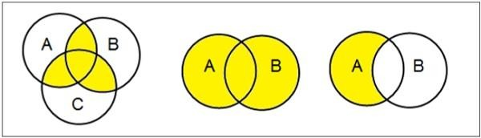**Examples**

**Set Operations**

Set Operations include Set Union, Set Intersection, Set Difference, Complement of Set, and Cartesian Product.

**Set Union**

The union of sets A and B (denoted by A ∪ B) is the set of elements which are in A, in B, or in both A and B. Hence, A ∪B = {x | x ∈ A OR x ∈ B}.

**Example** − If A = {10, 11, 12, 13} and B = {13, 14, 15}, then A ∪B = {10, 11, 12, 13, 14, 15}.

(The common element occurs only once)



**Set Intersection**

The intersection of sets A and B (denoted by A ∩ B) is the set of elements which are in both A and B. Hence, A ∩ B = {x | x ∈ A AND x ∈ B}.

**Example** − If A = {11, 12, 13} and B = {13, 14, 15}, then A ∩ B = {13}.

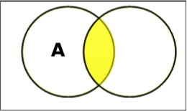

**Set Difference/ Relative Complement**

The set difference of sets A and B (denoted by A − B) is the set of elements which are only in A but not in B. Hence, A − B = {x | x ∈A AND x ∈ B}.

**Example** − If A = {10, 11, 12, 13} and B = {13, 14, 15}, then (A− B) = {10, 11, 12} and (B −

A) = {14, 15}. Here, we can see (A − B) ≠ (B − A)

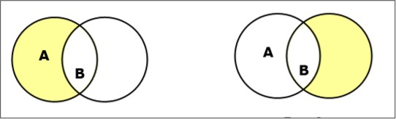

**Complement of a Set**

The complement of a set A (denoted by A’) is the set of elements which are not in set A. Hence, A' = {x | x ∈ A}.

More specifically, A'= (U − A) where U is a universal set which contains all objects.

**Example** − If A = {x | x belongs to set of odd integers} then A' = {y | y does not belong to set of odd integers}

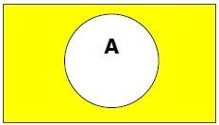

**Cartesian Product / Cross Product**

The Cartesian product of n number of sets A1, A2 .....An, defined as A1 × A2 ×..... × An, are the ordered pair (x1, x2,....xn) where x1 ∈ A1, x2 ∈ A2, ...... xn ∈An

**Example** − If we take two sets A = {a, b} and B = {1, 2},

The Cartesian product of A and B is written as − A × B = {(a, 1), (a, 2), (b, 1), (b, 2)} The Cartesian product of B and A is written as − B × A = {(1, a), (1, b), (2, a), (2, b)} **Power Set**

Power set of a set S is the set of all subsets of S including the empty set. The cardinality of a power set of a set S of cardinality n is 2n. Power set is denoted as P(S).

**Example −**

For a set S = {a, b, c, d} let us calculate the subsets −

* Subsets with 0 elements − {∅} (the empty set)
* Subsets with 1 element − {a}, {b}, {c}, {d}
* Subsets with 2 elements − {a,b}, {a,c}, {a,d}, {b,c}, {b,d},{c,d}
* Subsets with 3 elements − {a,b,c},{a,b,d},{a,c,d},{b,c,d}
* Subsets with 4 elements − {a,b,c,d}

Hence, P(S) = { {∅}, {a}, {b}, {c}, {d}, {a,b}, {a,c}, {a,d}, {b,c}, {b,d}, {c,d}, {a,b,c}, {a,b,d},

{a,c,d}, {b,c,d}, {a,b,c,d}}

| P(S) | = 24 = 16

**Note** − The power set of an empty set is also an empty set. | P ({∅}) | = 20 = 1.

Any set of elements in a mathematical system may be defined with a set of operators and a number of postulates.

**SUB- SET**

Let set A be a set containing all students of your school and B be a set containing all students of class XII of the school. In this example each element of set B is also an element of set A. Such a set B is said to be subset of the set A. It is written as B⊆ A.

Consider

D ={1, 2, 3, 4,........}

E = {.....−3,−2,−1, 0, 1, 2, 3, .......}

Clearly each element of set D is an element of set E also ∴ D⊆ E

If A and B are any two sets such that each element of the set A is an element of the set B also, then A is said to be a subset of B.

**Remarks**

1. Each set is a subset of itself i.e. A⊆ A
2. Null set has no element so the condition of becoming a subset is automatically satisfied. Therefore null set is a subset of every set.
3. If A⊆ B and B⊆ A then A = B.
4. If A⊆ B and A≠ B then A is said to be a proper subset of B and B is said to be a super set of A. i.e. A⊂ B or B⊃A.

**Example 2:** If A = {x : x is a prime number less than 5} and B = {y : y is an even prime number} then is B a proper subset of A ?

**Solution :** It is given that

A = {2, 3 }, B = {2}. Clearly

B⊆ A and B≠ A

We write B⊂ A and say that B is a proper subset of A.

**Example 3:** If A = {1, 2, 3, 4}, B = {2, 3, 4, 5}. is A⊆B or B⊆ A ?

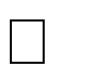**Solution :** Here 1∈A but1∉B⇒A⊆**/** B. Also 5∉ B but 5∈A⇒ B⊆**/**A.

Hence neither A is a subset of B nor B is a subset of A.

Example 4: If A = {a, e, i, o, u} ,B = {e, i, o, u, a } Is A⊆B or B⊆ A or both ?

**Solution :** Here in the given sets each element of set A is an element of set B also

⇒ ⊆

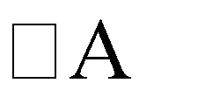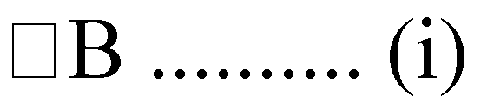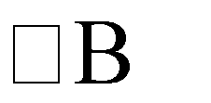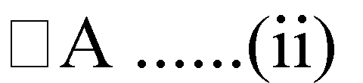

and each element of set B is an element of set A also. ⇒ ⊆

From (i) and (ii) A = B

**Binary Operator**

A **binary operator** defined on a set of elements is a rule that assigns to each pair of elements a unique element from that set. For example, given the set A = {1, 2, 3, 4, 5}, we can say ⊗ is a binary operator for the operation c = a ⊗ b, if it specifies a rule for finding c for the pair of (a,b), such that a, b, c ∈ A.

**Closure**

A set is closed with respect to a binary operator if for every pair of elements in the set, the operator finds a unique element from that set.

**Example** − Let A = {0, 1, 2, 3, 4, 5, …………. }

This set is closed under binary operator into (*), because for the operation c = a + b, for any a, b

∈A, the product c ∈ A.

The set is not closed under binary operator divide (÷), because, for the operation c = a + b, for any a, b ∈ A, the product c may not be in the set A. If a = 7, b = 2, then c = 3.5. Here a, b ∈ A but c ∈ A.

**Associative Laws**

A binary operator ⊗ on a set A is associative when it holds the following property − (x ⊗ y) ⊗ z = x ⊗ (y ⊗ z), where x, y, z ∈ A

**Example** − Let A = { 1, 2, 3, 4 }

The operator plus ( + ) is associative because for any three elements, x, y, z ∈ A, the property (x

+ y) + z = x + ( y + z ) holds.The operator minus ( − ) is not associative since ( x − y ) − z ≠ x − ( y − z )

**Commutative Laws**

A binary operator ⊗ on a set A is commutative when it holds the following property −

x ⊗ y = y ⊗ x, where x, y ∈A

**Example** − Let A = { 1, 2, 3, 4 }

The operator plus ( + ) is commutative because for any two elements, x, y ∈ A, the property x + y = y + x holds.

The operator minus ( − ) is not associative since x − y ≠ y − x

**Distributive Laws**

Two binary operators ⊗ and ⊛on a set A, are distributive over operator ⊛when the following property holds −

x ⊗ (y ⊛z) = (x ⊗ y) ⊛ (x ⊗ z), where x, y, z ∈ A

**Example** − Let A = { 1, 2, 3, 4 }

The operators into ( * ) and plus ( + ) are distributive over operator + because for any three elements, x, y, z ∈ A, the property x * (y + z) = (x * y) + (x * z) holds.

However, these operators are not distributive over * since x + ( y * z ) ≠ ( x + y ) * ( x + z )

**Identity Element**

A set A has an identity element with respect to a binary operation ⊗ on A, if there exists an element e ∈A, such that the following property holds −

e ⊗ x = x ⊗ e, where x ∈ A

**Example** − Let Z = { 0, 1, 2, 3, 4, 5, ……………….. }

The element 1 is an identity element with respect to operation * since for any element x ∈ Z, 1 * x = x * 1

On the other hand, there is no identity element for the operation minus ( − )

**Inverse**

If a set A has an identity element e with respect to a binary operator ⊗, it is said to have an inverse whenever for every element x ∈ A, there exists another element y ∈ A, such that the following property holds −

x ⊗ y = e

**Example** − Let A = { ………….. −4, −3, −2, −1, 0, 1, 2, 3, 4, 5, ………….. }

Given the operation plus ( + ) and e = 0, the inverse of any element x is (−x) since x + (− x) = 0

**De Morgan’s Law**

De Morgan’s Laws gives a pair of transformations between union and intersection of two (or more) sets in terms of their complements. The laws are −

(A ∪ B)′ = A′ ∩ B′ (A ∩ B)′ = A′∪ B′

**Example** − Let A = { 1, 2, 3, 4}, B = {1, 3, 5, 7}, and

Universal set U = { 1, 2, 3, ………, 9, 10 }

A′ = { 5, 6, 7, 8, 9, 10}

B′ = { 2, 4, 6, 8, 9, 10}

A ∪ B = {1, 2, 3, 4, 5, 7} A ∩ B = { 1, 3}

(A ∪ B)′ = { 6, 8, 9, 10}

A′ ∩ B′ = { 6, 8, 9, 10}

Thus, we see that (A ∪ B)′ = A′∩ B′ (A ∩ B)′ = { 2, 4, 5, 6, 7, 8, 9, 10}

A′ ∪ B′ = { 2, 4, 5, 6, 7, 8, 9, 10}

Thus, we see that (A ∩ B)′ = A′∪ B′.

**Partitioning of a Set**

Partition of a set, say *S*, is a collection of *n* disjoint subsets, say *P1, P2,...… Pn,* that satisfies the following three conditions –

* Pi does not contain the empty set. [ Pi ≠ {∅ } for all 0 < i ≤ n]
* The union of the subsets must equal the entire original set. [P1 ∪P2 ∪ ..... ∪Pn = S]
* The intersection of any two distinct sets is empty. [Pa ∩ Pb = {∅ }, for a ≠ b where n ≥ a, b ≥ 0 ]

The number of partitions of the set is called a Bell number denoted as Bn.

**Example**

Let S = {a, b, c, d, e, f, g, h}

One probable partitioning is {a}, {b, c, d}, {e, f, g, h} Another probable partitioning is {a, b}, { c, d}, {e, f, g, h}

In this way, we can find out Bn number of different partitions.

## Relations and Partial Ordering

Whenever sets are being discussed, the relationship between the elements of the sets is the next thing that comes up. **Relations** may exist between objects of the same set or between objects of two or more sets.

**Definition and Properties**

A binary relation R from set x to y (written as xRy or R(x,y)) is a subset of the Cartesian product x × y. If the ordered pair of G is reversed, the relation also changes.

Generally an n-ary relation R between sets A1, ... , and An is a subset of the n-ary product A1 × ...

× An. The minimum cardinality of a relation R is Zero and maximum is n2 in this case. A binary relation R on a single set A is a subset of A × A.

For two distinct sets, A and B, having cardinalities *m* and *n* respectively, the maximum cardinality of a relation R from A to B is *mn*.

**Domain and Range**

If there are two sets A and B, and relation R have order pair (x, y), then −

* The **domain** of R is the set { x | (x, y) ∈ R for some y in B }
* The **range** of R is the set { y | (x, y) ∈ R for some x in A }

**Examples**

Let, A = {1, 2, 9} and B = {1, 3, 7}

* Case 1 − If relation R is ‘equal to’ then R = {(1, 1), (3, 3)}
* Case 2 − If relation R is ‘less than’ then R = {(1, 3), (1, 7), (2, 3), (2, 7)}
* Case 3 − If relation R is ‘greater than’ then R = {(2, 1), (9, 1), (9, 3), (9, 7)}

**Representation of Relations using Graph**

A relation can be represented using a directed graph.

The number of vertices in the graph is equal to the number of elements in the set from which the relation has been defined. For each ordered pair (x, y) in the relation R, there will be a directed edge from the vertex ‘x’ to vertex ‘y’. If there is an ordered pair (x, x), there will be self- loop on vertex ‘x’.

Suppose, there is a relation R = {(1, 1), (1,2), (3, 2)} on set S = {1, 2, 3}, it can be represented by the following graph −

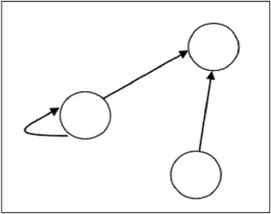

**Types of Relations**

* The **Empty Relation** between sets X and Y, or on E, is the empty set ∅
* The **Full Relation** between sets X and Y is the set X × Y
* The **Identity Relation** on set X is the set {(x, x) | x ∈ X}
* The Inverse Relation R' of a relation R is defined as − R’ = {(b, a) | (a, b) ∈ R}

**Example** − If R = {(1, 2), (2, 3)} then R’ will be {(2, 1), (3, 2)}

* A relation R on set A is called **Reflexive** if ∀a∈A is related to a (aRa holds).

**Example** − The relation R = {(a, a), (b, b)} on set X = {a, b} is reflexive

* A relation R on set A is called **Irreflexive** if no a ∈ A is related to a (aRa does not hold).

**Example** − The relation R = {(a, b), (b, a)} on set X = {a, b} is irreflexive

* A relation R on set A is called **Symmetric** if xRy implies yRx, ∀x∈A and ∀y∈A.

**Example** − The relation R = {(1, 2), (2, 1), (3, 2), (2, 3)} on set A = {1, 2, 3} is symmetric.

* A relation R on set A is called **Anti-Symmetric** if xRy and yRx implies x = y , ∀x ∈ A and ∀y ∈ A.

**Example** − The relation R = {(1, 2), (3, 2)} on set A = {1, 2, 3} is antisymmetric.

* A relation R on set A is called **Transitive** if xRy and yRz implies xRz, ∀x,y,z ∈ A.

**Example** − The relation R = {(1, 2), (2, 3), (1, 3)} on set A = {1, 2, 3} is transitive

* A relation is an **Equivalence Relation** if it is reflexive, symmetric, and transitive.

**Example** − The relation R = {(1, 1), (2, 2), (3, 3), (1, 2), (2,1), (2,3), (3,2), (1,3), (3,1)}

on set A = {1, 2, 3} is an equivalence relation since it is reflexive, symmetric, and transitive.

**Partially Ordered Set (POSET)**

A partially ordered set consists of a set with a binary relation which is reflexive, antisymmetric and transitive. "Partially ordered set" is abbreviated as POSET.

**Examples**

* The set of real numbers under binary operation less than or equal to (≤) is a poset.

Let the set S = {1, 2, 3} and the operation is ≤

The relations will be {(1, 1), (2, 2), (3, 3), (1, 2), (1, 3), (2, 3)}

This relation R is reflexive as {(1, 1), (2, 2), (3, 3)} ∈ R This relation R is anti-symmetric, as

{(1, 2), (1, 3), (2, 3)} ∈ R and {(1, 2), (1, 3), (2, 3)} ∉ R

This relation R is also transitive. Hence, it is a **poset**.

* The vertex set of a directed acyclic graph under the operation ‘reachability’ is a poset.

**Relations**

Consider the following example : A={Mohan, Sohan, David, Karim} B={Rita, Marry, Fatima}

Suppose Rita has two brothers Mohan and Sohan, Marry has one brother David, and Fatima has one brother Karim. If we define a relation R " is a brother of" between the elements of A and B then clearly.

Mohan R Rita, Sohan R Rita, David R Marry, Karim R Fatima. After omiting R between two names these can be written in the form of ordered pairs as : (Mohan, Rita), (Sohan, Rita), (David, Marry), (Karima, Fatima).

The above information can also be written in the form of a set R of ordered pairs as R= {(Mohan, Rita), (Sohan, Rita), (David, Marry), Karim, Fatima}

Clearly R  AB, i.e.R  {(a,b): aA, bB and aRb}

If A and B are two sets then a relation R from A toB is a sub set of A×B.

**Void Relation**

If (i) R  , R is called a void relation.

* 1. R=A×B, R is called a universal relation.
  2. If R is a relation defined from A to A, it is called a relation defined on A.
  3. R =  (a,a) a A  , is called the identity relation.

**Domain and Range of a Relation**

If R is a relation between two sets then the set of its first elements (components) of all the ordered pairs of R is called Domain and set of 2nd elements of all the ordered pairs of R is called range, of the given relation. Consider previous example given above.

Domain = {Mohan, Sohan, David, Karim} Range = {Rita, Marry, Fatima}

**Example1:** Given that A = {2, 4, 5, 6, 7}, B = {2, 3}.R is a relation from A to B defined by

R = {(a, b) : a A, bB and a is divisible by b} find (i) R in the roster form (ii) Domain of R (iii) Range of R (iv) Repersent R diagramatically.

**Solution :** (i) R = {(2, 2), (4, 2), (6, 2), (6, 3)}

1. Domain of R = {2, 4, 6}
2. Range of R = {2, 3}

**Example 2:** If R is a relation 'is greater than' from A to B, where

A= {1, 2, 3, 4, 5} and B = {1,2,6}. Find (i) R in the roster form. (ii) Domain of R (iii) Range of R.

**Solution :**

(i) R = {(3, 1), (3, 2), (4, 1), (4, 2), (5, 1), (5, 2)}

1. Domain of R = {3, 4, 5}
2. Range of R = {1, 2}

## Functions

A **Function** assigns to each element of a set, exactly one element of a related set. Functions find their application in various fields like representation of the computational complexity of algorithms, counting objects, study of sequences and strings, to name a few. The third and final chapter of this part highlights the important aspects of functions.

**Function – Definition**

A function or mapping (Defined as f: X→Y) is a relationship from elements of one set X to elements of another set Y (X and Y are non-empty sets). X is called Domain and Y is called Codomain of function ‘f’.

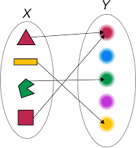

Function ‘f’ is a relation on X and Y s.t for each x ∈ X, there exists a unique y ∈ Y such that (x,y) ∈ R. x is called pre-image and y is called image of function f.

A function can be one to one, many to one (not one to many). A function f: A→B is said to be invertible if there exists a function g: B→A

**Injective / One-to-one function**

A function f: A→B is injective or one-to-one function if for every b ∈ B, there exists at most one a ∈ A such that f(s) = t.

This means a function **f** is injective if a1 ≠ a2 implies f(a1) ≠ f(a2).

**Example**

* + f: N→N, f(x) = 5x is injective.
  + f: Z+→Z+, f(x) = x2 is injective.
  + f: R→R, f(x) = x2 is not injective as (−x)2 = x2

**Surjective / Onto function**

A function f: A→B is surjective (onto) if the image of f equals its range. Equivalently, for every b ∈ B, there exists some a ∈A such that f(a) = b. This means that for any y in B, there exists some x in A such that y = f(x).

**Example**

* + f : Z+→Z+, f(x) = x2 is surjective.
  + f : N→N, f(x) = x2 is not injective as (−x)2 = x2

**Bijective / One-to-one Correspondent**

A function f: A→B is bijective or one-to-one correspondent if and only if f is both injective and surjective.

**Problem**

Prove that a function f: R→R defined by f(x) = 2x − 3 is a bijective function. **Explanation** − We have to prove this function is both injective and surjective. If f(x1) = f(x2), then 2x1 − 3 = 2x2 − 3 and it implies that x1 = x2.

Hence, f is **injective**. Here, 2x − 3 = y

So, x = (y + 5)/3 which belongs to R and f(x) = y. Hence, f is **surjective**.

Since **f** is both **surjective** and **injective**, we can say **f** is **bijective**.

**Composition of Functions**

Two functions f: A→B and g: B→C can be composed to give a composition g o f. This is a function from A to C defined by (gof)(x) = g(f(x))

**Example**

Let f(x) = x + 2 and g(x) = 2x, find ( f o g)(x) and ( g o f)(x)

**Solution**

(f o g)(x) = f (g(x)) = f(2x) = 2x+2

(g o f)(x) = g (f(x)) = g(x+2) = 2(x+2) = 2x+4

Hence, (f o g)(x) ≠ (g o f)(x)

**Some Facts about Composition**

* + If f and g are one-to-one then the function (g o f) is also one-to-one.
  + If f and g are onto then the function (g o f) is also onto.
  + Composition always holds associative property but does not hold commutative property.

**Types of functions**

A relation is a **function** if for every ***x* in the domain** there is **exactly** one ***y*** in the codomain. A **vertical line** through any element of the domain should intersect the graph of the function exactly once. (*one to one or many to one but not all the Bs have to be busy*)

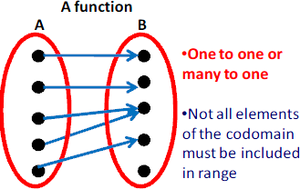

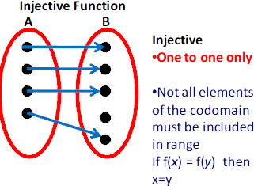A function is **injective** if for every ***y* in the codomain B** there is **at most** one *x* in the domain. A **horizontal line** should intersect the graph of the function at most once (i.e.not at all or once). (*one to one only but not all the Bs have to be busy*)

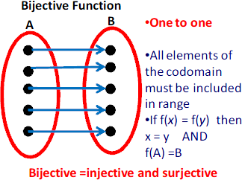A function is **bijective** if for every ***y*** in the codomain there is **exactly** one *x* in the domain. A horizontal line through any element of the range should intersect the graph of the function exactly once. (*one to one only and all the Bs must be busy*).

**A function is** surjective **if for every** *y* in the codomain B **there is** at least **one *x* in the domain. A** horizontal line **intersects the graph of the function at least once (i.e.once or more). The range and the codomain are identical. (*one to one or many to one and all the Bs must be busy*)**

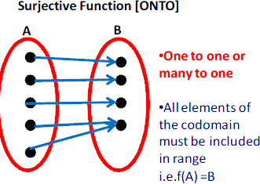

* [**Identity function**](https://en.wikipedia.org/wiki/Identity_function)**:** maps any given element to itself.
* [**Constant function**](https://en.wikipedia.org/wiki/Constant_function)**:** has a fixed value regardless of arguments.
* [**Empty function**](https://en.wikipedia.org/wiki/Empty_function)**: whose domain equals the** [**empty set**](https://en.wikipedia.org/wiki/Empty_set)**.**

**Example1:** Without using graph prove that the function F : R  R defined by f  x   4 3x is ***one-to-one***.

**Solution :** For a function to be one-one function **F  x1   f  x2   x1  x2  x1, x2  domain** Now f  x1   f  x2  gives

4  3x1  4 3x2 or x1 x2.

 F is a *one-one function*.

**Example2:** Prove that F : R  R defined by f  x   4x3 5 is a bijection

**Solution :** Now f  x1   f  x2   x1, x2 Domain

 4x13  5  4x23  5

⇒ x13  x23

⇒ x13  x23  0   x2  x1  x12  x1x2  x2 2  0  x1  x2 or x12  x1x2  x2 2  0 (rejected). It has no real value of x1 and x2 .  F is a ***one-one function***.

Again let y   x  where y  codomain, x  domain.

We have y  4x3 5 or x=

𝑦+5

1 / 3

( )

𝑛

 For each y  codomain  x  domain such that f  x   y . Thus F is ***onto function***.

 F is a bijection.

**Example3:** Prove that F : R  R defined by F  x   x 2 3 is neither ***one-one*** nor ***onto function***.

**Solution :** We have F  x1   F  x2   x1, x2  domain giving x12  3  x22 3 x1 2x22

or x12  x2 2 0 x1 x2 or x1  x2 or F is not ***one-one function***.

Again let y  F  x  where y  codomain x  domain.

⇒ y  x 2  3  x  √ y 3

⇒  y 3 no real value of x in the domain.

** F is not an** *onto finction***.**

**Example4:**Find domain of each of the following functions : (a) y   x  2 (b) y    2  x   4  x 

**Solution :**(a) Consider the function y   x  2

In order to have real values of y, we must have  x  2   0

* 1. x  2

 Domain of the function will be all real numbers  2 . (b) y    2 x   4 x 

In order to have real values of y, we must have  2  x   4  x  0 We can achieve this in the following two cases :

***Case I :***  2  x   0 and  4  x  0

⇒ x  2 and x  4

 Domain consists of all real values of x such that 4  x  2

***Case II :*** 2  x  0 and 4  x 0

⇒ 2  x and x  4 .

But, x cannot take any real value which is greater than or equal to 2 and less than or equal to

4 .

 From both the cases, we have Domain = 4  x  2 x R

**Example5:** For the function

f  x   y  2x  1, find the range when domain  3, 2, 1,0,1,2,3 .

**Solution :** For the given values of *x*, we have f  3   2 3   1  5

f  2   2  2 1  3 f  1  2  1  1  1 f  0   2  0  1 1

f 1   2 1 1 3

f  2   2  2  1 5 f  3   2  3  1 7

The given function can also be written as a set of ordered pairs.

 3, 5  ,  2, 3  ,  1, 1  ,  0,1  1, 3  , 2,5   3,7 

 Range  5, 3, 1,1,3,5,7

**Example 6:** If f  x   x 3, 0 x 4,find its range.

**Solution :** Here 0  x  4 or 0  3  x  3  4 3

or 3  f  x   7

 Range = f  x  : 3  f  x   7

**Example 7:** If f  x   x2 , 3 x 3 ,find its range.

**Solution :** Given  3  x  3 or 0  x2  9 or 0  f  x   9

 Range = f  x  : 0  f  x   9

# UNIT -3

**Algebraic Structures** **&**

**Lattices and Boolean Algebra**

## Algebraic Systems

**Semigroup**

A finite or infinite set ‘S’ with a binary operation ‘0’ (Composition) is called semigroup if it holds following two conditions simultaneously −

* **Closure** − For every pair (a, b) ∈S, (a 0 b) has to be present in the set S.
* **Associative** − For every element a, b, c ∈ S, (a 0 b) 0 c = a 0 (b 0 c) must hold.

**Example**

The set of positive integers (excluding zero) with addition operation is a semigroup. For example, S = {1, 2, 3,...}

Here closure property holds as for every pair (a, b) ∈ S, (a + b) is present in the set S. For example, 1 + 2 = 3 ∈ S]

Associative property also holds for every element a, b, c ∈ S, (a + b) + c = a + (b + c). For example, (1 + 2) + 3 = 1 + (2 + 3) = 5

**Monoid**

A monoid is a semigroup with an identity element. The identity element (denoted by **e** or **E**) of a set S is an element such that (a 0 e) = a, for every element a ∈ S. An identity element is also called a **unit element**. So, a monoid holds three properties simultaneously − **Closure, Associative, Identity element**.

**Example**

The set of positive integers (excluding zero) with multiplication operation is a monoid. S = {1, 2, 3,...}

Here closure property holds as for every pair (a, b) ∈ S, (a × b) is present in the set S. [For example, 1 × 2 = 2 ∈S and so on]

Associative property also holds for every element a, b, c ∈ S, (a × b) × c = a × (b × c) [For example, (1 × 2) × 3 = 1 × (2 × 3) = 6 and so on]

Identity property also holds for every element a ∈ S, (a × e) = a [For example, (2 × 1) = 2, (3 × 1)

= 3 and so on]. Here identity element is 1.

**Group**

A group is a monoid with an inverse element. The inverse element (denoted by I) of a set S is an element such that (a 0 I) = (I 0 a) = a, for each element a ∈ S. So, a group holds four properties simultaneously − **i) Closure, ii) Associative, iii) Identity element, iv) Inverse element**. The order of a group G is the number of elements in G and the order of an element in a group is the least positive integer n such that an is the identity element of that group G.

A **binary operation** * on a set *G* is a function that associates with every ordered pair of elements *a*, *b* ∈ *G*, a unique element of *G*, denoted by *a* * *b*.

A **group** (*G*, *) is a set *G* together with a binary operation * such that:

1. **Closure Law:** *a* * *b* ∈ *G* for all *a*, *b* ∈ *G*.
2. **Associative Law:** (*a* * *b*) * *c* = *a* * (*b* * *c*) for all *a*, *b*, *c* ∈ *G*.
3. **Identity Law:** There exists *e* ∈ *G* such that *a* * *e* = *a* = *e* * *a* for all *a* ∈ *G*.
4. **Inverse Law:** For all *a* ∈ *G* there exists *b* ∈ *G* such that *a* * *b* = *e* = *b* * *a*.

**Examples**

The set of **N × N** non-singular matrices form a group under matrix multiplication operation.

The product of two **N × N** non-singular matrices is also an **N × N** non-singular matrix which holds closure property.

Matrix multiplication itself is associative. Hence, associative property holds.

The set of **N × N** non-singular matrices contains the identity matrix holding the identity element property.

As all the matrices are non-singular they all have inverse elements which are also non-singular matrices. Hence, inverse property also holds.

**Abelian Group**

An abelian group G is a group for which the element pair (a, b) ∈ G always holds commutative law. So, a group holds five properties simultaneously − i) Closure, ii) Associative, iii) Identity element, iv) Inverse element, v) Commutative.

**Example**

The set of positive integers (including zero) with addition operation is an abelian group. G = {0, 1, 2, 3,…}

Here closure property holds as for every pair (a, b) ∈ S, (a + b) is present in the set S. [For example, 1 + 2 = 2 ∈ S and so on]

Associative property also holds for every element a, b, c ∈ S, (a + b) + c = a + (b + c) [For example, (1 + 2) + 3 = 1 + (2 + 3) = 6 and so on]

Identity property also holds for every element a ∈ S, (a × e) = a [For example, (2 × 1) = 2, (3 × 1)

= 3 and so on]. Here, identity element is 1.

Commutative property also holds for every element a ∈ S, (a × b) = (b × a) [For example, (2 × 3)

= (3 × 2) = 3 and so on]

**Cyclic Group and Subgroup**

A **cyclic group** is a group that can be generated by a single element. Every element of a cyclic group is a power of some specific element which is called a generator. A cyclic group can be generated by a generator ‘g’, such that every other element of the group can be written as a power of the generator ‘g’.

**Example**

The set of complex numbers {1, −1, i, − i} under multiplication operation is a cyclic group.

There are two generators − i and −i as i1 = i, i2 = −1, i3 = −i, i4 = 1 and also (−i)1 = −i, (−i)2 = −1, (−i)3 = i, (−i)4 = 1 which covers all the elements of the group. Hence, it is a cyclic group.

**Note** − A **cyclic group** is always an abelian group but not every abelian group is a cyclic group. The rational numbers under addition is not cyclic but is abelian.

**Subgroup**

A **subgroup** H is a subset of a group G (denoted by H ≤ G) if it satisfies the four properties simultaneously − **Closure, Associative, Identity element**, and **Inverse**.

A subgroup H of a group G that does not include the whole group G is called a proper subgroup (Denoted by H<G). A subgroup of a cyclic group is cyclic and a abelian subgroup is also abelian.

A subset *H* of *G* is a **subgroup** if:

1. *a*\* *b* ∈ *H* for all *a*, *b* ∈ *H*;
2. *e* (the identity element of *G*) ∈ *H*;
3. the inverse of every element of *H* is in *H*.

**Notation: *H* ≤ *G*.**

**Example1:**

Let a group G = {1, i, −1, −i}

Then some subgroups are H1 = {1}, H2 = {1, −1},

This is not a subgroup: H3 = {1, i} because that (i)−1 = −i is not in H3

**Example2: Let *G* = {*x* ∈ ℝ | *x* ≠ 1} and define *x* * *y* = *xy* − *x* − *y* + 2. Prove that (*G*, *) is a group. Solution:**

**Closure:** Let *a*, *b* ∈ *G*, so *a* ≠ 1 and *b* ≠ 1. Suppose *a* * *b* = 1.

Then *ab* − *a* − *b* + 2 = 1 and so (*a* − 1)(*b* − 1) = 0 which implies that *a* = 1 or *b* = 1, a contradiction.

**Associative:** Unlike the examples in exercise 1, this is a totally new operation that we have never encountered before. We must therefore carefully check the associative law.

(*a* * *b*) * *c* = (*a* * *b*)*c* − (*a* * *b*) − *c* + 2

= (*ab* − *a* − *b* + 2)*c* − (*ab* − *a* − *b* + 2) − *c* + 2

= *abc* − *ac* − *bc* + 2*c* − *ab* + *a* + *b* − 2 − *c* + 2

= *abc* − *ab* − *ac* − *bc* + *a* + *b* + *c*

Similarly *a* * (*b* * *c*) has the same value (we can actually see this by the symmetry of the expression.

**Identity:** An identity, e, would have to satisfy: *e* * *x* = *x* = *x* * *e* for all *x* ∈ G, that is, *ex* − *e* − *x* + 2 =

*x*, or (*e* − 2)(*x* − 1) = 0 for all *x*. Clearly *e* = 2 works. We can now check that 2 is indeed the identity.

**Inverses:** If *x* * *y* = 2, then *xy* − *x* − *y* + 2 = 2. So *y*(*x* − 1) = *x* + 2 and hence *y* = *x* + 2*x* − 1 . This exists for all *x* ≠ 1, i.e. for all *x* ∈ *G*. But we must also check that it is itself an element of *G*. Clearly this is so because *x* + 2*x* − 1 ≠ 1 for all *x* ≠ 1.

## Lattices

**Lattice**

A lattice is a poset (L, ≤) for which every pair {a, b} ∈ L has a least upper bound (denoted by a ∨ b) and a greatest lower bound (denoted by a ∧ b). LUB ({a,b}) is called the join of a and b. GLB ({a,b}) is called the meet of a and b.

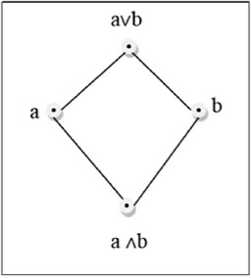

**Example**

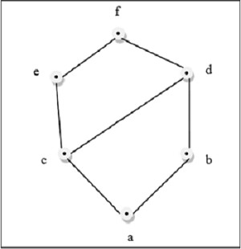

This above figure is a lattice because for every pair {a, b} ∈ L, a GLB and a LUB exists.

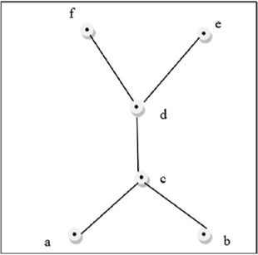

This above figure is a not a lattice because GLB (a, b) and LUB (e, f) does not exist. Some other lattices are discussed below −

**Bounded Lattice**

A lattice L becomes a bounded lattice if it has a greatest element 1 and a least element 0.

**Complemented Lattice**

A lattice L becomes a complemented lattice if it is a bounded lattice and if every element in the lattice has a complement. An element x has a complement x’ if ∃x(x ∧ x’= 0 and x ∨ x’ = 1)

**Distributive Lattice**

If a lattice satisfies the following two distribute properties, it is called a distributive lattice.

* + a ∨ (b ∧ c) = (a ∨ b) ∧ (a ∨ c)
  + a ∧ (b ∨ c) = (a ∧ b) ∨ (a ∧ c)

**Modular Lattice**

If a lattice satisfies the following property, it is called modular lattice. a ∧( b ∨ (a ∧ d)) = (a ∧ b) ∨ (a ∧ d)

**Properties of Lattices**

**Idempotent Properties**

* + a ∨ a = a
  + a ∧ a = a

**Absorption Properties**

* + a ∨ (a ∧ b) = a
  + a ∧ (a ∨ b) = a

**Commutative Properties**

* + a ∨ b = b ∨ a
  + a ∧ b = b ∧ a

**Associative Properties**

* + a ∨ (b ∨ c) = (a ∨ b) ∨ c
  + a ∧ (b ∧ c) = (a ∧ b) ∧ c

**Dual of a Lattice**

The dual of a lattice is obtained by interchanging the ‘∨’ and ‘∧’ operations.

**Example**

The dual of [a ∨ (b ∧ c)] is [a ∧ (b ∨ c)]

**Partially Ordered Set (POSET)**

A partially ordered set consists of a set with a binary relation which is reflexive, antisymmetric and transitive. "Partially ordered set" is abbreviated as POSET.

**Examples**

* + The set of real numbers under binary operation less than or equal to (≤) is a poset.

Let the set S = {1, 2, 3} and the operation is ≤

The relations will be {(1, 1), (2, 2), (3, 3), (1, 2), (1, 3), (2, 3)}

This relation R is reflexive as {(1, 1), (2, 2), (3, 3)} ∈ R This relation R is anti-symmetric, as

{(1, 2), (1, 3), (2, 3)} ∈ R and {(1, 2), (1, 3), (2, 3)} ∉ R

This relation R is also transitive. Hence, it is a **poset**.

* + The vertex set of a directed acyclic graph under the operation ‘reachability’ is a poset.

**Hasse Diagram**

The Hasse diagram of a poset is the directed graph whose vertices are the element of that poset and the arcs covers the pairs (x, y) in the poset. If in the poset x<y, then the point x appears lower than the point y in the Hasse diagram.If x<y<z in the poset, then the arrow is not shown between x and z as it is implicit.

**Example**

The poset of subsets of {1, 2, 3} = {φ, {1}, {2}, {3}, {1, 2}, {1, 3}, {2, 3}, {1, 2, 3}} is shown by the following Hasse diagram −

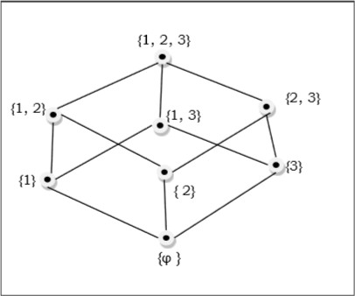

**Linearly Ordered Set**

A Linearly ordered set or Total ordered set is a partial order set in which every pair of element is comparable. The elements a, b ∈ S are said to be comparable if either a ≤ b or b ≤ a holds. Trichotomy law defines this total ordered set. A totally ordered set can be defined as a distributive lattice having the property {a ∨ b, a ∧ b} = {a, b} for all values of a and b in set S.

**Example**

The powerset of {a, b} ordered by ⊆ is a totally ordered set as all the elements of the power set P = {φ, {a}, {b}, {a, b}} are comparable.

**Example of non-total order set**

A set S = {1, 2, 3, 4, 5, 6} under operation x divides y is not a total ordered set.

Here, for all (x, y) ∈ S, x ≤ y have to hold but it is not true that 2 ≤ 3, as 2 does not divide 3 or 3 does not divide 2. Hence, it is not a total ordered set.

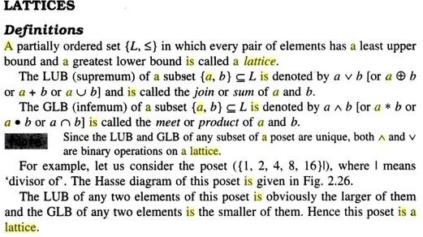

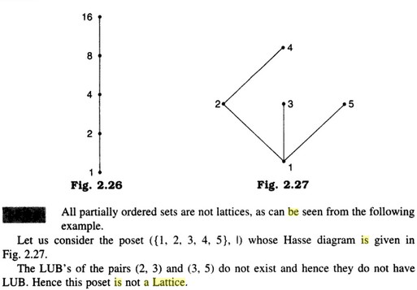

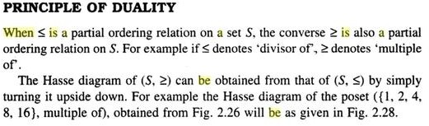

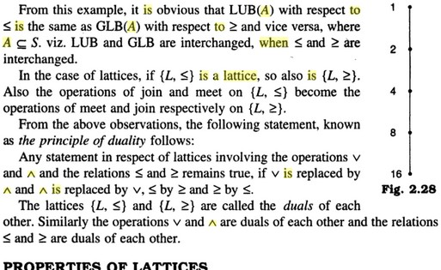

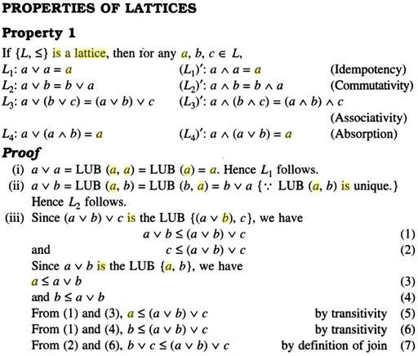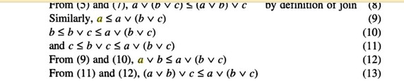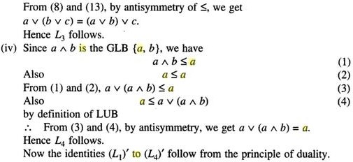

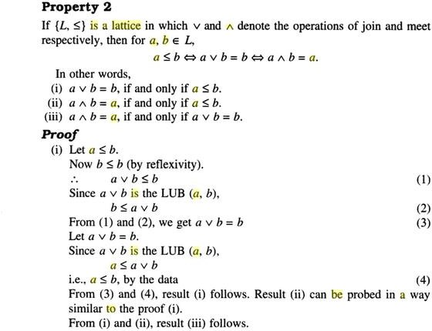

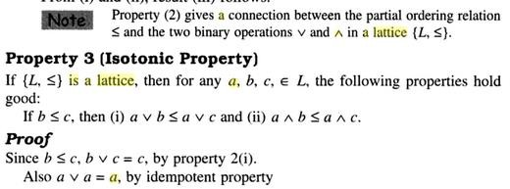

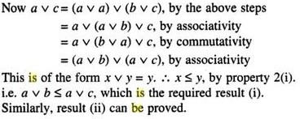

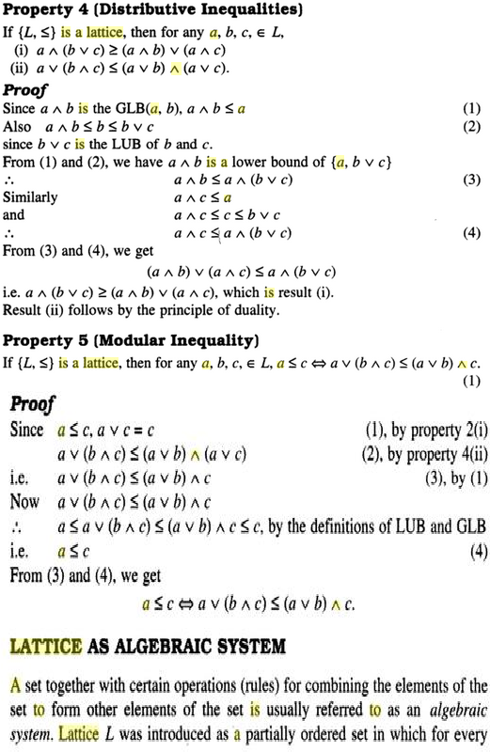

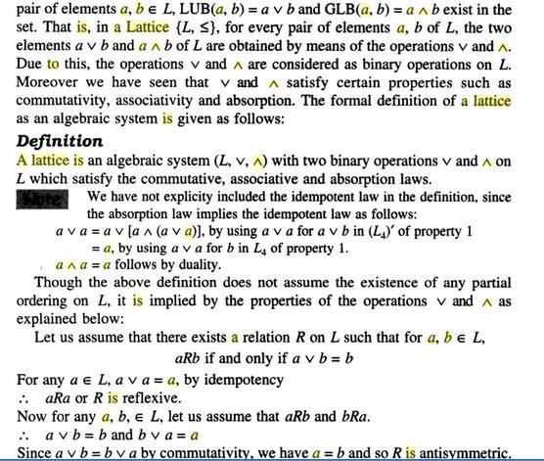

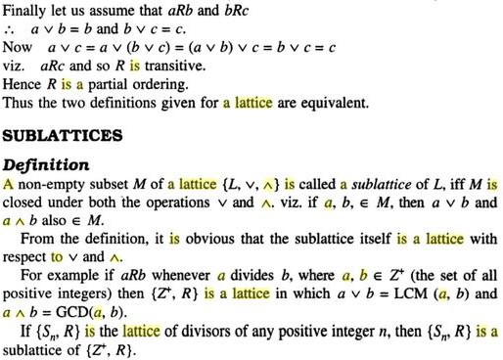

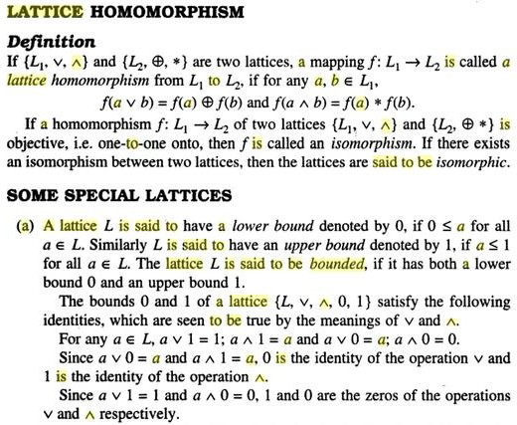

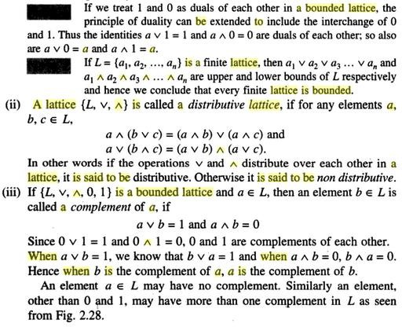

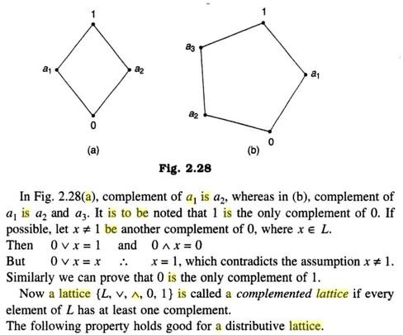

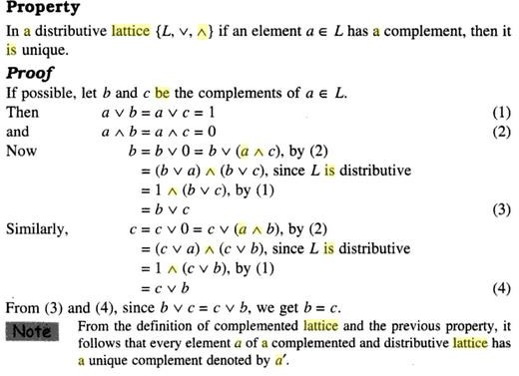

## 4.Boolean Algebra

Boolean algebra is algebra of logic. It deals with variables that can have two discrete values, 0 (False) and 1 (True); and operations that have logical significance. The earliest method of manipulating symbolic logic was invented by George Boole and subsequently came to be known as Boolean Algebra.

Boolean algebra has now become an indispensable tool in computer science for its wide applicability in switching theory, building basic electronic circuits and design of digital computers.

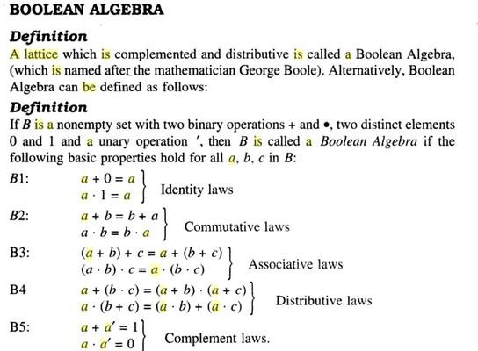

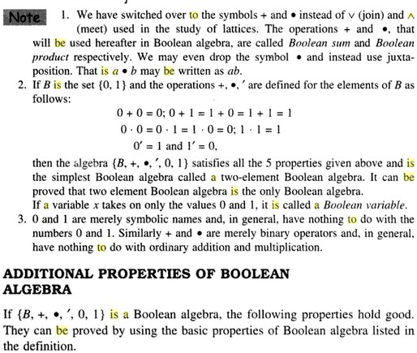

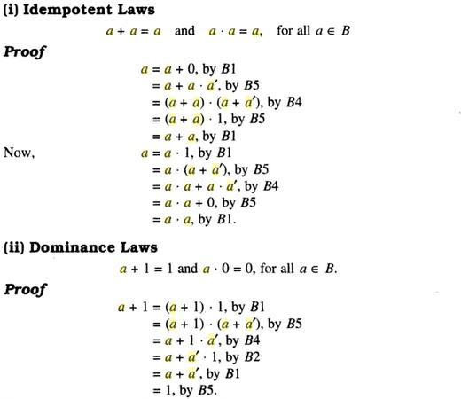

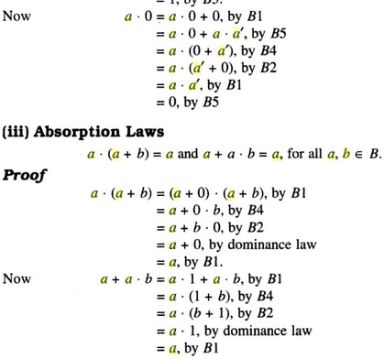

# UNIT -4

**Graph theory**

## 1. Graph Models

Introduction to graph Theory

The two discrete structures that we will cover are graphs and trees. A graph is a set of points, called nodes or vertices, which are interconnected by a set of lines called edges. The study of graphs, or **graph theory** is an important part of a number of disciplines in the fields of mathematics, engineering and computer science.

**What is a Graph?**

**Definition** − A graph (denoted as G = (V, E)) consists of a non-empty set of vertices or nodes V and a set of edges E.

**Example** − Let us consider, a Graph is G = (V, E) where V = {a, b, c, d} and E = {{a, b}, {a, c},

{b, c},{c, d}}

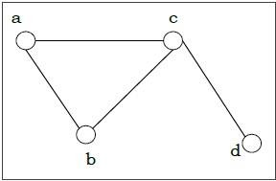

**Even and Odd Vertex** − If the degree of a vertex is even, the vertex is called an even vertex and if the degree of a vertex is odd, the vertex is called an odd vertex.

**Degree of a Vertex** − The degree of a vertex V of a graph G (denoted by deg (V)) is the number of edges incident with the vertex V.

|  |  |  |
| --- | --- | --- |
| **Vertex** | **Degree** | **Even / Odd** |
| a | 2 | even |
| b | 2 | even |
| c | 3 | odd |
| d | 1 | odd |

**Degree of a Graph** −The degree of a graph is the largest vertex degree of that graph. For the above graph the degree of the graph is 3.

**The Handshaking Lemma** − In a graph, the sum of all the degrees of vertices is equal to twice the number of edges.

**Types of Graphs**

There are different types of graphs, which we will learn in the following section

**Null Graph**

A null graph has no edges. The null graph of n vertices is denoted by Nn

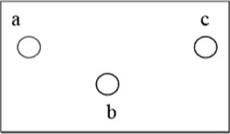

**Simple Graph**

A graph is called simple graph/strict graph if the graph is undirected and does not contain any loops or multiple edges.

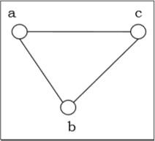

**Multi-Graph**

If in a graph multiple edges between the same set of vertices are allowed, it is called Multigraph.

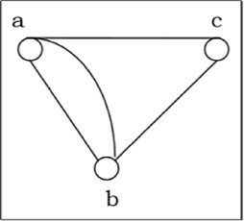

**Directed and Undirected Graph**

A graph G = (V, E) is called a directed graph if the edge set is made of ordered vertex pair and a graph is called undirected if the edge set is made of unordered vertex pair.

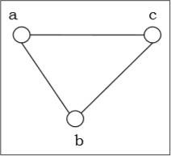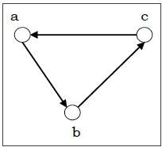

**Connected and Disconnected Graph**

A graph is connected if any two vertices of the graph are connected by a path and a graph is disconnected if at least two vertices of the graph are not connected by a path. If a graph G is unconnected, then every maximal connected subgraph of G is called a connected component of the graph G.

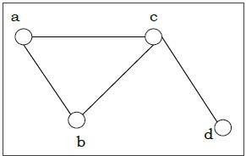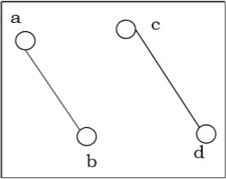

**Regular Graph**

A graph is regular if all the vertices of the graph have the same degree. In a regular graph G of degree r, the degree of each vertex of G is r.

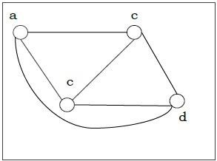

**Complete Graph**

A graph is called complete graph if every two vertices pair are joined by exactly one edge. The complete graph with n vertices is denoted by Kn

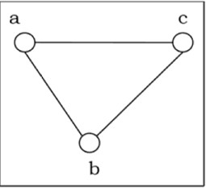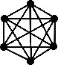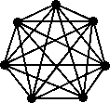

**K3 K4 K5 K6 K7**

**Cycle Graph**

If a graph consists of a single cycle, it is called cycle graph. The cycle graph with n vertices is denoted by Cn

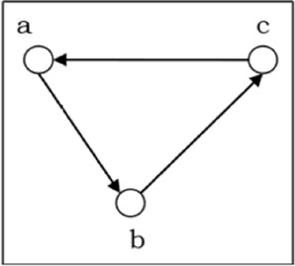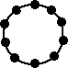

C3 C10

**Note: The no of vertices and edges of Cn are same and equal to ‘n’** **Wheel Graph : Wn**

Let Cn be a cycle consists of n>=3 vertices. The wheel Wn is obtained by adding a new vertex to the cycle Cn and connects this new vertex to each of the vertices of Cn.

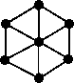

*W*(5) *W*(6)

Note: The no of vertices of a wheel Wn is n+1 and the no of edges is n+n=2n.

**Cube (Qn)**

The Cube Qn is a graph , whose vertices represents the 2 n bit strings of length n. Two vertices are adjacent iff the bit strings that they represent differ in exactly one bit possible.

Note: The no of vertices and edges in Qn are 2 n

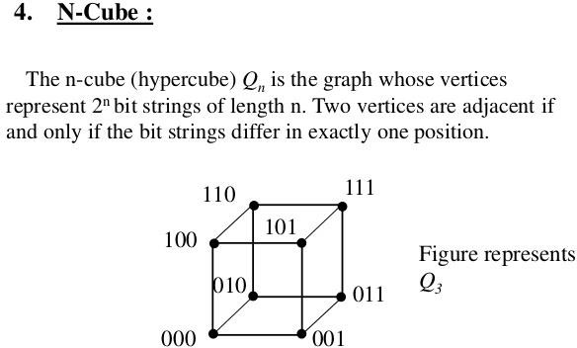

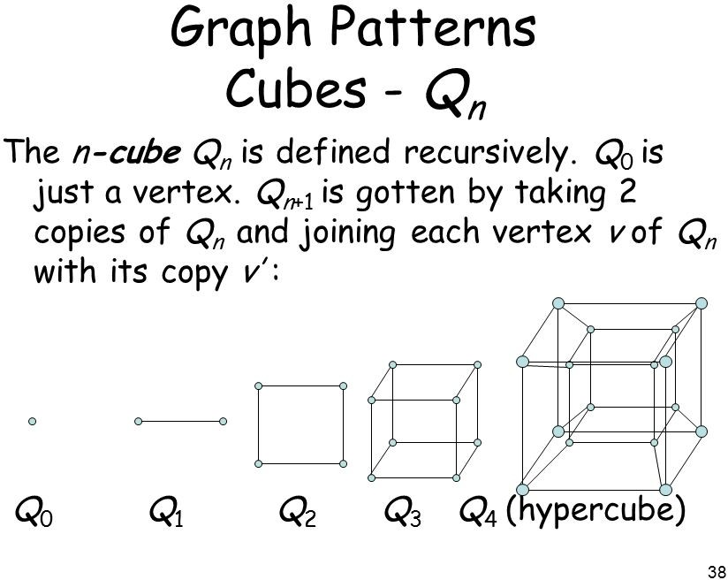

**Bipartite Graph**

If the vertex-set of a graph G can be split into two sets in such a way that each edge of the graph joins a vertex in first set to a vertex in second set, then the graph G is called a bipartite graph. A graph G is bipartite if and only if all closed walks in G are of even length or all cycles in G are of even length.

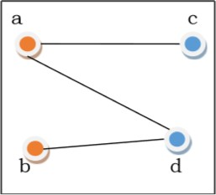

**Complete Bipartite Graph**

A complete bipartite graph is a bipartite graph in which each vertex in the first set is joined to every single vertex in the second set. The complete bipartite graph is denoted by Kr, s where the graph G contains x vertices in the first set and y vertices in the second set.

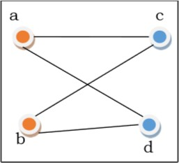

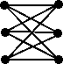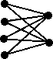

K3,3 k4,2

1. **Graph Theory - Fundamentals**

**Point**

**A point** is a particular position in a one-dimensional, two-dimensional, or three-dimensional space. For better understanding, a point can be denoted by an alphabet. It can be represented with a dot.

**Example**

Here, the dot is a point named ‘a’.

**Line**

A **Line** is a connection between two points. It can be represented with a solid line.

**Example**



Here, ‘a’ and ‘b’ are the points. The link between these two points is called a line.

**Vertex**

A vertex is a point where multiple lines meet. It is also called a **node**. Similar to points, a vertex is also denoted by an alphabet.

**Example**

Here, the vertex is named with an alphabet ‘a’.

**Edge**

An edge is the mathematical term for a line that connects two vertices. Many edges can be formed from a single vertex. Without a vertex, an edge cannot be formed. There must be a starting vertex and an ending vertex for an edge.

**Example**



Here, ‘a’ and ‘b’ are the two vertices and the link between them is called an edge.

**Graph**

A graph ‘G’ is defined as G = (V, E) Where V is a set of all vertices and E is a set of all edges in the graph.

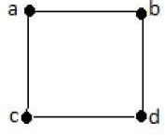**Example 1**

In the above example, ab, ac, cd, and bd are the edges of the graph. Similarly, a, b, c, and d are the vertices of the graph.

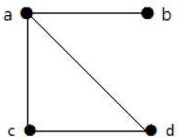**Example 2**

In this graph, there are four vertices a, b, c, and d, and four edges ab, ac, ad, and cd.

**Loop**

In a graph, if an edge is drawn from vertex to itself, it is called a loop.

**Example 1**



In the above graph, V is a vertex for which it has an edge (V, V) forming a loop.

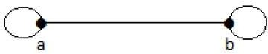**Example 2**

In this graph, there are two loops which are formed at vertex a, and vertex b.

**Degree of Vertex**

It is the number of vertices incident with the vertex V.

**Notation** − deg(V).

In a simple graph with n number of vertices, the degree of any vertices is −

deg(v) ≤ n – 1 ∀ v ∈ G

A vertex can form an edge with all other vertices except by itself. So the degree of a vertex will be up to the **number of vertices in the graph minus 1**. This 1 is for the self-vertex as it cannot form a loop by itself. If there is a loop at any of the vertices, then it is not a Simple Graph.

Degree of vertex can be considered under two cases of graphs −

* + Undirected Graph
  + Directed Graph

**Degree of Vertex in an Undirected Graph**

An undirected graph has no directed edges. Consider the following examples.

**Example 1**

Take a look at the following graph −

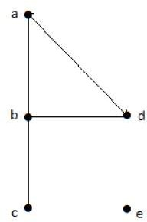

In the above Undirected Graph,

* + deg(a) = 2, as there are 2 edges meeting at vertex ‘a’.
  + deg(b) = 3, as there are 3 edges meeting at vertex ‘b’.
  + deg(c) = 1, as there is 1 edge formed at vertex ‘c’ So ‘c’ is a **pendent vertex**.
  + deg(d) = 2, as there are 2 edges meeting at vertex ‘d’.
  + deg(e) = 0, as there are 0 edges formed at vertex ‘e’.

So ‘e’ is an **isolated vertex**.

**Example 2**

Take a look at the following graph −

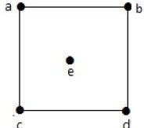

In the above graph,

deg(a) = 2, deg(b) = 2, deg(c) = 2, deg(d) = 2, and deg(e) = 0.

The vertex ‘e’ is an isolated vertex. The graph does not have any pendent vertex.

**Degree of Vertex in a Directed Graph**

In a directed graph, each vertex has an **indegree** and an **outdegree**.

**Indegree of a Graph**

* + Indegree of vertex V is the number of edges which are coming into the vertex V.
  + **Notation** − deg+(V).

**Outdegree of a Graph**

* + Outdegree of vertex V is the number of edges which are going out from the vertex V.
  + **Notation** − deg-(V).

Consider the following examples.

**Example 1**

Take a look at the following directed graph. Vertex ‘a’ has two edges, ‘ad’ and ‘ab’, which are going outwards. Hence its outdegree is 2. Similarly, there is an edge ‘ga’, coming towards vertex ‘a’. Hence the indegree of ‘a’ is 1.

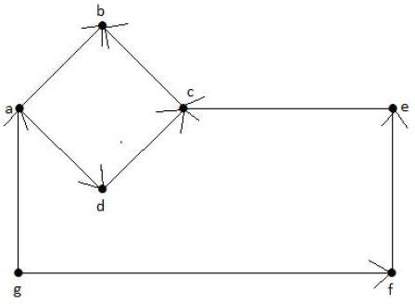

The indegree and outdegree of other vertices are shown in the following table −

|  |  |  |
| --- | --- | --- |
| **Vertex** | **Indegree** | **Outdegree** |
| a | 1 | 2 |
| b | 2 | 0 |
| c | 2 | 1 |
| d | 1 | 1 |
| e | 1 | 1 |
| f | 1 | 1 |
| g | 0 | 2 |

**Example 2**

Take a look at the following directed graph. Vertex ‘a’ has an edge ‘ae’ going outwards from vertex ‘a’. Hence its outdegree is 1. Similarly, the graph has an edge ‘ba’ coming towards vertex ‘a’. Hence the indegree of ‘a’ is 1.

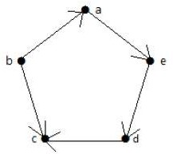

The indegree and outdegree of other vertices are shown in the following table −

|  |  |  |
| --- | --- | --- |
| **Vertex** | **Indegree** | **Outdegree** |
| a | 1 | 1 |
| b | 0 | 2 |
| c | 2 | 0 |
| d | 1 | 1 |
| e | 1 | 1 |

**Pendent Vertex**

By using degree of a vertex, we have a two special types of vertices. A vertex with degree one is called a pendent vertex.

**Example**



Here, in this example, vertex ‘a’ and vertex ‘b’ have a connected edge ‘ab’. So with respect to the vertex ‘a’, there is only one edge towards vertex ‘b’ and similarly with respect to the vertex ‘b’, there is only one edge towards vertex ‘a’. Finally, vertex ‘a’ and vertex ‘b’ has degree as one which are also called as the pendent vertex.

**Isolated Vertex**

A vertex with degree zero is called an isolated vertex.

**Example**



Here, the vertex ‘a’ and vertex ‘b’ has a no connectivity between each other and also to any other vertices. So the degree of both the vertices ‘a’ and ‘b’ are zero. These are also called as isolated vertices.

**Adjacency**

Here are the norms of adjacency −

* + In a graph, two vertices are said to be **adjacent,** if there is an edge between the two vertices. Here, the adjacency of vertices is maintained by the single edge that is connecting those two vertices.
  + In a graph, two edges are said to be adjacent, if there is a common vertex between the two edges. Here, the adjacency of edges is maintained by the single vertex that is connecting two edges.

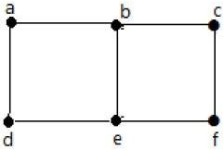**Example 1**

In the above graph −

* + ‘a’ and ‘b’ are the adjacent vertices, as there is a common edge ‘ab’ between them.
  + ‘a’ and ‘d’ are the adjacent vertices, as there is a common edge ‘ad’ between them.
  + ab’ and ‘be’ are the adjacent edges, as there is a common vertex ‘b’ between them.
  + be’ and ‘de’ are the adjacent edges, as there is a common vertex ‘e’ between them.

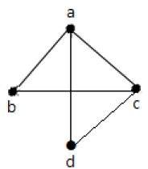**Example 2**

In the above graph −

* + a’ and ‘d’ are the adjacent vertices, as there is a common edge ‘ad’ between them.
  + ‘c’ and ‘b’ are the adjacent vertices, as there is a common edge ‘cb’ between them.
  + ‘ad’ and ‘cd’ are the adjacent edges, as there is a common vertex ‘d’ between them.
  + ac’ and ‘cd’ are the adjacent edges, as there is a common vertex ‘c’ between them.

**Parallel Edges**

In a graph, if a pair of vertices is connected by more than one edge, then those edges are called parallel edges.

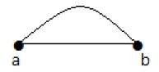

In the above graph, ‘a’ and ‘b’ are the two vertices which are connected by two edges ‘ab’ and ‘ab’ between them. So it is called as a parallel edge.

**Multi Graph**

A graph having parallel edges is known as a Multigraph.

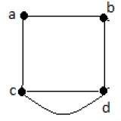**Example 1**

In the above graph, there are five edges ‘ab’, ‘ac’, ‘cd’, ‘cd’, and ‘bd’. Since ‘c’ and ‘d’ have two parallel edges between them, it a Multigraph.

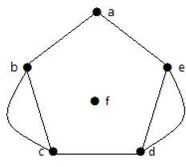**Example 2**

In the above graph, the vertices ‘b’ and ‘c’ have two edges. The vertices ‘e’ and ‘d’ also have two edges between them. Hence it is a Multigraph.

**Degree Sequence of a Graph**

If the degrees of all vertices in a graph are arranged in descending or ascending order, then the sequence obtained is known as the degree sequence of the graph.

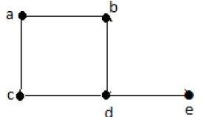**Example 1**

|  |  |  |  |  |  |
| --- | --- | --- | --- | --- | --- |
| **Vertex** | A | b | c | d | e |
| **Connecting to** | b,c | a,d | a,d | c,b,e | d |
| **Degree** | 2 | 2 | 2 | 3 | 1 |

In the above graph, for the vertices {d, a, b, c, e}, the degree sequence is {3, 2, 2, 2, 1}.

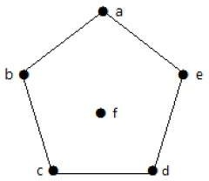**Example 2**

|  |  |  |  |  |  |  |
| --- | --- | --- | --- | --- | --- | --- |
| **Vertex** | A | b | c | d | e | f |
| **Connecting to** | b,e | a,c | b,d | c,e | a,d | - |
| **Degree** | 2 | 2 | 2 | 2 | 2 | 0 |

In the above graph, for the vertices {a, b, c, d, e, f}, the degree sequence is {2, 2, 2, 2, 2, 0}.

1. **Representation of Graphs**

There are mainly two ways to represent a graph −

* + Adjacency Matrix
  + Adjacency List

**Adjacency Matrix**

An Adjacency Matrix A[V][V] is a 2D array of size V×V where V is the number of vertices in a undirected graph. If there is an edge between Vx to Vy then the value of A[Vx][ Vy] = 1 and A[Vy][ Vx] = 1, otherwise the value will be zero. And for a directed graph, if there is an edge between Vx to Vy, then the value of A[Vx][ Vy] = 1, otherwise the value will be zero.

**Adjacency Matrix of an Undirected Graph**

Let us consider the following undirected graph and construct the adjacency matrix −

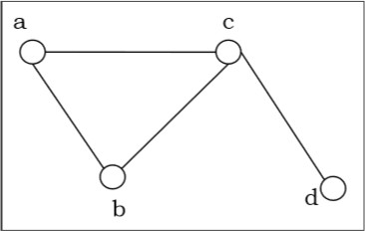

Adjacency matrix of the above undirected graph will be −

|  |  |  |  |  |
| --- | --- | --- | --- | --- |
|  | **a** | **b** | **c** | **d** |
| **a** | 0 | 1 | 1 | 0 |
| **b** | 1 | 0 | 1 | 0 |
| **c** | 1 | 1 | 0 | 1 |
| **d** | 0 | 0 | 1 | 0 |

**Adjacency Matrix of a Directed Graph**

Let us consider the following directed graph and construct its adjacency matrix −

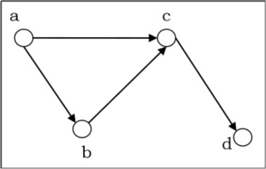

Adjacency matrix of the above directed graph will be −

|  |  |  |  |  |
| --- | --- | --- | --- | --- |
|  | **a** | **b** | **c** | **d** |
| **a** | 0 | 1 | 1 | 0 |
| **b** | 0 | 0 | 1 | 0 |
| **c** | 0 | 0 | 0 | 1 |
| **d** | 0 | 0 | 0 | 0 |

**Adjacency List**

In adjacency list, an array (A[V]) of linked lists is used to represent the graph G with V number of vertices. An entry A[Vx] represents the linked list of vertices adjacent to the V**x**-th vertex. The adjacency list of the graph is as shown in the figure below −

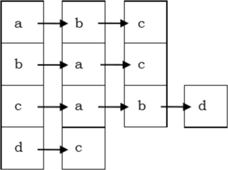

1. **Planar vs. Non-planar graph**

**Planar graph** − A graph G is called a planar graph if it can be drawn in a plane without any edges crossed. If we draw graph in the plane without edge crossing, it is called embedding the graph in the plane.

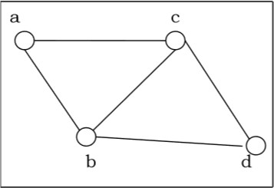

**Non-planar graph** − A graph is non-planar if it cannot be drawn in a plane without graph edges crossing.

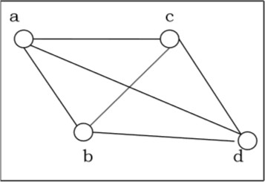

1. 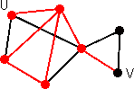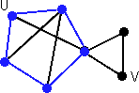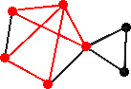**Walks: paths, cycles, trails, and circuits**

A *walk* is an alternating [sequence](http://www.edmath.org/MATtours/discrete/concepts/cseq.html) of vertices and connecting edges.

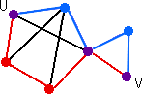Less formally a walk is any route through a graph from vertex to vertex along edges. A walk can end on the same vertex on which it began or on a different vertex. A walk can travel over any edge and any vertex any number of times.

|  |
| --- |
| A *path* is a walk that does not include any vertex twice, except that its  first vertex might be the same as its last. |
| Two paths from U to V |
| A *trail* is a walk that does not pass over the same edge twice. A trail might visit the same vertex twice, but only if it comes and goes from a different edge each time. |
| A trail from U to V |
| A *cycle* is a path that begins and ends on the same vertex. |
| A *circuit* is a trail that begins and ends on the same vertex. |

For [simple graphs,](http://www.edmath.org/MATtours/discrete/concepts/cmulti.html) it is unambigous to specify a walk by naming only the vertices that it crosses. For [pseudographs and multigraphs](http://www.edmath.org/MATtours/discrete/concepts/cmulti.html), you must also specify the edges since there might be multiple edges connecting vertices. For [digraphs](http://www.edmath.org/MATtours/discrete/concepts/ctypes.html), walks can travel edges only in the direction of the arrows.

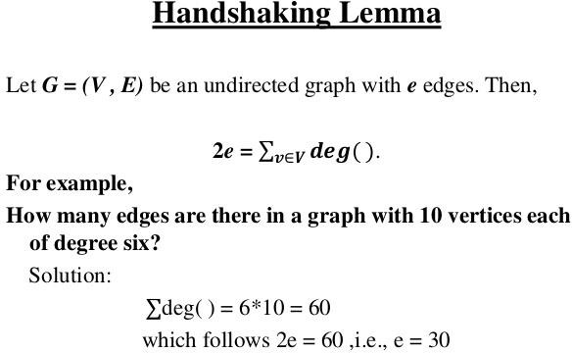

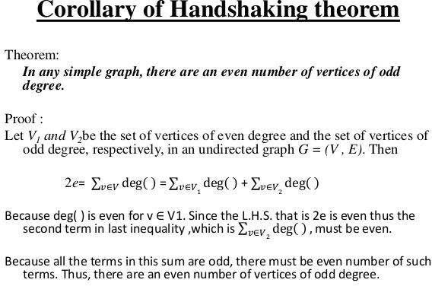

1. **Isomorphism**

If two graphs G and H contain the same number of vertices connected in the same way, they are called isomorphic graphs (denoted by G ≅ H).

It is easier to check non-isomorphism than isomorphism. If any of these following conditions occurs, then two graphs are non-isomorphic −

* + The number of connected components are different
  + Vertex-set cardinalities are different
  + Edge-set cardinalities are different
  + Degree sequences are different

**Example**

The following graphs are isomorphic −

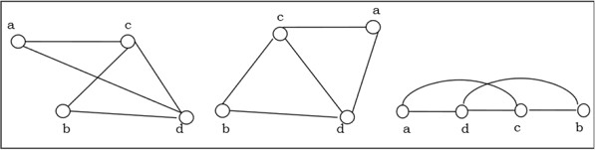

1. **Homomorphism**

A homomorphism from a graph G to a graph H is a mapping (May not be a bijective mapping) h: G→H such that − (x, y) ∈ E(G) → (h(x), h(y)) ∈ E(H). It maps adjacent vertices of graph G to the adjacent vertices of the graph H.

A homomorphism is an isomorphism if it is a bijective mapping. Homomorphism always preserves edges and connectedness of a graph. The compositions of homomorphisms are also homomorphisms. To find out if there exists any homomorphic graph of another graph is a NP- complete problem.

1. **Euler Graphs**

A connected graph G is called an Euler graph, if there is a closed trail which includes every edge of the graph G. An Euler path is a path that uses every edge of a graph exactly once. An Euler path starts and ends at different vertices.

An Euler circuit is a circuit that uses every edge of a graph exactly once. An Euler circuit always starts and ends at the same vertex. A connected graph G is an Euler graph if and only if all

vertices of G are of even degree, and a connected graph G is Eulerian if and only if its edge set can be decomposed into cycles.

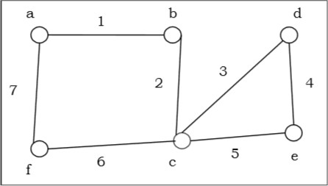

The above graph is an Euler graph as “a 1 b 2 c 3 d 4 e 5 c 6 f 7 g” covers all the edges of the graph.

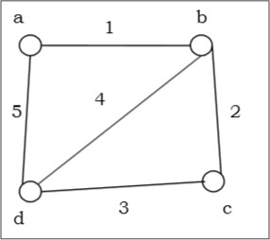

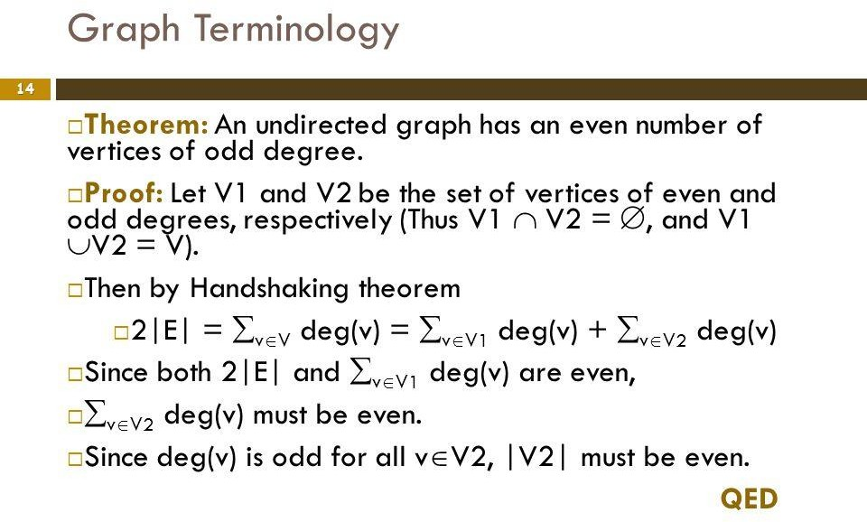

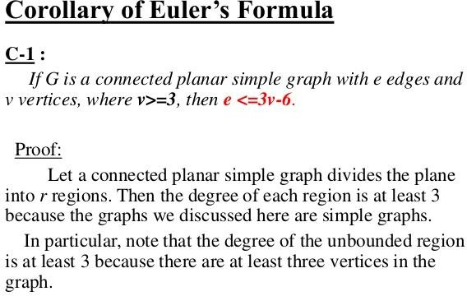

1. **Hamiltonian Graphs**

A connected graph G is called Hamiltonian graph if there is a cycle which includes every vertex of G and the cycle is called Hamiltonian cycle. Hamiltonian walk in graph G is a walk that passes through each vertex exactly once.

If G is a simple graph with n vertices, where n ≥ 3 If deg(v) ≥ 1/2 n for each vertex v, then the graph G is Hamiltonian graph. This is called **Dirac's Theorem**.

If G is a simple graph with n vertices, where n ≥ 2 if deg(x) + deg(y) ≥ n for each pair of non- adjacent vertices x and y, then the graph G is Hamiltonian graph. This is called **Ore's theorem.**

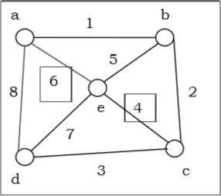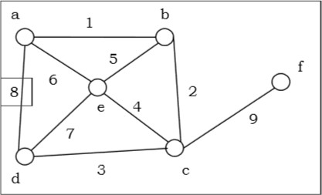

1. **Graph Coloring**

Graph coloring is the procedure of assignment of colors to each vertex of a graph G such that no adjacent vertices get same color. The objective is to minimize the number of colors while coloring a graph. The smallest number of colors required to color a graph G is called its chromatic number of that graph. Graph coloring problem is a NP Complete problem.

**Method to Color a Graph**

The steps required to color a graph G with n number of vertices are as follows −

**Step 1.** Arrange the vertices of the graph in some order.

**Step 2.**Choose the first vertex and color it with the first color.

**Step 3.** Choose the next vertex and color it with the lowest numbered color that has not been colored on any vertices adjacent to it. If all the adjacent vertices are colored with this color, assign a new color to it. Repeat this step until all the vertices are colored.

**Example**

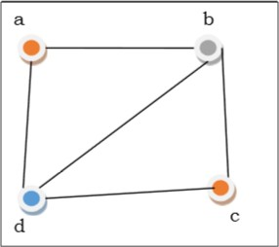

In the above figure, at first vertex **a** is colored red. As the adjacent vertices of vertex **a** are again adjacent, vertex **b** and vertex **d** are colored with different color, green and blue respectively. Then vertex **c** is colored as red as no adjacent vertex of **c** is colored red. Hence, we could color the graph by 3 colors. Hence, the chromatic number of the graph is 3.

**Applications of Graph Coloring**

Some applications of graph coloring include −

* + [Register Allocation](https://en.wikipedia.org/wiki/Register_allocation)
  + Map Coloring
  + Bipartite Graph Checking
  + [Mobile Radio Frequency Assignment](http://www.zib.de/groetschel/teaching/SS2012/GraphCol%20and%20FrequAssignment.pdf)
  + Making time table, etc.

1. **Graph Traversal**

Graph traversal is the problem of visiting all the vertices of a graph in some systematic order. There are mainly two ways to traverse a graph.

* + Breadth First Search
  + Depth First Search

•

**Breadth First Search**

Breadth First Search (BFS) starts at starting level-0 vertex X of the graph G. Then we visit all the vertices that are the neighbors of X. After visiting, we mark the vertices as "visited," and place them into level-1. Then we start from the level-1 vertices and apply the same method on every level-1 vertex and so on. The BFS traversal terminates when every vertex of the graph has been visited.

**BFS Algorithm** −

* + Visit all the neighbor vertices before visiting other neighbor vertices of neighbor vertices
  + Start traversing from vertex u
  + Visit all neighbor vertices of vertex u
  + Then visit all of their un-traversed neighbor vertices
  + Repeat until all nodes are visited

**Problem**

Let us take a graph (Source vertex is ‘a’) and apply the BFS algorithm to find out the traversal order.

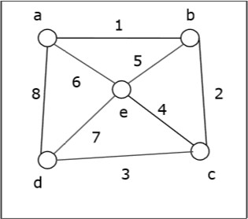

**Solution** −

Vertex ‘a’ (Level-0 vertex) is traversed first and marked as “visited”. Then we will visit the adjacent vertices ‘b’, ‘d’ and ‘e’ of vertex ‘a’, marked them as level-1 and added to the “visited” list. We can traverse ‘b’, ‘d’ and ‘e’ in any order. Next, we will visit the adjacent vertices of ‘b’ that is ‘c’. Then, it is marked as level-2 and added to the “visited” list. As all vertices are travelled, the algorithm is terminated.

So the alternate orders of traversal are – a→b→d→e→c

Or, a→b→e→d→c Or, a→d→b→e→c Or, a→e→b→d→c

Or, a→b→e→d→c Or, a→d→e→b→c

**Application of BFS**

* + Finding the shortest path
  + Minimum spanning tree for un-weighted graph
  + GPS navigation system
  + Detecting cycles in an undirected graph
  + Finding all nodes within one connected component

**Complexity Analysis**

Let G(V, E) be a graph with |V| number of vertices and |E| number of edges. If breadth first search algorithm visits every vertex in the graph and checks every edge, then its time complexity would be −

O(|V| + |E|). O(|E|)

It may vary between O(1) and O(|V2|)

**Depth First Search**

Depth First Search (DFS) algorithm starts from a vertex v, then it traverses to its adjacent vertex (say x) that has not been visited before and mark as "visited" and goes on with the adjacent vertex of x and so on.

If at any vertex, it encounters that all the adjacent vertices are visited, then it backtracks until it finds the first vertex having an adjacent vertex that has not been traversed before. Then, it traverses that vertex, continues with its adjacent vertices until it traverses all visited vertices and has to backtrack again. In this way, it will traverse all the vertices reachable from the initial vertex v.

**DFS Algorithm**

* + Visit all the neighbor vertices of a neighbor vertex before visiting the other neighbor vertices
  + Visit all vertices reachable from vertex u and mark them as visited
  + Then visit all unvisited nodes that are the neighbor vertices of u
  + Repeat until all vertices of the graph are visited

**Problem**

Let us take a graph (Source vertex is ‘a’) and apply the DFS algorithm to find out the traversal order.

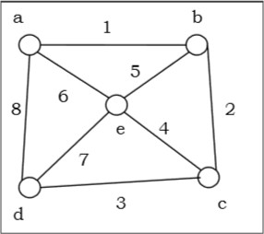

**Solution**

Vertex ‘a’ (Level-0 vertex) is traversed first and marked as “visited”. Then we will visit the a’s adjacent vertex **b** and add **b** to the “visited” list and proceed to **b**’s adjacent vertex **c** and add **c** to the “visited” list. Then we proceed to **c**’s adjacent vertex **d** and add **d** to the “visited” list. Next, we proceed to **d**’s adjacent vertex **e** and add **e** to the “visited” list and stop as all the vertices are visited.

Hence, the alternate orders of traversals are − a→b→c→d→e

Or, a→e→b→c→d Or, a→b→e→c→d Or, a→d→e→b→c Or, a→d→c→e→b Or, a→d→c→b→e

**Complexity Analysis**

Let G(V, E) be a graph with |V| number of vertices and |E| number of edges. If DFS algorithm visits every vertex in the graph and checks every edge, then the time complexity is −

Θ (|V| + |E|)

**Applications**

* + Detecting cycle in a graph
  + To find topological sorting
  + To test if a graph is bipartite
  + Finding connected components
  + Finding the bridges of a graph
  + Finding bi-connectivity in graphs
  + Solving the Knight’s Tour problem
  + Solving puzzles with only one solution

## Graph Theory - Isomorphism

A graph can exist in different forms having the same number of vertices, edges, and also the same edge connectivity. Such graphs are called isomorphic graphs. Note that we label the graphs in this chapter mainly for the purpose of referring to them and recognizing them from one another.

**Isomorphic Graphs**

Two graphs G1 and G2 are said to be isomorphic if −

* + Their number of components (vertices and edges) are same.
  + Their edge connectivity is retained.

**Note** − In short, out of the two isomorphic graphs, one is a tweaked version of the other. An unlabelled graph also can be thought of as an isomorphic graph.

There exists a function ‘f’ from vertices of G1 to vertices of G2 [f: V(G1) ⇒ V(G2)], such that Case (i): *f* is a bijection (both one-one and onto)

Case (ii): *f* preserves adjacency of vertices, i.e., if the edge {U, V} ∈ G1, then the edge

{f(U), f(V)} ∈ G2, then G1 ≡ G2.

**Note**

If G1 ≡ G2 then −

* + |V(G1)| = |V(G2)|
  + |E(G1)| = |E(G2)|
  + Degree sequences of G1 and G2 are same.
  + If the vertices {V1, V2, .. Vk} form a cycle of length K in G1, then the vertices {f(V1), f(V2),… f(Vk)} should form a cycle of length K in G2.

All the above conditions are necessary for the graphs G1 and G2 to be isomorphic, but not sufficient to prove that the graphs are isomorphic.

* + (G1 ≡ G2) if and only if (*G1−* ≡ *G2−*) where G1 and G2 are simple graphs.
  + (G1 ≡ G2) if the adjacency matrices of G1 and G2 are same.
  + (G1 ≡ G2) if and only if the corresponding subgraphs of G1 and G2 (obtained by deleting some vertices in G1 and their images in graph G2) are isomorphic.

**Example**

Which of the following graphs are isomorphic?

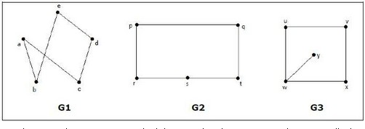

In the graph G3, vertex ‘w’ has only degree 3, whereas all the other graph vertices has degree 2. Hence G3 not isomorphic to G1 or G2.

Taking complements of G1 and G2, you have −

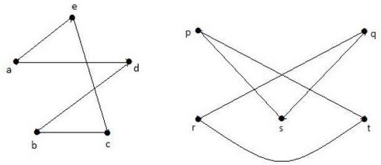

Here, (*G1−* ≡ *G2−*), hence (G1 ≡ G2).

**Planar Graphs**

A graph ‘G’ is said to be planar if it can be drawn on a plane or a sphere so that no two edges cross each other at a non-vertex point.

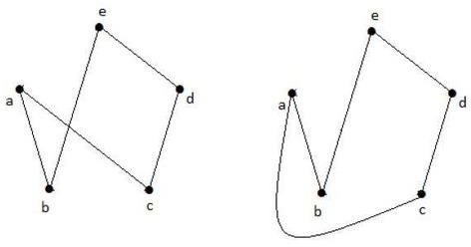**Example**

**Regions**

Every planar graph divides the plane into connected areas called regions.

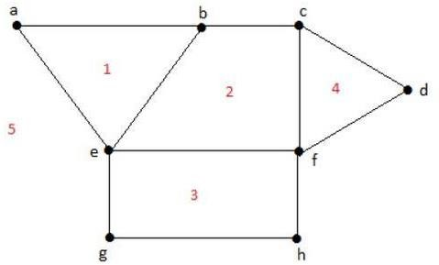**Example**

Degree of a bounded region **r = deg(r)** = Number of edges enclosing the regions **r**.

deg(1) = 3

deg(2) = 4

deg(3) = 4

deg(4) = 3

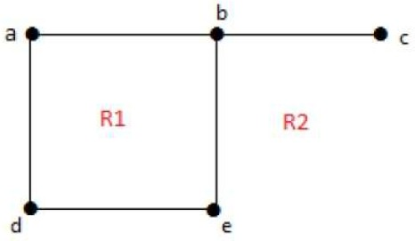deg(5) = 8

Degree of an unbounded region **r = deg(r)** = Number of edges enclosing the regions **r**.

deg(R1) = 4

deg(R2) = 6

In planar graphs, the following properties hold good −

* + **1.** In a planar graph with ‘n’ vertices, sum of degrees of all the vertices is

**n ∑ i=1 deg(Vi) = 2|E|**

* + **2.** According to **Sum of Degrees of Regions** Theorem, in a planar graph with ‘n’ regions, Sum of degrees of regions is −

**n ∑ i=1 deg(ri) = 2|E|**

Based on the above theorem, you can draw the following conclusions − In a planar graph,

* + - If degree of each region is K, then the sum of degrees of regions is K|R| = 2|E|
    - If the degree of each region is at least K(≥ K), then K|R| ≤ 2|E|
    - If the degree of each region is at most K(≤ K), then K|R| ≥ 2|E|

**Note** − Assume that all the regions have same degree.

1. According to **Euler’s Formulae** on planar graphs,
   * If a graph ‘G’ is a connected planar, then |V| + |R| = |E| + 2
   * If a planar graph with ‘K’ components then |V| + |R|=|E| + (K+1)

Where, |V| is the number of vertices, |E| is the number of edges, and |R| is the number of regions.

1. **Edge Vertex Inequality**

If ‘G’ is a connected planar graph with degree of each region at least ‘K’ then,

|E| ≤ *k k − 2* {|v| - 2}

You know, |V| + |R| = |E| + 2 K.|R| ≤ 2|E|

K(|E| - |V| + 2) ≤ 2|E| (K - 2)|E| ≤ K(|V| - 2)

|E| ≤ *k k − 2* {|v| - 2}

1. **If ‘G’ is a simple connected planar graph, then**

|E| ≤ 3|V| − 6

|R| ≤ 2|V| − 4

There exists at least one vertex V • ∈ G, such that deg(V) ≤ 5

1. **If ‘G’ is a simple connected planar graph (with at least 2 edges) and no triangles, then**

**|E| ≤ {2|V| – 4}**

1. **Kuratowski’s Theorem**

A graph ‘G’ is non-planar if and only if ‘G’ has a sub graph which is homeomorphism to K5 or K3,3.

**Homomorphism**

Two graphs G1 and G2 are said to be homomorphic, if each of these graphs can be obtained from the same graph ‘G’ by dividing some edges of G with more vertices. Take a look at the following example −

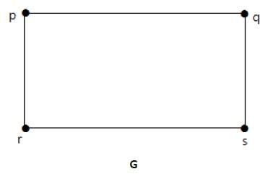

Divide the edge ‘rs’ into two edges by adding one vertex.

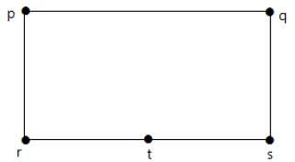

The graphs shown below are homomorphic to the first graph.

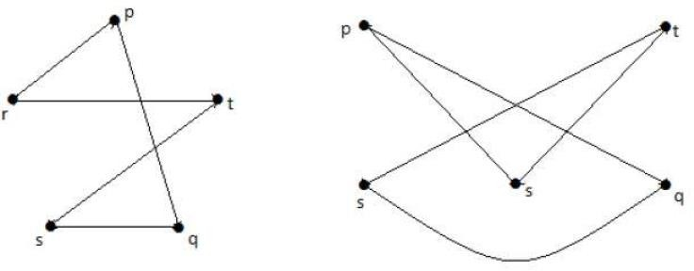

If G1 is isomorphic to G2, then G is homeomorphic to G2 but the converse need not be true.

* + Any graph with 4 or less vertices is planar.
  + Any graph with 8 or less edges is planar.
  + A complete graph Kn is planar if and only if n ≤ 4.
  + The complete bipartite graph Km, n is planar if and only if m ≤ 2 or n ≤ 2.
  + A simple non-planar graph with minimum number of vertices is the complete graph K5.
  + The simple non-planar graph with minimum number of edges is K3, 3.

**Polyhedral graph**

A simple connected planar graph is called a polyhedral graph if the degree of each vertex is ≥ 3, i.e., deg(V) ≥ 3 • ∀ V • ∈ G.

* + 3|V| ≤ 2|E|
  + 3|R| ≤ 2|E|

## Graph Theory - Traversability

A graph is traversable if you can draw a path between all the vertices without retracing the same path. Based on this path, there are some categories like Euler’s path and Euler’s circuit which are described in this chapter.

**Euler’s Path**

An Euler’s path contains each edge of ‘G’ exactly once and each vertex of ‘G’ at least once. A connected graph G is said to be traversable if it contains an Euler’s path.

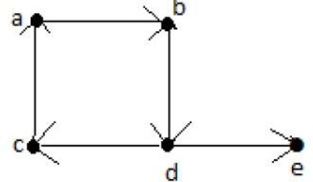**Example**

**Euler’s Path** = d-c-a-b-d-e.

**Euler’s Circuit**

In an Euler’s path, if the starting vertex is same as its ending vertex, then it is called an Euler’s circuit.

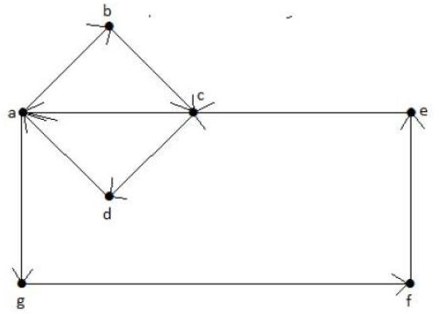**Example**

**Euler’s Path** = a-b-c-d-a-g-f-e-c-a.

**Euler’s Circuit Theorem**

A connected graph ‘G’ is traversable if and only if the number of vertices with odd degree in G is exactly 2 or 0. A connected graph G can contain an Euler’s path, but not an Euler’s circuit, if it has exactly two vertices with an odd degree.

**Note** − This Euler path begins with a vertex of odd degree and ends with the other vertex of odd degree.

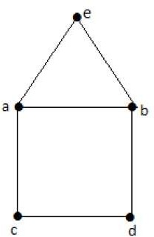**Example**

**Euler’s Path** − b-e-a-b-d-c-a is not an Euler’s circuit, but it is an Euler’s path. Clearly it has exactly 2 odd degree vertices.

**Note** − In a connected graph G, if the number of vertices with odd degree = 0, then Euler’s circuit exists.

**Hamiltonian Graph**

A connected graph G is said to be a Hamiltonian graph, if there exists a cycle which contains all the vertices of G.

Every cycle is a circuit but a circuit may contain multiple cycles. Such a cycle is called a

**Hamiltonian cycle** of G.

**Hamiltonian Path**

A connected graph is said to be Hamiltonian if it contains each vertex of G exactly once. Such a path is called a **Hamiltonian path**.

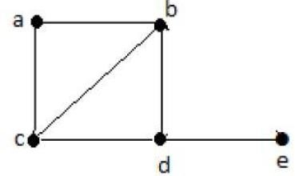**Example**

**Hamiltonian Path** − e-d-b-a-c.

**Note** −

* + Euler’s circuit contains each edge of the graph exactly once.
  + In a Hamiltonian cycle, some edges of the graph can be skipped.

**Example**

Take a look at the following graph −

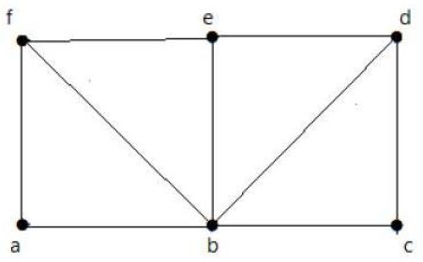

For the graph shown above −

* + Euler path exists – false
  + Euler circuit exists – false
  + Hamiltonian cycle exists – true
  + Hamiltonian path exists – true

G has four vertices with odd degree, hence it is not traversable. By skipping the internal edges, the graph has a Hamiltonian cycle passing through all the vertices.

Theorem1:

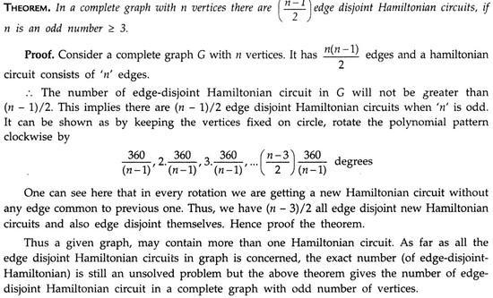

Theorem2:

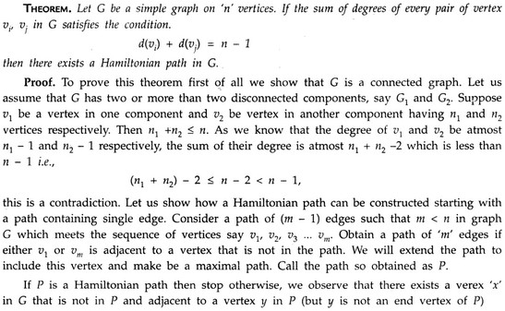

Theorem3:

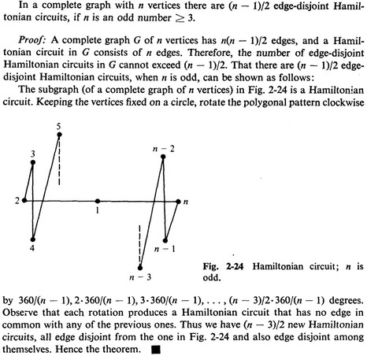

**Necessary and sufficient conditions for Euler paths**

Theorem 1. A connected multigraph has an Euler path but not an Euler circuit if and only if it has exactly two vertices of odd degree.

Proof:

(ONLY IF) Assume the graph has an Euler path but not a circuit.

Notice that every time the path passes through a vertex, it contributes 2 to the degree of the vertex (1 when it enters, 1 when it leaves).

Obviously the first and the last vertices will have odd degree and all the other vertices - even degree.

(IF) Assume exactly two vertices, u and v, have odd degree.

If we connect these two vertices, then every vertex will have even degree. By Theorem 1, there is an Euler circuit in such a graph.

If we remove the added edge {u,v} from this circuit, we will get an Euler path for the original graph. End of proof

Theorem2. A connected, undirected multigraph has an Euler path but not an Euler circuit if and only if it has exactly two vertices of odd degree.

Proof:

Suppose G is a connected multigraph that does not have an Euler circuit. If G has an Euler path, we can make a new graph by adding on one edge that joins the endpoints of the Euler path. If we add this edge to the Euler path we get an Euler circuit. Thus there is an Euler circuit for our new graph.

By the previous theorem, this implies every vertex in the new graph has even degree. However, this graph was obtained from G by adding the one edge between distinct vertices. This edge added one to the degrees of these two vertices. Thus in G these vertices must have odd degree and are the only vertices in G with odd degree.

Conversely, suppose G has exactly two vertices with odd degree. Again, add an edge joining the vertices with odd degree. The previous theorem tells us there is an Euler circuit. Since it is a circuit, we could consider the circuit as one which begins and ends at one of these vertices where the degree is odd in G. Now, remove the edge we added earlier and we get G back and an Euler path in G.

Theorem 3. (Euler) A connected graph G is an Euler graph if and only if all vertices of G are of even degree.

Proof:

Necessity Let G(V, E) be an Euler graph. Thus G contains an Euler line Z, which is a closed walk. Let this walk start and end at the vertex u € V. Since each visit of Z to an intermediate vertex v of Z contributes two to the degree of v and since Z traverses each edge exactly once, d(v) is even for every such vertex. Each intermediate visit to u contributes two to the degree of u, and also the initial and final edges of Z contribute one each to the degree of u. So the degree d(u) of u is also even.

Sufficiency Let G be a connected graph and let degree of each vertex of G be even. Assume G is not Eulerian and let G contain least number of edges. Since δ≥ 2, G has a cycle. Let Z be a closed walk in G of maximum length. Clearly, G−E(Z) is an even degree graph. Let C1 be one of the components of G−E(Z). As C1 has less number of edges than G, it is Eulerian and has a vertex v in common with Z. Let Z’ be an Euler line in C1. Then Z’UZ is closed in G, starting and ending at v. Since it is longer than Z, the choice of Z is contradicted. Hence G is Eulerian.

Second proof for sufficiency

Assume that all vertices of G are of even degree. We construct a walk starting at an arbitrary vertex v and going through the edges of G such that no edge of G is traced more than once. The tracing is continued as far as possible. Since every vertex is of even degree, we exit from the vertex we enter and the tracing clearly cannot stop at any vertex but v. As v is also of even degree, we reach v when the tracing comes to an end. If this closed walk Z we just traced includes all the edges of G, then G is an Euler graph. If not, we remove from G all the edges in Z and obtain a subgraph Z’ of G formed by the remaining edges. Since both G and Z have all their

vertices of even degree, the degrees of the vertices of Z’ are also even. Also, Z’ touches Z at least at one vertex say

u, because G is connected. Starting from u, we again construct a new walk in Z’. As all the vertices of Z’ are of even degree, therefore this walk in Z’ terminates at vertex u. This walk in Z’combined with Z forms a new walk, which starts and ends at the vertex v and has more edges than Z. This process is repeated till we obtain a closed walk that traces all the edges of G. Hence G is an Euler graph (Fig. 3.2)

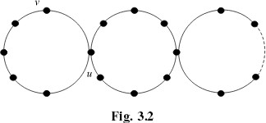

Theorem 4: A connected graph G is Eulerian if and only if its edge set can be decomposed into cycles.

Proof: Let G(V, E) be a connected graph and let G be decomposed into cycles. If k of these cycles are incident at a particular vertex v, then d(v) = 2k. Therefore the degree of every vertex of G is even and hence G is Eulerian.

Conversely, let G be Eulerian. We show G can be decomposed into cycles. To prove this, we use induction on the number of edges. Since d(v) ≥2 for each v €V, G has a cycle C. Then G−E(C) is possibly a disconnected graph, each of whose components C1, C2, . . . , Ck is an even degree graph and hence Eulerian. By the induction hypothesis, each Ci is a disjoint union of cycles. These together with C provide a partition of E(G) into cycles.

Biconnected Graph

* + ***Articulation point:* An Articulation point in a connected graph is a vertex that, if delete, would break the graph into two or more pieces (connected component).**
  + ***Biconnected graph:* A graph with no articulation point called biconnected. In other words, a graph is biconnected if and only if any vertex is deleted, the graph remains connected.**
  + ***Biconnected component:* A biconnected component of a graph is a maximal biconnected subgraph- a biconnected subgraph that is not properly contained in a larger biconnected subgraph.**
  + **A graph that is not biconnected can divide into biconnected components, sets of nodes mutually accessible via two distinct paths.**

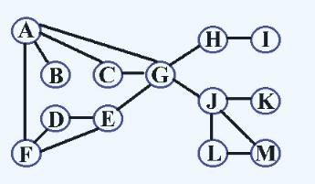

**Figure 1. The graph G that is not biconnected**

* + **Articulation points: A, H, G, J**
  + **Biconnected components: {A, C, G, D, E, F}、{G, J, L, B}、B、H、I、K**

*How to find articulation points?*

|  |  |
| --- | --- |
| **[Step 1.]** | **Find the depth-first spanning tree T for G** |
| **[Step 2.]** | **Add back edges in T** |
| **[Step 3.]** | **Determine DNF(i) and L(i)**   * **DNF(i): the visiting sequence of vertices i by depth first search** * **L(i): the least DFN reachable frome i through a path consisting of zero or more tree edges followed by zero or one back edge** |
| **[Step 4.]** | **Vertex i is an articulation point of G if and only if eather:**   * **i is the root of T and has at least two children** * **i is not the root and has a child j for which L(j)>=DFN(i)** |

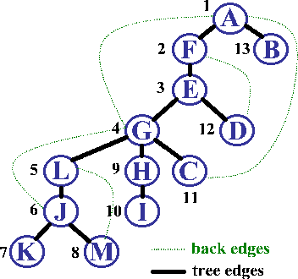

**Figure 2. Depth-first panning tree of the graph G**

**[Example] The DFN(i) and L(i) of Graph G in Figure 1 are:**

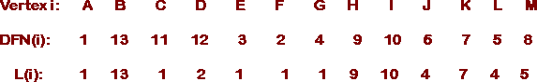

* + - **Vertex G is an articulation point because G is not the root and in depth-first spanning tree in Figure 2, L(L)>=DFN(G), that L is one of its children**
    - **Vertex A is an articulation point because A is the root and in depth-first spanning tree in Figure 2, it has more than one child, B and F**
    - **Vertex E is not an articulation point because E is not the root and in depth-first spanning tree in Figure 2, L(G)<DFN(E) and L(D)<DFN(E), that G and D are its children**

**Graph Theory - Examples**

In this chapter, we will cover a few standard examples to demonstrate the concepts we already discussed in the earlier chapters.

**Example 1**

**Find the number of spanning trees in the following graph.**

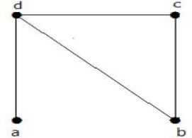

**Solution**

The number of spanning trees obtained from the above graph is 3. They are as follows −

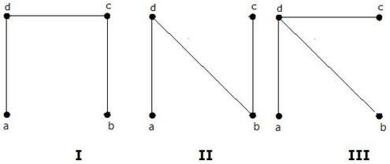

These three are the spanning trees for the given graphs. Here the graphs I and II are isomorphic to each other. Clearly, the number of non-isomorphic spanning trees is two.

**Example 2**

**How many simple non-isomorphic graphs are possible with 3 vertices?**

**Solution**

There are 4 non-isomorphic graphs possible with 3 vertices. They are shown below.

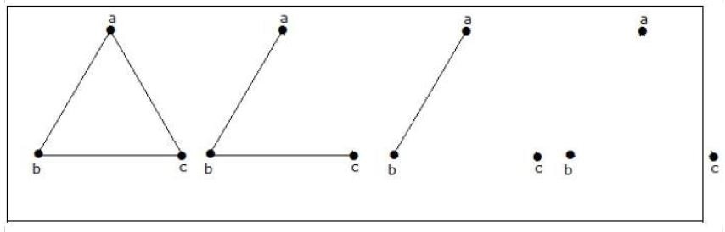

**Example 3**

**Let ‘G’ be a connected planar graph with 20 vertices and the degree of each vertex is 3. Find the number of regions in the graph.**

**Solution**

By the sum of degrees theorem, 20 ∑ i=1 deg(Vi) = 2|E|

20(3) = 2|E|

|E| = 30

By Euler’s formula,

|V| + |R| = |E| + 2 20+ |R| = 30 + 2

|R| = 12

Hence, the number of regions is 12.

**Example 4**

**What is the chromatic number of complete graph Kn?**

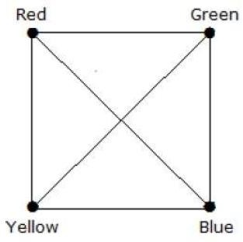**Solution**

In a complete graph, each vertex is adjacent to is remaining (n–1) vertices. Hence, each vertex requires a new color. Hence the chromatic number *Kn = n*.

**Example 5**

**What is the matching number for the following graph?**

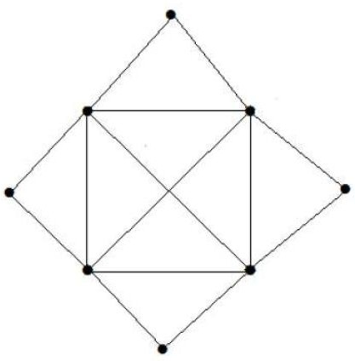**Solution**

Number of vertices = 9

We can match only 8 vertices. Matching number is 4.

 

**Example 6**

**What is the line covering number of for the following graph?**

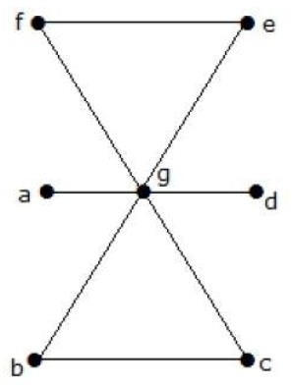**Solution**

Number of vertices = |V| = n = 7

Line covering number = (α1) ≥ ⌈ *n* 2 ⌉ = 3 α1 ≥ 3

By using 3 edges, we can cover all the vertices. Hence, the line covering number is 3

## 2. TREES

Introduction to Trees

**Tree**

A **connected acyclic graph** is called a tree. In other words, a connected graph with no cycles is called a tree.

The edges of a tree are known as **branches**. Elements of trees are called their **nodes**. The nodes without child nodes are called **leaf nodes**.

A tree with ‘n’ vertices has ‘n-1’ edges. If it has one more edge extra than ‘n-1’, then the extra edge should obviously has to pair up with two vertices which leads to form a cycle. Then, it becomes a cyclic graph which is a violation for the tree graph.

Example 1

The graph shown here is a tree because it has no cycles and it is connected. It has four vertices and three edges, i.e., for ‘n’ vertices ‘n-1’ edges as mentioned in the definition.

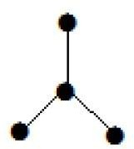

**Note** − Every tree has at least two vertices of degree one.

Example 2



In the above example, the vertices ‘a’ and ‘d’ has degree one. And the other two vertices ‘b’ and ‘c’ has degree two. This is possible because for not forming a cycle, there should be at least two single edges anywhere in the graph. It is nothing but two edges with a degree of one.

**Forest**

A **disconnected acyclic graph** is called a forest. In other words, a disjoint collection of trees is called a forest.

Example

The following graph looks like two sub-graphs; but it is a single disconnected graph. There are no cycles in this graph. Hence, clearly it is a forest.

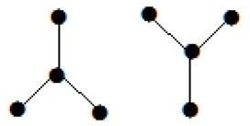

#### Spanning Trees

Let G be a connected graph, then the sub-graph H of G is called a spanning tree of G if −

* + H is a tree
  + H contains all vertices of G.

A spanning tree T of an undirected graph G is a subgraph that includes all of the vertices of G.

Example

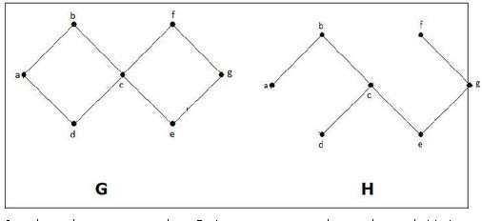

In the above example, G is a connected graph and H is a sub-graph of G.

Clearly, the graph H has no cycles, it is a tree with six edges which is one less than the total number of vertices. Hence H is the Spanning tree of G.

**Properties of tree:**

**Theorem1: If a,b are distinct vertices in a tree T=(V,E) then there is a unique path that connects these vertices**

**Theorem2:If G=(V,E) is an undirected graph, then g is connected iff G has a spanning tree Theorem 3:in every tree T= (V,E) ,|V|=|E|+1.**

**Theorem 4:For every tree T =(V,E) ,if |v|≥2 then T has atleast two pendent vertices**

**Theorem4: For a loop-free undirected graph G=(V,E)**

1. **G is tree**
2. **G is connected ,but the removal of any edge from g disconnects g into two subgraphs that are trees**
3. **contains no cycles and |V|=|E|+1**
4. **G is connected and |V|=|E|+1**

**Definition of Tree**

**Tree** is a discrete structure that represents hierarchical relationships between individual elements or nodes. A tree in which a parent has no more than two children is called a binary tree.

**Tree and its Properties**

**Definition** − A Tree is a connected acyclic graph. There is a unique path between every pair of vertices in G. A tree with N number of vertices contains (N-1) number of edges. The vertex which is of 0 degree is called root of the tree. The vertex which is of 1 degree is called leaf node of the tree and the degree of an internal node is at least 2.

**Example** − The following is an example of a tree −

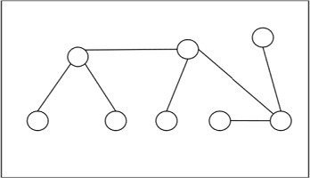

**Centers and Bi-Centers of a Tree**

The center of a tree is a vertex with minimal eccentricity. The eccentricity of a vertex X in a tree G is the maximum distance between the vertex X and any other vertex of the tree. The maximum eccentricity is the tree diameter. If a tree has only one center, it is called Central Tree and if a tree has only more than one centers, it is called Bi-central Tree. Every tree is either central or bi- central.

**Algorithm to find centers and bi-centers of a tree**

**Step 1** − Remove all the vertices of degree 1 from the given tree and also remove their incident edges.

**Step 2** − Repeat step 1 until either a single vertex or two vertices joined by an edge is left. If a single vertex is left then it is the center of the tree and if two vertices joined by an edge is left then it is the bi-center of the tree.

**Problem 1**

Find out the center/bi-center of the following tree −

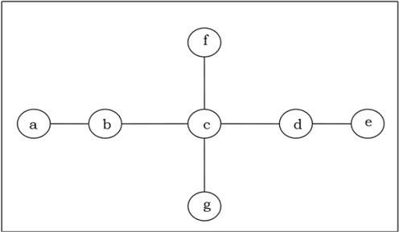

**Solution**

At first, we will remove all vertices of degree 1 and also remove their incident edges and get the following tree −

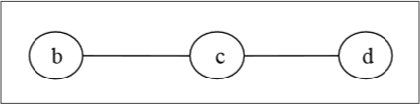

Again, we will remove all vertices of degree 1 and also remove their incident edges and get the following tree −

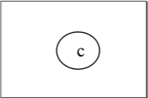

Finally we got a single vertex ‘c’ and we stop the algorithm. As there is single vertex, this tree has one center ‘c’ and the tree is a central tree.

**Problem 2**

Find out the center/bi-center of the following tree −

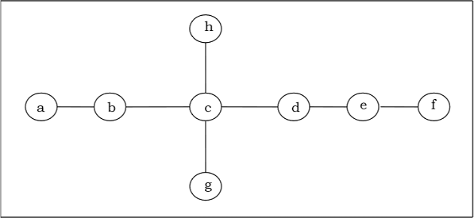

**Solution**

At first, we will remove all vertices of degree 1 and also remove their incident edges and get the following tree −

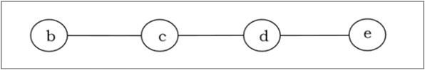

Again, we will remove all vertices of degree 1 and also remove their incident edges and get the following tree −

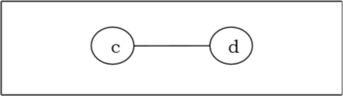

Finally, we got two vertices ‘c’ and ‘d’ left, hence we stop the algorithm. As two vertices joined by an edge is left, this tree has bi-center ‘cd’ and the tree is bi-central.

**Labeled Trees**

**Definition** − A labeled tree is a tree the vertices of which are assigned unique numbers from 1 to

1. We can count such trees for small values of n by hand so as to conjecture a general formula. The number of labeled trees of n number of vertices is nn-2. Two labelled trees are isomorphic if their graphs are isomorphic and the corresponding points of the two trees have the same labels.

**Example**

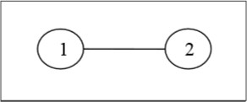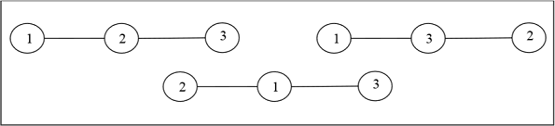

**Unlabeled Trees**

**Definition** − An unlabeled tree is a tree the vertices of which are not assigned any numbers. The number of labeled trees of n number of vertices is (2n)! / (n+1)!n!

Example

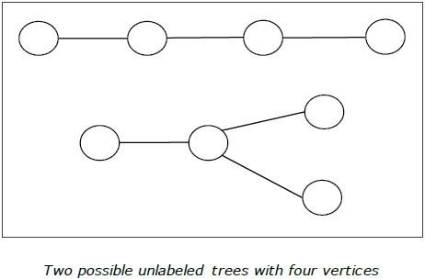

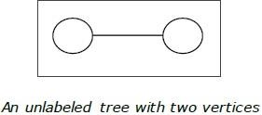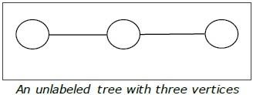

**Rooted Tree**

A rooted tree G is a connected acyclic graph with a special node that is called the root of the tree and every edge directly or indirectly originates from the root. An ordered rooted tree is a rooted tree where the children of each internal vertex are ordered. If every internal vertex of a rooted tree has not more than m children, it is called an m-ary tree. If every internal vertex of a rooted tree has exactly m children, it is called a full m-ary tree. If m = 2, the rooted tree is called a binary tree.

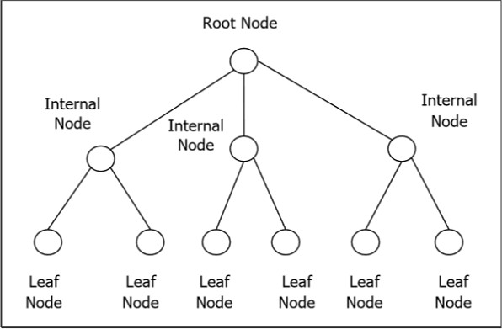

**Binary Search Tree**

Binary Search tree is a binary tree which satisfies the following property −

* + X in left sub-tree of vertex V, Value(X) ≤ Value (V)
  + Y in right sub-tree of vertex V, Value(Y) ≥ Value (V)

So, the value of all the vertices of the left sub-tree of an internal node V are less than or equal to V and the value of all the vertices of the right sub-tree of the internal node V are greater than or equal to V. The number of links from the root node to the deepest node is the height of the Binary Search Tree.

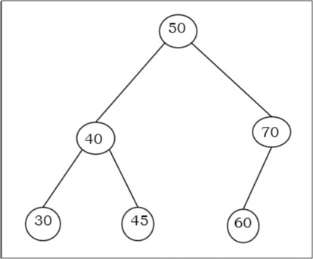**Example**

**Algorithm to search for a key in BST**

BST_Search(x, k)

if ( x = NIL or k = Value[x] ) return x;

if ( k < Value[x])

return BST_Search (left[x], k); else

return BST_Search (right[x], k)

**Complexity of Binary search tree**

|  |  |  |
| --- | --- | --- |
|  | **Average Case** | **Worst case** |
| **Space Complexity** | O(n) | O(n) |
| **Search Complexity** | O(log n) | O(n) |
| **Insertion Complexity** | O(log n) | O(n) |
| **Deletion Complexity** | O(log n) | O(n) |

**Spanning Trees**

A spanning tree of a connected undirected graph G is a tree that minimally includes all of the vertices of G. A graph may have many spanning trees.

Example

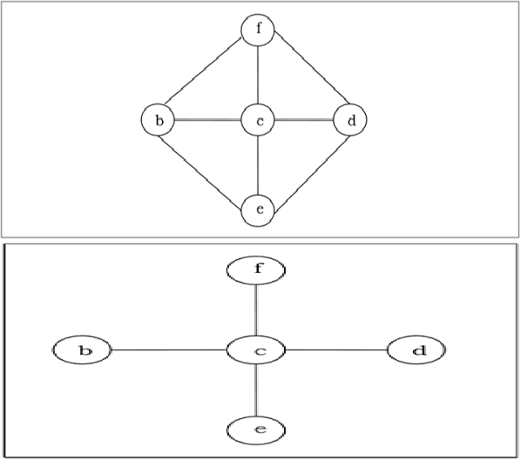

**Minimum Spanning Tree**

A spanning tree with assigned weight less than or equal to the weight of every possible spanning tree of a weighted, connected and undirected graph G, it is called minimum spanning tree (MST). The weight of a spanning tree is the sum of all the weights assigned to each edge of the spanning tree.

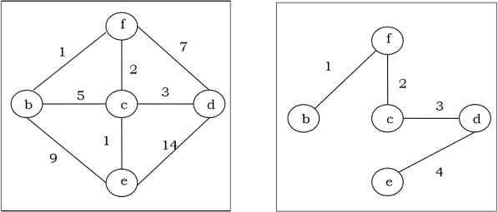**Example**

**Kruskal's Algorithm**

Kruskal's algorithm is a greedy algorithm that finds a minimum spanning tree for a connected weighted graph. It finds a tree of that graph which includes every vertex and the total weight of all the edges in the tree is less than or equal to every possible spanning tree.

**Algorithm**

**Step 1** − Arrange all the edges of the given graph G (V,E) in non-decreasing order as per their edge weight.

**Step 2** − Choose the smallest weighted edge from the graph and check if it forms a cycle with the spanning tree formed so far.

**Step 3** − If there is no cycle, include this edge to the spanning tree else discard it.

**Step 4** − Repeat Step 2 and Step 3 until (V−1) number of edges are left in the spanning tree.

**Problem**

Suppose we want to find minimum spanning tree for the following graph G using Kruskal’s algorithm.

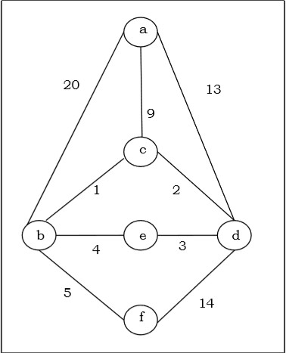

**Solution**

From the above graph we construct the following table −

|  |  |  |
| --- | --- | --- |
| **Edge No.** | **Vertex Pair** | **Edge Weight** |
| E1 | (a, b) | 20 |
| E2 | (a, c) | 9 |
| E3 | (a, d) | 13 |
| E4 | (b, c) | 1 |
| E5 | (b, e) | 1 |
| E6 | (b, f) | 5 |
| E7 | (c, d) | 2 |
| E8 | (d, e) | 3 |
| E9 | (d, f) | 14 |

Now we will rearrange the table in ascending order with respect to Edge weight –

|  |  |  |
| --- | --- | --- |
| **Edge No.** | **Vertex Pair** | **Edge Weight** |
| E4 | (b, c) | 1 |
| E7 | (c, d) | 2 |
| E8 | (d, e) | 3 |
| E5 | (b, e) | 4 |
| E6 | (b, f) | 05 |
| E2 | (a, c) | 9 |
| E3 | (a, d) | 13 |
| E9 | (d, f) | 14 |
| E1 | (a, b) | 20 |

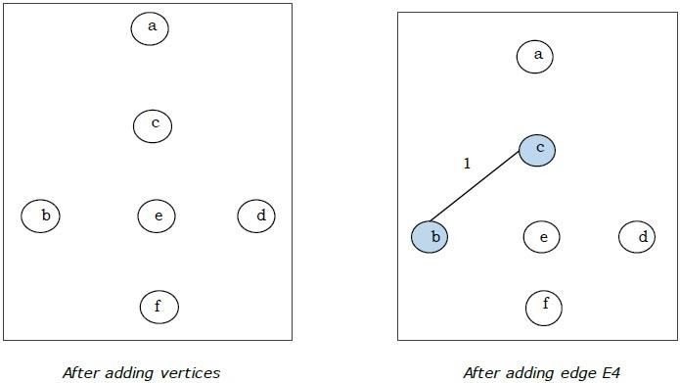

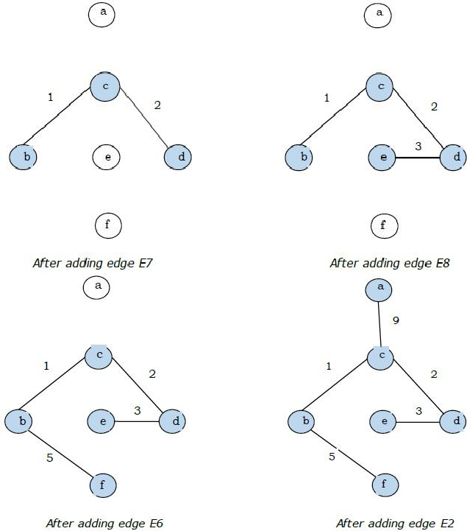

Since we got all the 5 edges in the last figure, we stop the algorithm and this is the minimal spanning tree and its total weight is (1+2+3+5+9) = 20

**Prim's Algorithm**

Prim's algorithm, discovered in 1930 by mathematicians, Vojtech Jarnik and Robert C. Prim, is a greedy algorithm that finds a minimum spanning tree for a connected weighted graph. It finds a tree of that graph which includes every vertex and the total weight of all the edges in the tree is less than or equal to every possible spanning tree. Prim’s algorithm is faster on dense graphs.

**Algorithm**

* + Create a vertex set V that keeps track of vertices already included in MST.
  + Assign a key value to all vertices in the graph. Initialize all key values as infinite. Assign key value as 0 for the first vertex so that it is picked first.
  + Pick a vertex ‘x’ that has minimum key value and is not in V.
  + Include the vertex U to the vertex set V.
  + Update the value of all adjacent vertices of x.
  + Repeat step 3 to step 5 until the vertex set V includes all the vertices of the graph.

**Problem**

Suppose we want to find minimum spanning tree for the following graph G using Prim’s algorithm.

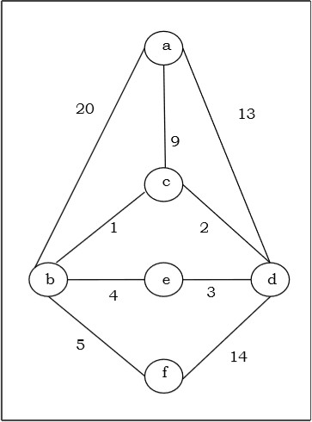

**Solution**

Here we start with the vertex ‘a’ and proceed.

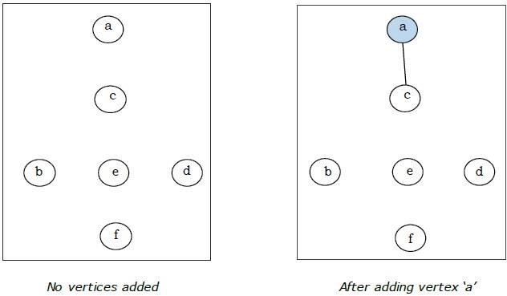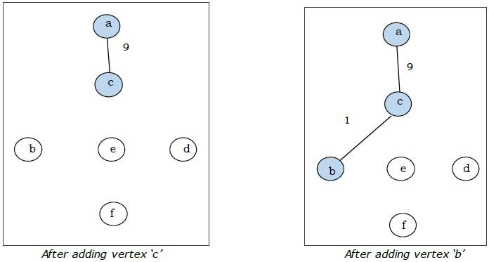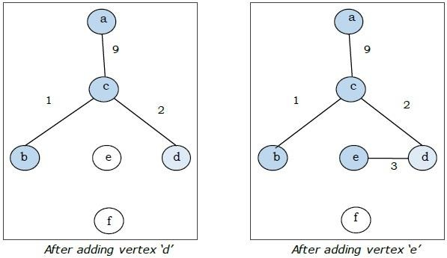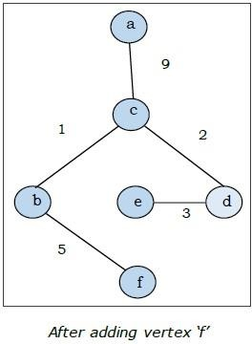

This is the minimal spanning tree and its total weight is (1+2+3+5+9) = 20.

**UNIT-5**

1. **Fundamental Principals of Counting**
2. **The principle of Inclusion and Exclusion**
3. **Generating Functions**

### 1.Fundamental Principals of Counting

In daily lives, many a times one needs to find out the number of all possible outcomes for a series of events. For instance, in how many ways can a panel of judges comprising of 6 men and 4 women be chosen from among 50 men and 38 women? How many different 10 lettered PAN numbers can be generated such that the first five letters are capital alphabets, the next four are digits and the last is again a capital letter. For solving these problems, mathematical theory of counting are used. **Counting** mainly encompasses fundamental counting rule, the permutation rule, and the combination rule.

**The Rules of Sum and Product**

The **Rule of Sum** and **Rule of Product** are used to decompose difficult counting problems into simple problems.

* + **The Rule of Sum** − If a sequence of tasks T1, T2, …, Tm can be done in w1, w2, … wm ways respectively (the condition is that no tasks can be performed simultaneously), then the number of ways to do one of these tasks is w1+w2+… +wm. If we consider two tasks A and B which are disjoint (i.e. A ∩ B = ∅ ), then mathematically |A ∪ B| = |A| + |B|
  + **The Rule of Product** − If a sequence of tasks T1, T2, …, Tm can be done in w1, w2, … wm ways respectively and every task arrives after the occurrence of the previous task, then there are w1×w2 ×...× wm ways to perform the tasks. Mathematically, if a task B arrives after a task A, then |A×B| = |A|×|B|

**Example**

**Question** − A boy lives at X and wants to go to School at Z. From his home X he has to first reach Y and then Y to Z. He may go X to Y by either 3 bus routes or 2 train routes. From there, he can either choose 4 bus routes or 5 train routes to reach Z. How many ways are there to go from X to Z?

**Solution** − From X to Y, he can go in 3+2 = 5 ways (Rule of Sum). Thereafter, he can go Y to Z in 4+5 = 9 ways (Rule of Sum). Hence from X to Z he can go in 5×9 = 45 ways (Rule of Product).

**Permutations**

A **permutation** is an arrangement of some elements in which order matters. In other words a Permutation is an ordered Combination of elements.

**Examples**

* + From a set S = {x, y, z} by taking two at a time, all permutations are − xy, yx, xz, zx, yz, zy.
  + We have to form a permutation of three digit numbers from a set of numbers S = {1, 2, 3}. Different three digit numbers will be formed when we arrange the digits. The permutation will be = 123,132,213,231,312,321

**Number of Permutations**

The number of permutations of ‘n’ different things taken ‘r’ at a time is denoted by *nPr nPr*=*n*!(*n*−*r*)! ,where *n*!=1.2.3.…..(*n*−1).*n*

**Proof** − Let there be ‘n’ different elements.

There are n number of ways to fill up the first place. After filling the first place (n− 1) number of elements is left. Hence, there are (n − 1) ways to fill up the second place. After filling the first and second place, (n − 2) number of elements is left. Hence, there are (n − 2) ways to fill up the third place. We can now generalize the number of ways to fill up r-th place as [n − (r−1)] = n−r+1

So, the total no. of ways to fill up from first place upto r-th-place −

*nPr*=*n*(*n*−1)(*n*−2).....(*n*−*r*+1)

=[*n*(*n*−1)(*n*−2)...(*n*−*r*+1)][(*n*−*r*)(*n*−*r*−1)−−−−−3.2.1]/[(*n*−*r*)(*n*−*r*−1)..3.2.1]

Hence, *nPr*=*n*!/(*n*−*r*)!

**Some important formulas of permutation**

* + If there are *n* elements of which a1 are alike of some kind, a2 are alike of another kind; a3 are alike of third kind and so on and ar are of rth kind, where (*a*1+*a*2+...*ar*)=*n*.

Then, number of permutations of these n objects is = *n*!/[(*a*1!)(*a*2!).....(*ar*1!)].

* + Number of permutations of n distinct elements taking n elements at a time = *nPn*=*n*!
  + The number of permutations of n dissimilar elements taking r elements at a time, when x particular things always occupy definite places = *n*−*xpr*−*x*
  + The number of permutations of n dissimilar elements when r specified things always come together is: *r*!(*n*−*r*+1)!
  + The number of permutations of n dissimilar elements when r specified things never come together is: *n*!−[*r*!(*n*−*r*+1)!]
  + The number of circular permutations of n different elements taken x elements at time =

*nPx*/*x*

* + The number of circular permutations of n different things = *nPn*/*n*

**Some Problems**

**Problem 1** − From a bunch of 6 different cards, how many ways we can permute it?

**Solution** − As we are taking 6 cards at a time from a deck of 6 cards, the permutation will be

###### 6*P*6=6!=720

**Problem 2** − In how many ways can the letters of the word 'READER' be arranged? **Solution** − There are 6 letters word (2 E, 1 A, 1D and 2R.) in the word 'READER'. The permutation will be =6!/[(2!)(1!)(1!)(2!)]=180.

**Problem 3** − In how ways can the letters of the word 'ORANGE' be arranged so that the consonants occupy only the even positions?

**Solution** − There are 3 vowels and 3 consonants in the word 'ORANGE'. Number of ways of arranging the consonants among themselves = 3*P*3=3!=6

The remaining 3 vacant places will be filled up by 3 vowels in 3*P*3=3!=6*ways*. Hence, the total number of permutation is 6×6=36

**Combinations**

A **combination** is selection of some given elements in which order does not matter. The number of all combinations of n things, taken r at a time is −*nCr*=*n*!*r*!(*n*−*r*)!

**Problem 1**

Find the number of subsets of the set {1, 2, 3, 4, 5, 6} having 3 elements.

**Solution**

The cardinality of the set is 6 and we have to choose 3 elements from the set. Here, the ordering does not matter. Hence, the number of subsets will be 6*C*3=20

**Problem 2**

There are 6 men and 5 women in a room. In how many ways we can choose 3 men and 2 women from the room?

**Solution**

The number of ways to choose 3 men from 6 men is 6*C*3

and the number of ways to choose 2 women from 5 women is 5*C*2

Hence, the total number of ways is − 6*C*3×5*C*2=20×10=200

**Problem 3**

How many ways can you choose 3 distinct groups of 3 students from total 9 students?

**Solution**

Let us number the groups as 1, 2 and 3

For choosing 3 students for 1st group, the number of ways − 9*C*3

The number of ways for choosing 3 students for 2nd group after choosing 1st group − 6*C*3

The number of ways for choosing 3 students for 3rd group after choosing 1st and 2nd group − 6*C*3

Hence, the total number of ways = 9*C*3×6*C*3×3*C*3=84×20×1=1680

**Pascal's Identity**

**Pascal's identity**, first derived by Blaise Pascal in 19th century, states that the number of ways to choose k elements from n elements is equal to the summation of number of ways to choose (k−1) elements from (n−1) elements and the number of ways to choose *k* elements from n−1 elements.

Mathematically, for any positive integers k and n : *nCk*=*n*−1*Ck*−1+*n*−1*Ck*

**Proof**

*n*−1*Ck*−1+*n*−1*Ck*

=(*n*−1)!(*k*−1)!(*n*−*k*)!+(*n*−1)!*k*!(*n*−*k*−1)!

=(*n*−1)!(*kk*!(*n*−*k*)!+*n*−*kk*!(*n*−*k*)!)

=(*n*−1)!.*nk*!(*n*−*k*)!

=*n*!*k*!(*n*−*k*)!

=*nCk*

**Pigeonhole Principle**

In 1834, German mathematician, Peter Gustav Lejeune Dirichlet, stated a principle which he called the drawer principle. Now, it is known as the pigeonhole principle.

**Pigeonhole Principle** states that if there are fewer pigeon holes than total number of pigeons and each pigeon is put in a pigeon hole, then there must be at least one pigeon hole with more than one pigeon. If n pigeons are put into m pigeonholes where n>m, there's a hole with more than one pigeon.

**Examples**

* + Ten men are in a room and they are taking part in handshakes. If each person shakes hands at least once and no man shakes the same man’s hand more than once then two men took part in the same number of handshakes.
  + There must be at least two people in a big city with the same number of hairs on their heads.

**THEOREM 1 THE PIGEONHOLE PRINCIPLE** If *k* is a positive integer and *k* + 1 or more objects are placed into *k* boxes, then there is at least one box containing two or more of the objects.

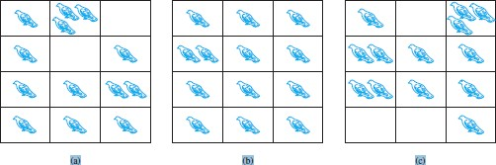

**FIGURE 1 There Are More Pigeons Than Pigeonholes.**

***Proof:*** We prove the pigeonhole principle using a proof by contraposition. Suppose that none of the *k* boxes contains more than one object. Then the total number of objects would be at most *k*. This is a contradiction,

because there are at least *k* + 1 objects. The pigeonhole principle is also called the **Dirichlet drawer principle**, after the nineteenthcentury .German mathematician G. Lejeune Dirichlet, who often used this principle in his work.

**COROLLARY 1** Afunction *f* from a set with *k* + 1 or more elements to a set with *k* elements is not one-to- one.

***Proof:*** Suppose that for each element *y* in the codomain of *f* we have a box that contains all elements *x* of the

domain of *f* such that *f (x)* = *y*. Because the domain contains *k* + 1 or more elements and the co-domain

contains only *k* elements, the pigeonhole principle tells us that one of these boxes contains two or more elements *x* of the domain. This means that *f* cannot be one-to-one.

**Examples 1–3 show how the pigeonhole principle is used.**

**EXAMPLE 1** Among any group of 367 people, there must be at least two with the same birthday, because there are only 366 possible birthdays. ▲

**EXAMPLE 2** In any group of 27 English words, there must be at least two that begin with the same letter, because there are 26 letters in the English alphabet. ▲

**EXAMPLE 3** How many students must be in a class to guarantee that at least two students receive the same score on the final exam, if the exam is graded on a scale from 0 to 100 points?

***Solution:*** There are 101 possible scores on the final. The pigeonhole principle shows that among any 102 students there must be at least 2 students with the same score.

**EXAMPLE 4** Show that for every integer *n* there is a multiple of *n* that has only 0s and 1s in its decimal expansion.

***Solution:*** Let *n* be a positive integer. Consider the *n* + 1 integers 1*,* 11*,* 111*, . . . ,* 11 *. . .* 1 (where the last integer in this list is the integer with *n* + 1 1s in its decimal expansion). Note that there are *n* possible

remainders when an integer is divided by *n*. Because there are *n* + 1 integers in this list, by the pigeonhole principle there must be two with the same remainder when divided by *n*. The larger of these integers less the smaller one is a multiple of *n*, which has a decimal expansion consisting entirely of 0s and 1s.

The Generalized Pigeonhole Principle

**THEOREM 2 THE GENERALIZED PIGEONHOLE PRINCIPLE** If *N* objects are placed into *k*

boxes, then there is at least one box containing at least ┌*N/k*ךּ objects.

***Proof:*** We will use a proof by contraposition. Suppose that none of the boxes contains more than ┌*N/k*ךּ − 1 objects. Then, the total number of objects is at most



where the inequality ┌*N/k*ךּ*< (N/k)* + 1 has been used. This is a contradiction because there are a total of *N*

objects.

**EXAMPLE 5** Among 100 people there are at least ┌100*/*12ךּ= 9 who were born in the same month.

**EXAMPLE 6** What is the minimum number of students required in a discrete mathematics class to be sure that at least six will receive the same grade, if there are five possible grades, A, B, C, D, and F?

***Solution:*** The minimum number of students needed to ensure that at least six students receive the same grade is the smallest integer *N* such that ┌*N/*5ךּ = 6. The smallest such integer is *N* = 5 · 5 + 1 = 26. If you have only 25 students, it is possible for there to be five who have received each grade so that no six students have

received the same grade. Thus, 26 is the minimum number of students needed to ensure that at least six

students will receive the same grade.▲

**EXAMPLE 7**

1. How many cards must be selected from a standard deck of 52 cards to guarantee that at least three cards of the same suit are chosen?
2. How many must be selected to guarantee that at least three hearts are selected?

***Solution:* a)** Suppose there are four boxes, one for each suit, and as cards are selected they are placed in the box reserved for cards of that suit. Using the generalized pigeonhole principle, we see that if *N* cards are selected, there is at least one box containing at least ┌*N/*4ךּ cards.

**Consequently**, we know that at least three cards of one suit are selected if ┌*N/*4 ךּ ≥ 3. The smallest integer *N*

such that ┌*N/*4ךּ ≥ 3 is *N* = 2 · 4 + 1 = 9, so nine cards suffice. Note that if eight cards are selected, it is

possible to have two cards of each suit, so more than eight cards are needed. Consequently, nine cards must be selected to guarantee that at least three cards of one suit are chosen. One good way to think about this is to note that after the eighth card is chosen, there is no way to avoid having a third card of some suit.

**b)** We do not use the generalized pigeonhole principle to answer this question, because we want to make sure that there are three hearts, not just three cards of one suit. Note that in the worst case, we can select all the clubs, diamonds, and spades, 39 cards in all, before we select a single heart. The next three cards will be all hearts, so we may need to select 42 cards to get three hearts.

**EXAMPLE 8** What is the least number of area codes needed to guarantee that the 25 million phones in a state can be assigned distinct 10-digit telephone numbers? (Assume that telephone numbers are of the form

*NXX*-*NXX*-*XXXX*, where the first three digits form the area code, *N* represents a digit from 2 to 9 inclusive, and

*X* represents any digit.)

***Solution:*** There are eight million different phone numbers of the form *NXX*-*XXXX* (as shown in Example 8 of Section 6.1). Hence, by the generalized pigeonhole principle, among 25 million telephones, at least

┌25*,*000*,*000*/*8*,*000*,*000ךּ = 4 of them must have identical phone numbers. Hence, at least four area codes are required to ensure that all 10-digit numbers are different. ▲

### Binomial Theorem

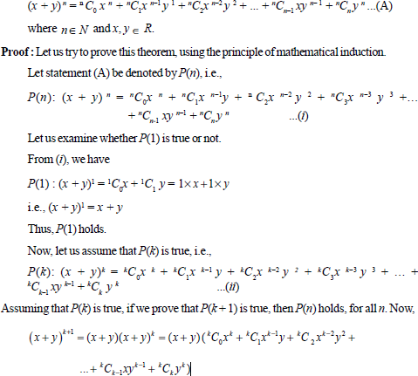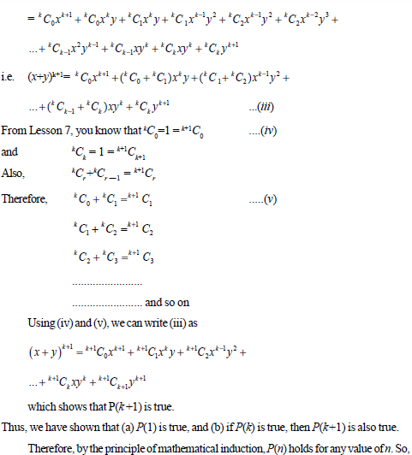

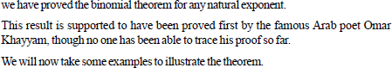

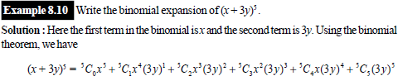

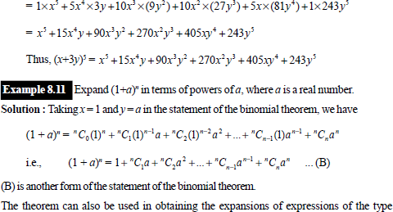

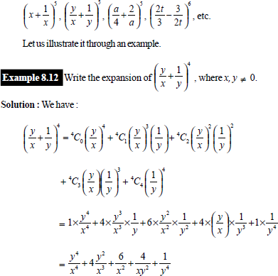

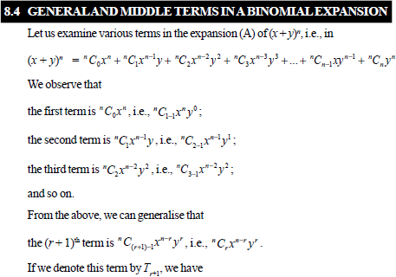

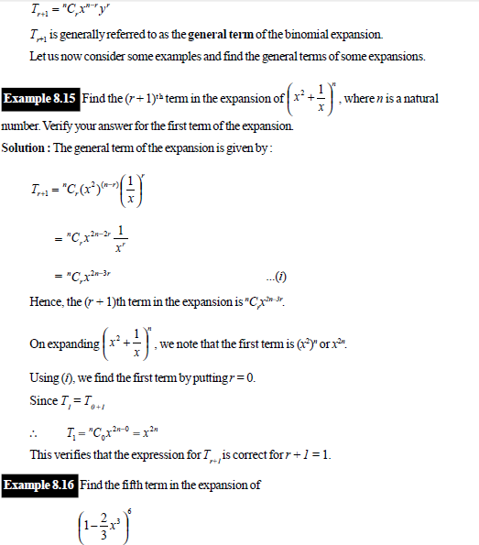

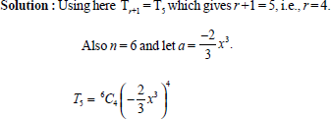

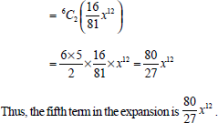

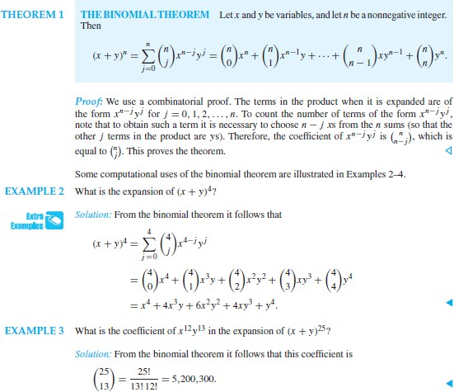

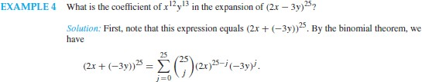

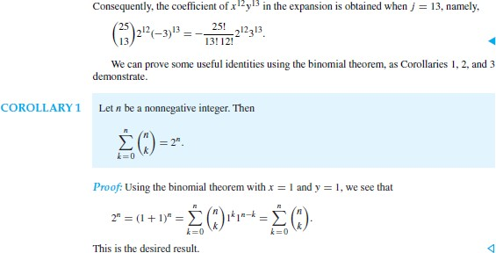

**Permutations and Combinations**

**1.Permutation**

A **permutation** of a set of distinct objects is an ordered arrangement of these objects. We also are interested in ordered arrangements of some of the elements of a set. An ordered arrangement of *r* elements of a set is called an ***r*-permutation**.

**EXAMPLE 2** Let *S* = {1*,* 2*,* 3}.The ordered arrangement 3, 1, 2 is a permutation of *S*. The ordered arrangement 3, 2 is a 2-permutation of *S*. ▲

**The number of *r*-permutations of a set with *n* elements is denoted by *P(n, r)*. We can find *P(n, r)* using the product rule.**

**EXAMPLE 3** Let *S* = {*a, b, c*}. The 2-permutations of *S* are the ordered arrangements *a, b*; *a, c*; *b, a*; *b, c*; *c,*

*a*; and *c, b*. Consequently, there are six 2-permutations of this set with three elements. There are always six 2- permutations of a set with three elements. There are three ways to choose the first element of the arrangement. There are two ways to choose the second element of the arrangement, because it must be different from the

first element. Hence, by the product rule, we see that *P(*3*,* 2*)* = 3 · 2 = 6. the first element. By the product rule, it follows that *P(*3*,* 2*)* = 3 · 2 = 6.

**THEOREM 1** If *n* is a positive integer and *r* is an integer with 1 ≤ *r* ≤ *n*, then there are

*P(n, r)* = *n(n* − 1*)(n* − 2*)* · · · *(n* − *r* + 1*) r*-permutations of a set with *n* distinct elements.

***Proof:*** We will use the product rule to prove that this formula is correct. The first element of the permutation can be chosen in *n* ways because there are *n* elements in the set. There are *n* – 1 ways to choose the second

element of the permutation, because there are *n* − 1 elements left in the set after using the element picked for the first position. Similarly, there are *n* − 2 ways to choose the third element, and so on, until there are exactly *n* − *(r* − 1*)* = *n* − *r* + 1 ways to choose the *r*th element. Consequently, by the product rule, there are

*n(n* − 1*)(n* − 2*)* · · · *(n* − *r* + 1*) r*-permutations of the set.

**COROLLARY 1** If *n* and *r* are integers with 0 ≤ *r* ≤ *n*, then *P(n, r)* =

𝑛!

(𝑛 − 𝑟)! .

***Proof:*** When *n* and *r* are integers with 1 ≤ *r* ≤ *n*, by Theorem 1 we have

𝑛!

*P(n, r)* = *n(n* − 1*)(n* − 2*)* · · · *(n* − *r* + 1*)* =

(𝑛 − 𝑟)! .

Because

𝑛! =

(𝑛−0)!

𝑛1

𝑛1

𝑛1

= 1 whenever *n* is a nonnegative integer, we see that the formula

*P(n, r)* =

(𝑛 − 𝑟)!

also holds when *r* = 0.

**EXAMPLE 4** How many ways are there to select a first-prize winner, a second-prize winner, and a third- prize winner from 100 different people who have entered a contest?

***Solution:*** Because it matters which person wins which prize, the number of ways to pick the three prize winners is the number of ordered selections of three elements from a set of 100 elements, that is, the number of

3-permutations of a set of 100 elements. Consequently, the answer is *P(*100*,* 3*)* = 100 · 99 · 98 = 970*,*200*.* ▲

**EXAMPLE 5** Suppose that there are eight runners in a race. The winner receives a gold medal, the second place finisher receives a silver medal, and the third-place finisher receives a bronze medal. How many different ways are there to award these medals, if all possible outcomes of the race can occur and there are no ties?

***Solution****:* The number of different ways to award the medals is the number of 3-permutations of a set with eight elements. Hence, there are *P(*8*,* 3*)* = 8 · 7 · 6 = 336 possible ways to award the medals. ▲

**EXAMPLE 6** Suppose that a saleswoman has to visit eight different cities. She must begin her trip in a specified city, but she can visit the other seven cities in any order she wishes. How many possible orders

can the saleswoman use when visiting these cities?

***Solution:*** The number of possible paths between the cities is the number of permutations of seven elements, because the first city is determined, but the remaining seven can be ordered arbitrarily. Consequently, there are

7! = 7 · 6 · 5 · 4 · 3 · 2 · 1 = 5040 ways for the saleswoman to choose her tour. If, for instance, the saleswoman wishes to find the path between the cities with minimum distance, and she computes the total distance for each possible path, she must consider a total of 5040 paths! ▲

**EXAMPLE 7** How many permutations of the letters *ABCDEFGH* contain the string *ABC* ?

***Solution:*** Because the letters *ABC* must occur as a block, we can find the answer by finding the number of permutations of six objects, namely, the block *ABC* and the individual letters *D*, *E*,*F*, *G*, and *H*. Because these

six objects can occur in any order, there are 6! = 720 permutations of the letters *ABCDEFGH* in which *ABC*

occurs as a block.

**Combinations**

An ***r*-combination** of elements of a set is an unordered selection of *r* elements from the set.Thus, an

*r*-combination is simply a subset of the set with *r* elements.

**EXAMPLE 9** Let *S* be the set {1*,* 2*,* 3*,* 4}. Then {1*,* 3*,* 4} is a 3-combination from *S*. (Note that {4*,* 1*,* 3} is the same 3-combination as {1*,* 3*,* 4}, because the order in which the elements of a set are listed does not matter.) ▲

The number of *r*-combinations of a set with *n* distinct elements is denoted by *C(n, r)*.

Note that *C(n, r)* is also denoted by  and is called a **binomial coefficient**.

**EXAMPLE 10** We see that *C(*4*,* 2*)* = 6, because the 2-combinations of {*a, b, c, d*} are the six subsets {*a, b*},

{*a, c*}, {*a, d*}, {*b, c*}, {*b, d*}, and {*c, d*}.

**THEOREM 2** The number of *r*-combinations of a set with *n* elements, where *n* is a nonnegative integer and

𝑛!

*r* is an integer with 0 ≤ *r* ≤ *n*, equals *C(n, r)* =

𝑟!(𝑛−𝑟)!

***Proof:*** The *P(n, r) r*-permutations of the set can be obtained by forming the *C(n, r) , r*-combinations of the set, and then ordering the elements in each *r*-combination, which can be done in *P(r*, *r)* ways. Consequently,

by the product rule, *P(n, r)* = *C(n, r)* · *P(r, r).*

This implies that *C(n, r)* =

𝑃(𝑛,𝑟) =

𝑛!

𝑟!

=

𝑛!

𝑃(𝑟,𝑟)

𝑟!(𝑛−𝑟)! (𝑟−𝑟)!

𝑟!(𝑛−𝑟)!

We can also use the division rule for counting to construct a proof of this theorem. Because the order of elements in a combination does not matter and there are *P(r, r)*ways to order *r* elements in an *r*-combination of *n* elements, each of the *C(n, r) r*-combinations of a set with *n* elements corresponds to exactly *P(r, r) r*-

𝑃(𝑛,𝑟)

permutations. Hence, by the division rule, *C(n, r)* =

𝑃(𝑟,𝑟) )

*,* which implies as before that

*C(n, r)* =

𝑛!

𝑟!(𝑛−𝑟)!

**COROLLARY 2** Let *n* and *r* be nonnegative integers with *r* ≤ *n*. Then *C(n, r)* = *C(n, n* − *r)*.

𝑛!

***Proof:*** From Theorem 2 it follows that *C(n, r)* =

𝑟!(𝑛−𝑟)!

*C(n, n* − *r)* = 𝑛!

(𝑛 − 𝑟)! [𝑛 − (𝑛 − 𝑟)]!

Hence, *C(n, r)* = *C(n, n* − *r)*.

= *n*! *(n* − *r)*! *r*! *.*

**EXAMPLE 12** How many ways are there to select five players from a 10-member tennis team to make a trip to a match at another school?

***Solution:*** The answer is given by the number of 5-combinations of a set with 10 elements. By Theorem 2, the number of such combinations is *C(*10*,* 5*)* = 10! 5! 5! = 252*.*

**EXAMPLE 13** A group of 30 people have been trained as astronauts to go on the first mission to Mars. How many ways are there to select a crew of six people to go on this mission (assuming that all crew members have the same job)?

***Solution:*** The number of ways to select a crew of six from the pool of 30 people is the number of 6- combinations of a set with 30 elements, because the order in which these people are chosen does not matter. By Theorem 2, the number of such combinations is

*C(*30*,* 6*)* = 30! 6! 24! = 30 · 29 · 28 · 27 · 26 · 25 6 · 5 · 4 · 3 · 2 · 1 = 593*,*775*.* ▲

**EXAMPLE 15** Suppose that there are 9 faculty members in the mathematics department and 11 in the computer science department. How many ways are there to select a committee to develop a discrete mathematics course at a school if the committee is to consist of three faculty members from the mathematics department and four from the computer science department?

***Solution:*** By the product rule, the answer is the product of the number of 3-combinations of a set with nine elements and the number of 4-combinations of a set with 11 elements. By Theorem 2, the number of ways to

9!

select the committee is *C(*9*,* 3*)* · *C(*11*,* 4*)* =

3!6!

· 11! = 84 · 330 = 27*,*720*.*

4!7!

Permutations with Repetition

Counting permutations when repetition of elements is allowed can easily be done using the product rule,

**EXAMPLE 1** How many strings of length *r* can be formed from the uppercase letters of the English alphabet?

***Solution:*** By the product rule, because there are 26 uppercase English letters, and because each letter can be used repeatedly, we see that there are 26*r* strings of uppercase English letters of length *r*. ▲

The number of *r*-permutations of a set with *n* elements when repetition is allowed is given in Theorem 1.

**THEOREM 1** The number of *r*-permutations of a set of *n* objects with repetition allowed is *nr* .

***Proof:*** There are *n* ways to select an element of the set for each of the *r* positions in the *r*-permutation when repetition is allowed, because for each choice all *n* objects are available. Hence, by the product rule there are *nr r*-permutations when repetition is allowed.

Combinations with Repetition

**THEOREM 2** There are *C(n* + *r* − 1*, r)* = *C(n* + *r* − 1*, n* − 1*) r*-combinations from a set with *n* elements when repetition of elements is allowed.

**EXAMPLE 1:** Suppose that a cookie shop has four different kinds of cookies. How many different ways can six cookies be chosen? Assume that only the type of cookie, and not the individual cookies or the order in which they are chosen, matters.

***Solution:*** The number of ways to choose six cookies is the number of 6-combinations of a set with four elements. From Theorem 2 this equals *C(*4 + 6 − 1*,* 6*)* = *C(*9*,* 6*)*. Because

9 · 8 · 7

*C(*9*,* 6*)* = *C(*9*,* 3*)* =

1 · 2 · 3

= 84*,* there are 84 different ways to choose the six cookies.

**EXAMPLE 2** How many solutions does the equation *x*1 + *x*2 + *x*3 = 11 have, where *x*1, *x*2, and *x*3 are nonnegative integers?

*Solution:* To count the number of solutions, we note that a solution corresponds to a way of selecting 11 items

from a set with three elements so that *x*1 items of type one, *x*2 items of type two, and *x*3 items of type three are chosen. Hence, the number of solutions is equal to the number of 11-combinations with repetition allowed from a set with three elements. From Theorem 2 it follows that there are

13 · 12

*C(*3 + 11 − 1*,* 11*)* = *C(*13*,* 11*)* = *C(*13*,* 2*)* =

solutions.

1 · 2

= 78

The number of solutions of this equation can also be found when the variables are subject to constraints. For instance, we can find the number of solutions where the variables are integers with *x*1 ≥ 1, *x*2 ≥ 2, and *x*3 ≥ 3. A solution to the equation subject to these constraints corresponds to a selection of 11 items with *x*1 items of type

one, *x*2 items of type two, and *x*3 items of type three, where, in addition, there is at least one item of type one,

two items of type two, and three items of type three. So, a solution corresponds to a choice of one item of type one, two of type two, and three of type three, together with a choice of five additional items of any type. By

7 · 6

Theorem 2 this can be done in *C(*3 + 5 − 1*,* 5*)* = *C(*7*,* 5*)* = *C(*7*,* 2*)* =

solutions of the equation subject to the given constraints. ▲

1 · 2

= 21 ways. Thus, there are 21

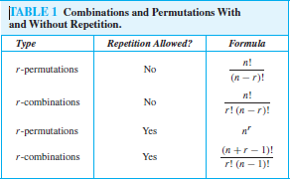

Permutations with Indistinguishable Objects

**THEOREM 3** The number of different permutations of *n* objects, where there are *n*1 indistinguishable objects of type 1, *n*2 indistinguishable objects of type 2*, . . . ,* and *nk* indistinguishable objects

𝑛!

of type *k*, is

𝑛1!𝑛2!𝑛3!…𝑛𝑘!

**EXAMPLE 7** How many different strings can be made by reordering the letters of the word *SUCCESS*? ***Solution****:* Because some of the letters of *SUCCESS* are the same, the answer is *not* given by the number of permutations of seven letters. This word contains three *S*s, two *C*s, one *U*, and one *E*. To determine the number of different strings that can be made by reordering the letters, first note that the three *S*s can be placed among the seven positions in *C(*7*,* 3*)* different ways, leaving four can be placed in *C(*2*,* 1*)* ways, leaving just one position free. Hence *E* can be placed in *C(*1*,* 1*)* way. Consequently, from the product rule, the number of different strings that can be made is *C(*7*,* 3*)C(*4*,* 2*)C(*2*,* 1*)C(*1*,* 1*)*

7! 4!

=

2! 1! 7!

=

=420 *.*

3!4! 2!2! 1!1! 1!0!

3!2!1!1!

**Distributing Objects into Boxes**

**DISTINGUISHABLE OBJECTS AND DISTINGUISHABLE BOXES** We first consider the case when distinguishable objects are placed into distinguishable boxes.

**EXAMPLE 8** How many ways are there to distribute hands of 5 cards to each of four players from the standard

deck of 52 cards?

*Solution:*We will use the product rule to solve this problem. To begin, note that the first player can be dealt 5 cards in *C(*52*,* 5*)* ways. The second player can be dealt 5 cards in *C(*47*,* 5*)* ways, because only 47 cards are left. The third player can be dealt 5 cards in *C(*42*,* 5*)* ways. Finally, the fourth player can be dealt 5 cards in *C(*37*,* 5*)* ways. Hence, the total number of ways to deal four players 5 cards each is

*C(*52*,* 5*)C(*47*,* 5*)C(*42*,* 5*)C(*37*,* 5*)* =

52!

47!

42!

37!

=

52!

47!5! 42!5! 37!5! 32!5! 5! 5! 5! 5! 32!

**Permutations and Combinations Solved Problems:**

|  |  |
| --- | --- |
| **1. Out of 7 consonants and 4 vowels, how many words of 3 consonants and 2 vowels can be formed?** | |
| **A. 24400** | **B. 21300** |
| **C. 210** | **D. 25200** |

Answer with explanation Answer: Option D Explanation:

Number of ways of selecting 3 consonants from 7 = 7C3

Number of ways of selecting 2 vowels from 4 = 4C2

Number of ways of selecting 3 consonants from 7 and 2 vowels from 4 = 7C3 × 4C2

=(7×6×53×2×1)×(4×32×1)=210

It means we can have 210 groups where each group contains total 5 letters *(3 consonants and 2 vowels)*.

Number of ways of arranging 5 letters among themselves =5!=5×4×3×2×1=120.

Hence, required number of ways =210×120=25200.

|  |  |
| --- | --- |
| **2. In a group of 6 boys and 4 girls, four children are to be selected. In how many different ways can they be selected such that at least one boy should be there?** | |
| **A. 159** | **B. 209** |
| **C. 201** | **D. 212** |

Answer with explanation Answer: Option B Explanation:

In a group of 6 boys and 4 girls, four children are to be selected such that at least one boy should be there.

Hence we have 4 options as given below

We can select 4 boys ...(option 1) Number of ways to this = 6C4

We can select 3 boys and 1 girl ...(option 2) Number of ways to this = 6C3 × 4C1

We can select 2 boys and 2 girls ...(option 3) Number of ways to this = 6C2 × 4C2

We can select 1 boy and 3 girls ...(option 4) Number of ways to this = 6C1 × 4C3

Total number of ways

= 6C4 + 6C3 × 4C1 + 6C2 × 4C2 + 6C1 × 4C3

= 6C2 + 6C3 × 4C1 + 6C2 × 4C2 + 6C1 × 4C1[∵ nCr = nC(n-r)]

=6×52×1+6×5×43×2×1×4

+6×52×1×4×32×1+6×4

=15+80+90+24=209

|  |  |
| --- | --- |
| **3. From a group of 7 men and 6 women, five persons are to be selected to form a committee so that at least 3 men are there in the committee. In how many ways can it be done?** | |
| **A. 624** | **B. 702** |
| **C. 756** | **D. 812** |

Answer with explanation Answer: Option C Explanation:

From a group of 7 men and 6 women, five persons are to be selected with at least 3 men. Hence we have the following 3 options.

We can select 5 men ...(option 1) .. Number of ways to do this = 7C5

We can select 4 men and 1 woman ...(option 2).. Number of ways to do this = 7C4 × 6C1

We can select 3 men and 2 women ...(option 3) .. Number of ways to do this = 7C3 × 6C2

Total number of ways

= 7C5 + (7C4 × 6C1) + (7C3 × 6C2)

= 7C2 + (7C3 × 6C1) + (7C3 × 6C2)[∵ nCr = nC(n - r) ]

=7×62×1+7×6×53×2×1×6

+7×6×53×2×1×6×52×1

=21+210+525=756

|  |  |
| --- | --- |
| **4. In how many different ways can the letters of the word 'OPTICAL' be arranged so that the vowels always come together?** | |
| **A. 610** | **B. 720** |
| **C. 825** | **D. 920** |

Answer with explanation Answer: Option B Explanation:

The word 'OPTICAL' has 7 letters. It has the vowels 'O','I','A' in it and these 3 vowels should always come together. Hence these three vowels can be grouped and considered as a single letter. That is, PTCL(OIA).

Hence we can assume total letters as 5 and all these letters are different. Number of ways to arrange these letters =5!=5×4×3×2×1=120

All the 3 vowels (OIA) are different

Number of ways to arrange these vowels among themselves =3!=3×2×1=6 Hence, required number of ways =120×6=720

|  |  |
| --- | --- |
| **5. In how many different ways can the letters of the word 'CORPORATION' be arranged so that the vowels always come together?** | |
| **A. 47200** | **B. 48000** |
| **C. 42000** | **D. 50400** |

Answer with explanation Answer: Option D Explanation:

The word 'CORPORATION' has 11 letters. It has the vowels 'O','O','A','I','O' in it and these 5 vowels should always come together. Hence these 5 vowels can be grouped and considered as a single letter. that is, CRPRTN(OOAIO).

Hence we can assume total letters as 7. But in these 7 letters, 'R' occurs 2 times and rest of the letters are different.

Number of ways to arrange these letters

=7!2!=7×6×5×4×3×2×12×1=2520

In the 5 vowels (OOAIO), 'O' occurs 3 and rest of the vowels are different.

Number of ways to arrange these vowels among themselves =5!3!=5×4×3×2×13×2×1=20 Hence, required number of ways =2520×20=50400

|  |  |
| --- | --- |
| **6. In how many ways can a group of 5 men and 2 women be made out of a total of 7 men and 3 women?** | |
| **A. 1** | **B. 126** |
| **C. 63** | **D. 64** |

Answer with explanation Answer: Option C Explanation:

We need to select 5 men from 7 men and 2 women from 3 women.

Number of ways to do this

= 7C5 × 3C2

= 7C2 × 3C1 [∵ nCr = nC(n-r)]

=7×62×1×3=21×3=63

|  |  |
| --- | --- |
| **7. In how many different ways can the letters of the word 'MATHEMATICS' be arranged such that the vowels must always come together?** | |
| **A. 9800** | **B. 100020** |
| **C. 120960** | **D. 140020** |

Answer with explanation Answer: Option C Explanation:

The word 'MATHEMATICS' has 11 letters. It has the vowels 'A','E','A','I' in it and these 4 vowels must always come together. Hence these 4 vowels can be grouped and considered as a single letter. That is, MTHMTCS(AEAI).

Hence we can assume total letters as 8. But in these 8 letters, 'M' occurs 2 times, 'T' occurs 2 times but rest of the letters are different.

Hence,number of ways to arrange these letters =8!(2!)(2!)

=8×7×6×5×4×3×2×1(2×1)(2×1)=10080

In the 4 vowels (AEAI), 'A' occurs 2 times and rest of the vowels are different. Number of ways to arrange these vowels among themselves =4!2!=4×3×2×12×1=12 Hence, required number of ways =10080×12=120960

|  |  |
| --- | --- |
| **8. There are 8 men and 10 women and you need to form a committee of 5 men and 6 women. In how many ways can the committee be formed?** | |
| **A. 10420** | **B. 11** |
| **C. 11760** | **D. None of these** |

Answer with explanation Answer: Option C Explanation:

We need to select 5 men from 8 men and 6 women from 10 women

Number of ways to do this

= 8C5 × 10C6

= 8C3 × 10C4 [∵ nCr = nC(n-r)]

=(8×7×63×2×1)(10×9×8×74×3×2×1)=56×210=11760

|  |  |
| --- | --- |
| **9. How many 3-letter words with or without meaning, can be formed out of the letters of the word, 'LOGARITHMS', if repetition of letters is not allowed?** | |
| **A. 720** | **B. 420** |
| **C. None of these** | **D. 5040** |

Answer with explanation Answer: Option A Explanation:

The word 'LOGARITHMS' has 10 different letters.

Hence, the number of 3-letter words(with or without meaning) formed by using these letters

= 10P3

=10×9×8=720

|  |  |
| --- | --- |
| **10. In how many different ways can the letters of the word 'LEADING' be arranged such that the vowels should always come together?** | |
| **A. None of these** | **B. 720** |
| **C. 420** | **D. 122** |

Answer with explanation Answer: Option B Explanation:

The word 'LEADING' has 7 letters. It has the vowels 'E','A','I' in it and these 3 vowels should always come together. Hence these 3 vowels can be grouped and considered as a single letter. that is, LDNG(EAI).

Hence we can assume total letters as 5 and all these letters are different. Number of ways to arrange these letters =5!=5×4×3×2×1=120

In the 3 vowels (EAI), all the vowels are different. Number of ways to arrange these vowels among themselves =3!=3×2×1=6

Hence, required number of ways =120×6=720

|  |  |
| --- | --- |
| **11. A coin is tossed 3 times. Find out the number of possible outcomes.** | |
| **A. None of these** | **B. 8** |
| **C. 2** | **D. 1** |

Answer with explanation Answer: Option B Explanation:

When a coin is tossed once, there are two possible outcomes: Head(H) and Tale(T) Hence, when a coin is tossed 3 times, the number of possible outcomes =2×2×2=8 (The possible outcomes are HHH, HHT, HTH, HTT, THH, THT, TTH, TTT )

|  |  |
| --- | --- |
| **12. In how many different ways can the letters of the word 'DETAIL' be arranged such that the vowels must occupy only the odd positions?** | |
| **A. None of these** | **B. 64** |
| **C. 120** | **D. 36** |

Answer with explanation Answer: Option D

**Explanation:**

The word 'DETAIL' has 6 letters which has 3 vowels (EAI) and 3 consonants(DTL)

The 3 vowels(EAI) must occupy only the odd positions. Let's mark the positions as (1) (2) (3) (4)

(5) (6). Now, the 3 vowels should only occupy the 3 positions marked as (1),(3) and (5) in any order.

Hence, number of ways to arrange these vowels= 3P3 =3!=3×2×1=6

Now we have 3 consonants(DTL) which can be arranged in the remaining 3 positions in any order. Hence, number of ways to arrange these consonants

= 3P3=3!=3×2×1=6

Total number of ways

= number of ways to arrange the vowels × number of ways to arrange the consonants

=6×6=36

**The Inclusion-Exclusion principle**

The **Inclusion-exclusion principle** computes the cardinal number of the union of multiple non- disjoint sets. For two sets A and B, the principle states −

|*A*∪ *B*|=|*A*|+|*B*|−|*A*∩*B*|

For three sets A, B and C, the principle states −

|*A*∪ *B*∪ *C*|=|*A*|+|*B*|+|*C*|−|*A*∩*B*|−|*A*∩*C*|−|*B*∩*C*|+|*A*∩*B*∩*C*|

The generalized formula −

∣∣⋃∏ *Ai*∣∣=∑1≤*i*<*j*≤*n*|*Ai*∩*Aj*|+∑1≤*i*<*j*<*k*≤*n*|*Ai*∩*Aj*∩*Ak*|−.....+(−1)*n*−1|*A*1∩...∩*A*2

*I* =1

**Problem 1**

How many integers from 1 to 50 are only multiples of 2 or 3?

**Solution**

From 1 to 100, there are 50/2=25

numbers which are multiples of 2. There are 50/3=16

numbers which are multiples of 3. There are 50/6=8

numbers which are multiples of both 2 and 3. So, |*A*|=25,|*B*|=16 and |*A*∩*B*|=8

|*A*∪ *B*|=|*A*|+|*B*|−|*A*∩*B*|=25+16−8=33

**Problem 2**

In a group of 50 students 24 like cold drinks and 36 like hot drinks and each student likes at least one of the two drinks. How many like both coffee and tea?

**Solution**

Let X be the set of students who like cold drinks and Y be the set of people who like hot drinks.

So, |*X*∪*Y*|=50, |*X*|=24, |*Y*|=36

|*X*∩*Y*|=|*X*|+|*Y*|−|*X*∪*Y*|=24+36−50=60−50=10

Hence, there are 10 students who like both tea and coffee.

**Probability**

Closely related to the concepts of counting is Probability. We often try to guess the results of games of chance, like card games, slot machines, and lotteries; i.e. we try to find the likelihood or probability that a particular result with be obtained.

**Probability** can be conceptualized as finding the chance of occurrence of an event. Mathematically, it is the study of random processes and their outcomes. The laws of probability have a wide applicability in a variety of fields like genetics, weather forecasting, opinion polls, stock markets etc.

**Basic Concepts**

Probability theory was invented in the 17th century by two French mathematicians, Blaise Pascal and Pierre de Fermat, who were dealing with mathematical problems regarding of chance.

Before proceeding to details of probability, let us get the concept of some definitions.

**Random Experiment** − An experiment in which all possible outcomes are known and the exact output cannot be predicted in advance is called a random experiment. Tossing a fair coin is an example of random experiment.

**Sample Space** − When we perform an experiment, then the set S of all possible outcomes is called the sample space. If we toss a coin, the sample space **S = {H, T}**

**Event** − Any subset of a sample space is called an event. After tossing a coin, getting Head on the top is an event.

The word "probability" means the chance of occurrence of a particular event. The best we can say is how likely they are to happen, using the idea of probability.

*Probabilityofoccurenceofanevent*=*TotalnumberoffavourableoutcomeTotalnumberofOutcomes*

As the occurrence of any event varies between 0% and 100%, the probability varies between 0 and 1.

**Steps to find the probability**

Step 1 − Calculate all possible outcomes of the experiment.

Step 2 − Calculate the number of favorable outcomes of the experiment. Step 3 − Apply the corresponding probability formula.

**Tossing a Coin**

If a coin is tossed, there are two possible outcomes − Heads (H) or Tails (T) So, Total number of outcomes = 2

Hence, the probability of getting a Head (H) on top is ½ and the probability of getting a Tails (T) on top is ½

**Throwing a Dice**

When a dice is thrown, six possible outcomes can be on the top: 1, 2, 3, 4, 5, 6. The probability of any one of the numbers is ⅙

The probability of getting even numbers is 3/6 = 1/3

The probability of getting odd numbers is 3/6 = 1/3

**Taking Cards From a Deck**

From a deck of 52 cards, if one card is picked find the probability of an ace being drawn and also find the probability of a diamond being drawn.

Total number of possible outcomes − 52 Outcomes of being an ace − 4 Probability of being an ace = 4/52 = 1/13

Probability of being a diamond = 13/52 = 1/4

**Probability Axioms**

* The probability of an event always varies from 0 to 1. [0 ≤ P(x) ≤ 1]
* For an impossible event the probability is 0 and for a certain event the probability is 1.
* If the occurrence of one event is not influenced by another event, they are called mutually exclusive or disjoint.

If A1, A2....An are mutually exclusive/disjoint events, then P(Ai ∩ Aj) = ¢ for i ≠ j and P(A1 ∪ A2 ∪.... An) = P(A1) + P(A2)+..... P(An)

**Properties of Probability**

* If there are two events *x* and *x*¯¯¯ ,which are complementary, then the probability of the complementary event is *p*(*x*¯¯¯)=1−*p*(*x*)

•

* For two non-disjoint events A and B, the probability of the union of two events − P(A ∪ B) = P(A) + P(B)
* If an event A is a subset of another event B (i.e. A ⊂ B), then the probability of A is less than or equal to the probability of B. Hence, A ⊂ B implies P(A) ≤ p(B).

**Conditional Probability**

The conditional probability of an event B is the probability that the event will occur given an event A has already occurred. This is written as P(B|A). If event A and B are mutually exclusive, then the conditional probability of event B after the event A will be the probability of event B that is P(B).

Mathematically − P(B|A) = P(A ∩ B) / P(A)

**Problem 1**

In a country 50% of all teenagers own a cycle and 30% of all teenagers own a bike and cycle. What is the probability that a teenager owns bike given that the teenager owns a cycle?

**Solution**

Let us assume A is the event of teenagers owning only a cycle and B is the event of teenagers owning only a bike.

So, P(A) = 50/100 = 0.5 and P(A ∩ B) = 30/100 = 0.3 from the given problem. P(B|A) = P(A ∩ B) / P(A) = 0.3/0.5 = 0.6

Hence, the probability that a teenager owns bike given that the teenager owns a cycle is 60%.

**Problem 2**

In a class, 50% of all students play cricket and 25% of all students play cricket and volleyball. What is the probability that a student plays volleyball given that the student plays cricket?

**Solution**

Let us assume A is the event of students playing only cricket and B is the event of students playing only volleyball.

So, P(A) = 50/100 = 0.5 and P(A ∩ B) = 25/100 = 0.25 from the given problem. P(B|A) = P(A ∩ B) / P(A) = 0.25/0.5 = 0.5

Hence, the probability that a student plays volleyball given that the student plays cricket is 50%.

**Problem 3**

Six good laptops and three defective laptops are mixed up. To find the defective laptops all of them are tested one-by-one at random. What is the probability to find both of the defective laptops in the first two pick?

**Solution**

Let A be the event that we find a defective laptop in the first test and B be the event that we find a defective laptop in the second test.

Hence, P(A ∩ B) = P(A)P(B|A) = 3/9 × 2/8 = 1/21

**Bayes' Theorem**

**Theorem** − If A and B are two mutually exclusive events, where P(A) is the probability of A and P(B) is the probability of B, P(A | B) is the probability of A given that B is true. P(B | A) is the probability of B given that A is true, then Bayes’ Theorem states −

*P*(*A*|*B*)=*P*(*B*|*A*)*P*(*A*)∑*ni*=1*P*(*B*|*Ai*)*P*(*Ai*)

**Application of Bayes’ Theorem**

* In situations where all the events of sample space are mutually exclusive events.
* In situations where either P( Ai ∩ B ) for each Ai or P( Ai ) and P(B|Ai ) for each Ai is known.

**Problem**

Consider three pen-stands. The first pen-stand contains 2 red pens and 3 blue pens; the second one has 3 red pens and 2 blue pens; and the third one has 4 red pens and 1 blue pen. There is equal probability of each pen-stand to be selected. If one pen is drawn at random, what is the probability that it is a red pen?

**Solution**

Let Ai be the event that ith pen-stand is selected. Here, i = 1,2,3.

Since probability for choosing a pen-stand is equal, P(Ai) = ⅓ Let B be the event that a red pen is drawn.

The probability that a red pen is chosen among the five pens of the first pen-stand, P(B|A1) = 2/5

The probability that a red pen is chosen among the five pens of the second pen-stand, P(B|A2) = 3/5

The probability that a red pen is chosen among the five pens of the third pen-stand, P(B|A3) = 4/5

According to Bayes’ Theorem,

P(B) = P(A1).P(B|A1) + P(A2).P(B|A2) + P(A3).P(B|A3)

= 1/3 ∙ 2/5 + 1/3 ∙ 3/5 + 1/3 ∙ 4/5

= 3/5

**3. Generating Functions**

**Generating Functions**

**DEFINITION 1** The *generating function for the sequence a*0*, a*1*, . . . , ak, . . .* of real numbers is the infinite series

*G(x)* = *a*0 + *a*1*x* +· · ·+*akxk* +· · · =∑∞ 𝑎𝑘 𝑥𝑘

𝑘=0

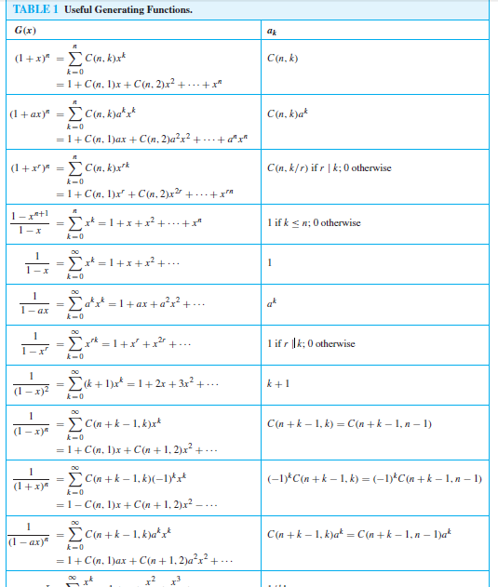

1. Recurrence Relation

In this chapter, we will discuss how recursive techniques can derive sequences and be used for solving counting problems. The procedure for finding the terms of a sequence in a recursive manner is called **recurrence relation**. We study the theory of linear recurrence relations and their solutions. Finally, we introduce generating functions for solving recurrence relations.

**Definition**

A recurrence relation is an equation that recursively defines a sequence where the next term is a function of the previous terms (Expressing Fn as some combination of Fi with i<n).

**Example** − Fibonacci series: Fn = Fn−1 + Fn−2, Tower of Hanoi: Fn = 2Fn−1 + 1

**Linear Recurrence Relations**

A linear recurrence equation of degree k is a recurrence equation which is in the format xn = A1 xn−1 + A2 xn−1 + A3 xn−1 +... Ak xn−k (An is a constant and Ak ≠ 0) on a sequence of numbers as a first-degree polynomial.

These are some examples of linear recurrence equations −

|  |  |  |
| --- | --- | --- |
| **Recurrence relations** | **Initial values** | **Solutions** |
| Fn = Fn−1 + Fn−2 | a1 = a2 = 1 | [Fibonacci number](http://mathworld.wolfram.com/FibonacciNumber.html) |
| Fn = Fn−1 + Fn−2 | a1 = 1, a2 = 3 | [Lucas number](http://mathworld.wolfram.com/LucasNumber.html) |
| Fn = Fn−2 + Fn−3 | a1 = a2 = a3 = 1 | [Padovan sequence](http://mathworld.wolfram.com/PadovanSequence.html) |
| Fn = 2Fn−1 + Fn−2 | a1 = 0, a2 = 1 | [Pell number](http://mathworld.wolfram.com/PellNumber.html) |

**How to solve linear recurrence relation**

Suppose, a two ordered linear recurrence relation is: Fn = AFn−1 + BFn−2 where A and B are real numbers.

The characteristic equation for the above recurrence relation is − x2 − Ax − B = 0

Three cases may occur while finding the roots −

**Case 1** − If this equation factors as (x − x1)(x − x1) = 0 and it produces two distinct real roots x1 and x2, then Fn = ax1n+ bx2n is the solution. [Here, a and b are constants]

**Case 2** − If this equation factors as (x − x1)2 = 0 and it produces single real root x1, then Fn = a x n + bn x n is the solution.

1 1

**Case 3** − If the equation produces two distinct real roots x1 and x2 in polar form x1 = r ∠ θ and x2

= r ∠(− θ), then Fn = rn (a cos(nθ) + b sin(nθ)) is the solution.

**Problem 1**

Solve the recurrence relation Fn = 5Fn−1 − 6Fn−2 where F0 = 1 and F1 = 4

**Solution**

The characteristic equation of the recurrence relation is − x2 − 5x + 6 = 0,

So, (x − 3) (x − 2) = 0

Hence, the roots are − x1 = 3 and x2 = 2

The roots are real and distinct. So, this is in the form of case 1 Hence, the solution is −

Fn = ax n + bx n

1 2

Here, Fn = a3n + b2n (As x1 = 3 and x2 = 2) Therefore,

1 = F0 = a30 + b20 = a+b

4 = F1 = a31 + b21 = 3a+2b

Solving these two equations, we get a = 2 and b = −1 Hence, the final solution is −

Fn = 2.3n + (−1) . 2n = 2.3n − 2n

**Problem 2**

Solve the recurrence relation Fn = 10Fn−1 − 25Fn−2 where F0 = 3 and F1 = 17

**Solution**

The characteristic equation of the recurrence relation is − x2 − 10x −25 = 0,

So, (x − 5)2 = 0

Hence, there is single real root x1 = 5

As there is single real valued root, this is in the form of case 2 Hence, the solution is −

Fn = ax n + bnx n

1 1

3 = F0 = a.50 + b.0.50 = a

17 = F1 = a.51 + b.1.51 = 5a+5b

Solving these two equations, we get a = 3 and b = 2/5 Hence, the final solution is −

Fn = 3.5n + (2/5) .n.2n

**Problem 3**

Solve the recurrence relation Fn = 2Fn−1 − 2Fn−2 where F0 = 1 and F1 = 3

**Solution**

The characteristic equation of the recurrence relation is − x2 −2x −2 = 0

Hence, the roots are − x1 = 1 + i andx2 = 1 − i In polar form,

x1 = r ∠ θ andx2 = r ∠(− θ), where r = √2 and θ = π / 4 The roots are imaginary. So, this is in the form of case 3. Hence, the solution is −

Fn = (√2 )n (a cos(n. π / 4) + b sin(n. π / 4))

1 = F0 = (√2 )0 (a cos(0. π / 4) + b sin(0. π / 4) ) = a

3 = F1 = (√2 )1 (a cos(1. π / 4) + b sin(1. π / 4) ) = √2 ( a/√2 + b/√2) Solving these two equations we get a = 1 and b = 2

Hence, the final solution is −

Fn = (√2 )n (cos(n. π / 4) + 2 sin(n. π / 4))

**Particular Solutions**

A recurrence relation is called non-homogeneous if it is in the form

*Fn = AFn−1 + BFn−2 + F(n)*where F(n) ≠ 0

The solution (an) of a non-homogeneous recurrence relation has two parts. First part is the solution (ah) of the associated homogeneous recurrence relation and the second part is the particular solution (at). So, an = ah + at.

Let F(n) = cxn and x1 and x2 are the roots of the characteristic equation −

x2 = Ax + B which is the characteristic equation of the associated homogeneous recurrence relation −

* + If x ≠ x1 and x ≠ x2, then at = Axn
  + If x = x1, x ≠ x2, then at = Anxn
  + If x = x1 = x2, then at = An2xn

**Problem**

Solve the recurrence relation Fn = 3Fn−1 + 10Fn−2 + 7.5n where F0 = 4 and F1 = 3

**Solution**

The characteristic equation is − x2 − 3x −10 = 0

Or, (x − 5)(x + 2) = 0

Or, x1= 5 and x2 = −2

Since, x = x1 and x ≠ x2, the solution is − at = Anxn = An5n

After putting the solution into the non-homogeneous relation, we get − An5n = 3A(n − 1)5n−1 + 10A(n − 2)5n−2 + 7.5n

Dividing both sides by 5n−2, we get − An52 = 3A(n − 1)5 + 10A(n − 2)50 + 7.52

Or, 25An = 15An − 15A + 10An − 20A + 175 Or, 35A = 175

Or, A = 5

So, Fn = n5n+1

Hence, the solution is − Fn = n5n+1 + 6.(−2)n −2.5n

**Generating Functions**

**Generating Functions** represents sequences where each term of a sequence is expressed as a coefficient of a variable *x* in a formal power series.

Mathematically, for an infinite sequence, say a0, a1, a2,…………, ak,………, the generating function will be −

*Gx*=*a*0+*a*1*x*+*a*2*x*2+.........+*akxk*+.........=∑*k*=0∞*akxk*

**Some Areas of Application**

Generating functions can be used for the following purposes −

* + For solving a variety of counting problems. For example, the number of ways to make change for a Rs. 100 note with the notes of denominations Rs.1, Rs.2, Rs.5, Rs.10, Rs.20 and Rs.50
  + For solving recurrence relations
  + For proving some of the combinatorial identities
  + For finding asymptotic formulae for terms of sequences

**Problem 1**

What are the generating functions for the sequences {ak} with ak = 2 and = 3k?

**Solution**

When ak = 2, generating function,

*G*(*x*)=∑∞*k*=02*xk*=2+2*x*+2*x*2+2*x*3+.........

When *ak*=3*k*,*G*(*x*)=∑∞*k*=03*kxk*=0+3*x*+6*x*2+9*x*3+......

**Problem 2**

What is the generating function of the infinite series; 1, 1, 1, 1, ……….?

**Solution**

Here, ak = 1, *for* 0 ≤k≤ ∞.

Hence, *G*(*x*)=1+*x*+*x*2+*x*3+........=1(1−*x*)

**Some Useful Generating Functions**

* + For *ak*=*ak*,*G*(*x*)=∑∞*k*=0*akxk*=1+*ax*+*a*2*x*2+.........=1(1−*ax*)

• • For *ak*=(*k*+1),*G*(*x*)=∑∞*k*=0(*k*+1)*xk*=1+2*x*+3*x*2.........=1(1−*x*)2

• • For *ak*=*cnk*,*G*(*x*)=∑∞*k*=0*cnkxk*=1+*cn*1*x*+*cn*2*x*2+.........+*x*2=(1+*x*)*n*

• • For *ak*=1*k*!,*G*(*x*)=∑∞*k*=0*xkk*!=1+*x*+*x*22!+*x*33!.........=*ex*

•

**Mathematical induction**, is a technique for proving results or establishing statements for natural numbers. This part illustrates the method through a variety of examples.

**Definition**

**Mathematical Induction** is a mathematical technique which is used to prove a statement, a formula or a theorem is true for every natural number.

The technique involves *two* steps to prove a statement, as stated below −

**Step 1(Base step)** − It proves that a statement is true for the initial value.

**Step 2(Inductive step)** − It proves that if the statement is true for the nth iteration (or number *n*), then it is also true for (n+1)th iteration ( or number *n+1*).

**How to Do It**

**Step 1** − Consider an initial value for which the statement is true. It is to be shown that the statement is true for n = initial value.

**Step 2** − Assume the statement is true for any value of *n = k*. Then prove the statement is true for *n = k+1*. We actually break *n = k+1* into two parts, one part is n = k (which is already proved) and try to prove the other part.

**Problem 1**

3n−1 is a multiple of 2 for n = 1, 2, ...

**Solution**

Step 1 − For n = 1, 31−1 = 3−1 = 2 which is a multiple of 2

Step 2 − Let us assume 3n−1 is true for n = k, Hence, 3k −1 is true (It is an assumption) We have to prove that 3k+1−1 is also a multiple of 2

3k+1 − 1 = 3 × 3k − 1 = (2 × 3k) + (3k −1)

The first part (2 × 3k) is certain to be a multiple of 2 and the second part (3k −1) is also true as our previous assumption.

Hence, 3k+1 − 1 is a multiple of 2.

So, it is proved that 3n − 1 is a multiple of 2.

**Problem 2**

1 + 3 + 5 + ... + (2n−1) = n2 for n = 1, 2, ...

**Solution**

Step 1 − For n = 1, 1 = 12, Hence, step 1 is satisfied. Step 2 − Let us assume the statement is true for n = k.

Hence, 1 + 3 + 5 + ... + (2k−1) = k2 is true (It is an assumption)

We have to prove that 1 + 3 + 5 + ... + (2(k+1)−1) = (k+1)2 also holds 1 + 3 + 5 + ... + (2(k+1) − 1)

= 1 + 3 + 5 + ... + (2k+2 − 1)

= 1 + 3 + 5 + ... + (2k + 1)

= 1 + 3 + 5 + ... + (2k − 1) + (2k + 1)

= k2 + (2k + 1)

= (k + 1)2

So, 1 + 3 + 5 + ... + (2(k+1) − 1) = (k+1)2 hold which satisfies the step 2. Hence, 1 + 3 + 5 + ... + (2n − 1) = n2 is proved.

**Problem 3**

Prove that (ab)n = anbn is true for every natural number *n*

**Solution**

Step 1 − For n = 1, (ab)1 = a1b1 = ab, Hence, step 1 is satisfied.

Step 2 − Let us assume the statement is true for n = k, Hence, (ab)k = akbk is true (It is an assumption).

We have to prove that (ab)k+1 = ak+1bk+1 also hold Given, (ab)k = akbk

Or, (ab)k(ab) = (akbk) (ab) [Multiplying both side by ‘ab’]

Or, (ab)k+1 = (aak) ( bbk) Or, (ab)k+1 = (ak+1bk+1) Hence, step 2 is proved.

So, (ab)n = anbn is true for every natural number n.

**Strong Induction**

Strong Induction is another form of mathematical induction. Through this induction technique, we can prove that a propositional function, *P(n)* is true for all positive integers, *n*, using the following steps −

* + **Step 1(Base step)** − It proves that the initial proposition *P(1)* true.
  + **Step 2(Inductive step)** − It proves that the conditional statement [p(1) ∧ p(2) ∧ p(3)

∧…………∧ p(k)] → p(k + 1) is true for positive integers k.